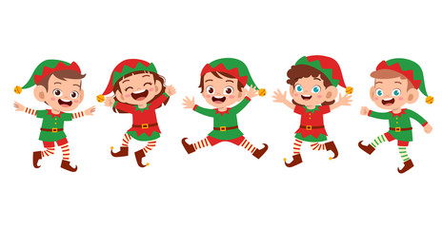
Friday Night Information
Come join us dressed in fun Christmas PJs.
We will have a hospitality suite with lots of delicious foods/treats including drinks and “drinks”.
We will have music and trivia in our meeting room (Ivy Room).

***If you wish to bring alcoholic beverages into the Ivy Room, you must purchase them from the Crosby Pub which is conveniently located 2 doors down the hall from the Ivy Room.
The only outside beverages allowed in the Ivy Room is water.
Thank you for understanding.
(Hotel policy)

We can have alcoholic beverages in our rooms and hospitality suite.
Saturday Information
Complimentary Hot Breakfast Buffet Provided by the hotel (6:30-9:30 am)
We will have our normal business meeting after breakfast in The Ivy Room.
Catered Lunch will take place in the Ivy Room consisting of a Sandwich Bar.
**If you choose to participate – bring a NEW hometown ornament or one that represents your area in the state. ***

Saturday afternoon is open to your own activities. We will provide area information including local vineyards/wineries, shopping, etc.

Saturday night!!! We will have a fun casual Christmas Party!!
Please bring your UGLY Sweaters!!! We will have an ugly sweater contest!
We will have a DJ that can play all of our favorites including current line-dance songs, etc.
We will have a delicious buffet with different offering but including a vegetarian option.
Be ready to show your best dance moves!!!

