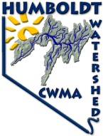**Humboldt Watershed Cooperative Weed Management Area**

HWCWMA 🞟 P.O. Box 570 🞟 Elko, NV 89803-0570 🞟 [hwcwma@gmail.com](mailto:hwcwma@gmail.com)

[www.HumboldtWeedFree.org](http://www.HumboldtWeedFree.org) ⁂ [aporreca@humboldtweedfree.org](mailto:aporreca@humboldtweedfree.org)

Providing land managers, owners and local weed control groups assistance

through funding, agency and weed group coordination, communication and cooperation



Hello from the Humboldt Watershed Cooperative Weed Management Area! This month we would like to introduce you to another state listed noxious weed, medusahead (*Taeniatherum caput-medusae*). Although not much is known about this fairly recently introduced plant, this aggressive winter annual grass is changing the [ecology](http://en.wikipedia.org/wiki/Ecology) of western [rangelands](http://en.wikipedia.org/wiki/Rangeland) in North America. Medusahead was first described in the United States in [Oregon](http://en.wikipedia.org/wiki/Oregon) in 1903 and as of 2005, medusahead has infested approximately 972,700 acres in 17 western states (from [North Dakota](http://en.wikipedia.org/wiki/North_Dakota) south to [Texas](http://en.wikipedia.org/wiki/Texas) and west to the Pacific coast), and spreads at an average rate of 12% per year. As medusahead establishes itself, it outcompetes native vegetation, reduces land value, and creates a [wildfire](http://en.wikipedia.org/wiki/Wildfire) hazard.

Medusahead is a winter annual, germinating in the fall and undergoing root growth in the winter and early spring. Since its roots develop early and reach deep in the soil, it [outcompetes](http://en.wikipedia.org/wiki/Competition_(biology)) native plants for moisture. It flowers in early spring, and by June or July its seeds, which are covered with tiny barbs, are mature. The barbs help the seeds attach to livestock, humans or vehicles that pass by. As the grass grows it accumulates [silica](http://en.wikipedia.org/wiki/Silica), making it unpalatable to livestock except for early in its life cycle. It creates a dense layer of litter, and because of the silica content, the litter decomposes more slowly than that of other plants. This litter suppresses native plant growth while encouraging the [germination](http://en.wikipedia.org/wiki/Germination) of its own seed, and after a few years it creates an enormous load of dry fuel that can lead to wildfires.

Stands of medusahead vary in density from several hundred to 2,000 plants per square foot. This variance is directly related to annual [precipitation](http://en.wikipedia.org/wiki/Precipitation_(meteorology)), soil type, and other vegetation in the area. Since it matures later than most other annuals, it is easy to identify as it is often bright green when other annuals are brown. As it matures, it turns shades of purple and eventually tan. Medusahead can also be easily confused with squirrel-tail or foxtail barley.

Medusahead ranges in height from 20 to 60 centimeters. It has slender, weak stems that often branch at the base. It has spike [inflorescences](http://en.wikipedia.org/wiki/Inflorescence) similar to those of [wheat](http://en.wikipedia.org/wiki/Wheat) or [rye](http://en.wikipedia.org/wiki/Rye). The grass spikelet or lemma, has long [awns](http://en.wikipedia.org/wiki/Awn_(botany)) and the [glumes](http://en.wikipedia.org/wiki/Glume) have shorter ones, giving the seed head a layered look. As the awns dry, they twist and spread in all directions, similar to the snake-covered head of the mythological [Medusa](http://en.wikipedia.org/wiki/Medusa). The barbs on the awns help the seed drive into the soil. The grainlike seed may remain viable in the soil for a number of years.

Control Methods:

**Mechanical -** Tillage will control existing medusahead plants and can be used to break up deep thatch layers. But, it can increase potential for soil erosion and loss of soil moisture. Mowing is not an effective control strategy for medusahead.

**Chemical** - Several herbicides provide excellent control of medusahead. Herbicides differ in selectivity, persistence

in the environment, grazing restrictions, and many other parameters. Always read the label before applying any

herbicide.

Foliar active compounds such as glyphosate (trade name: Roundup ™ herbicide, etc.) can be very effective if good

coverage is obtained. Applications of foliar active herbicides will be less effective if a heavy thatch intercepts the spray. Soil active compounds such as Aminopyralid (trade name: MilestoneMedushead™) and imazapic (trade name: Plateau™) are two relatively new compounds on the market that provide foliar control and several months of soil activity.

**Grazing** - Medusahead has minimal value for livestock grazing, but livestock will graze medusahead when it is in a vegetative stage. The nutritive value of medusahead foliage is comparable to cheatgrass, except medusahead has a high level of silica and the season of use is much shorter. Grazing values diminish rapidly as the plants mature and is due in part to the awned seeds. The awned seeds can cause injury to eyes, nose, and mouths of grazers.

As always, please notify the HWCWMA if you see medusahead growing within the Humboldt River watershed. Our [staff](http://www.kingcounty.gov/environment/animalsAndPlants/noxious-weeds/program-information/who-we-are.aspx) can provide the property owner or appropriate public agency with site-specific advice on how best to remove it. We have an opportunity to stop it from spreading if we act quickly. We [map](http://www.kingcounty.gov/environment/animalsAndPlants/noxious-weeds/maps.aspx) all known locations of regulated noxious weeds in order to help us and others locate new infestations in time to control them.

The Humboldt Watershed CWMA has also developed a website to serve as a clearinghouse for information on weeds in the Humboldt Watershed. Our website (http://www.humboldtweedfree.org) contains fact sheets for state listed noxious weeds in Nevada, Board of Director’s information, funding partner’s links, and many more features including a detailed project proposal packet that you can print, fill out and mail back to us at your convenience. We are looking to expand our project area outside of the Humboldt River and always welcome new funding opportunities and partnerships.

If you have any questions, please feel free to contact Andi Porreca, HWCWMA Coordinator at (775) 762-2636 or email her at [aporreca@humboldtweedfree.org](mailto:aporreca@humboldtweedfree.org). Or you may speak with Rhonda Heguy, HWCWMA President at (775) 738-3085, email: [hwcwma@gmail.com](mailto:hwcwma@gmail.com).

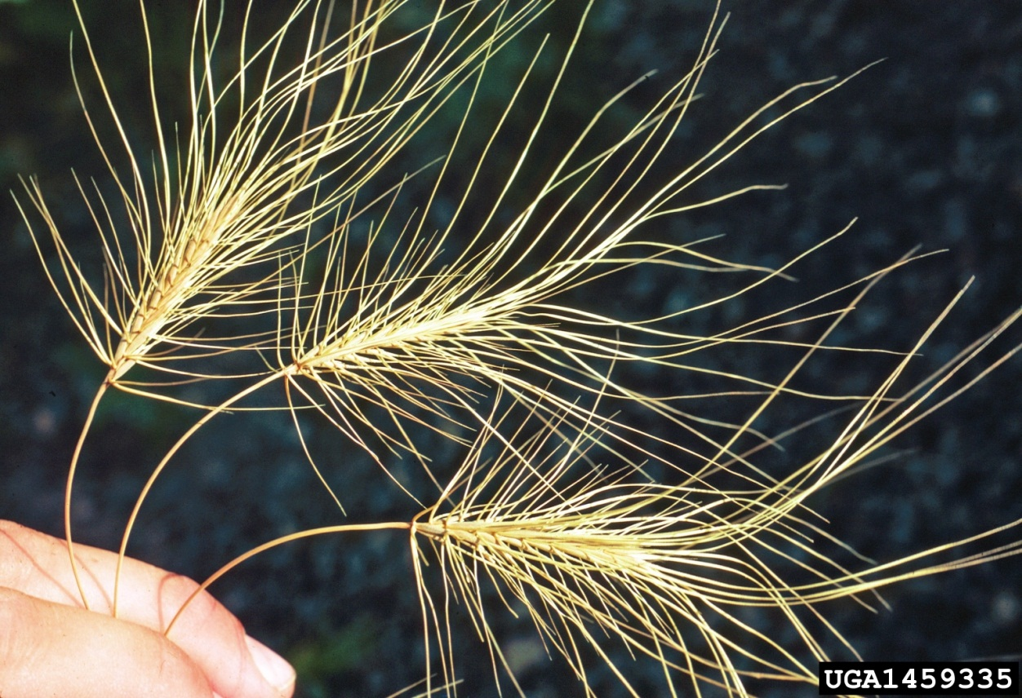

Senescent medusahead with twisting awns.

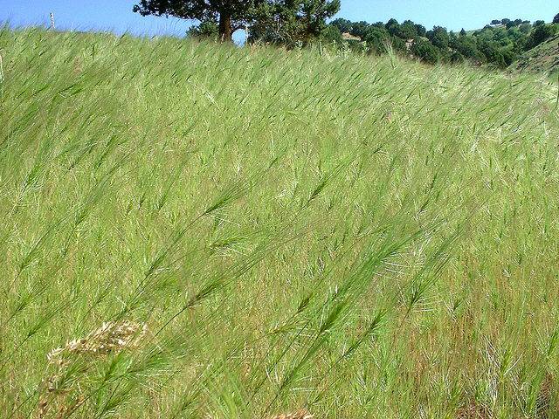 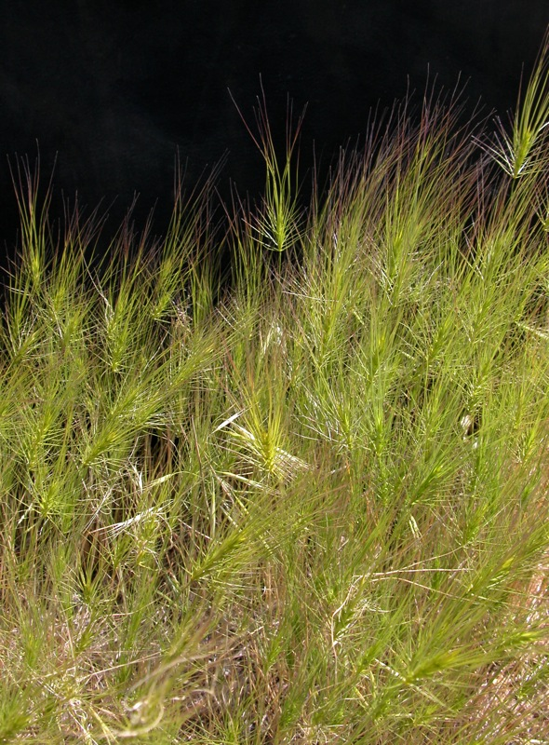

Monocultures of medusahead.