CENTER DIRECTOR: NANCY LEE

ASSISTANT DIRECTOR: DEANA DILLON

TELEPHONE: (614) 837-3020 / FAX: (614) 833-6471
HOURS: MON-THURS 8:30 a.m. - 4:30 p.m.
FRIDAYS 8:30 a.m. – 2:30 p.m.
WEB PAGE: http://pickeringtonseniorcenter.org
EMAIL: NLee@pickeringtonseniorcenter.com

$10.00 CLUB
Just a reminder that we have a donation called the
$10.00 Club. You can donate any amount you would like. The money donated helps with the purchase of items that we need for the kitchen and
office supplies, etc.

NEW MEMBERS
We welcome the following new members to our Center and hope they will join us for some of our activities: Jim Billings, Judy Brenning, Leslee Dixon, Joanne Kitchen, Jackie Montgomery, Carol Pope, Ann Smith.

MEMBERSHIP INCENTIVE PROGRAM
Any member who signs up four new members will receive a $25.00 gift card. Tell the office to put your name on the form when you sign up a new member. All you need is four members!

SEASONAL FLU & OTHER IMMUNIZATIONS
WEDNESDAY / OCTOBER 13th
11:00 a.m. – 1:00 p.m.

Trish Brewster and her staff from the Kroger Store pharmacy on Hill Road North in Pickerington will be at our Center to administer seasonal flu shots: Fluzone HD ($85) if you are 65 or older, or Flublok Quad ($85) for adults ender 65. Typically, if you have Part B Medicare, both original Medicare and Medicare Advantage will cover the immunization.

They will also have the following additional vaccines with them for anyone interested:

Prevnar 13 – $260
Pneumovax 23 - $160
Boostrix (tetanus, diphtheria, pertussis) - $85
Shingrix (shingles) - $225
Pfizer COVID 19 (NOT the Booster shot) - FREE

Be sure to bring your insurance card with you, they will need to make a copy of it. You can call your insurance company to check whether you are covered. Credit cards are not accepted, please pay by check or the exact amount in cash.

VOLUNTEER OF THE MONTH
Our Center would like to honor Richard Anderson as Volunteer for the month of October. Richard is available almost everytime we need help. He helps with setting up for most events, helps get things ready for Friday Exercise Class, and helps make noodles. He is the all around handyman. Richard will receive a $15.00 gift card. Enjoy your reserved parking space for the month of October. Thanks for all your help!

ANNUAL SOUP DINNER AND BINGO
THURSDAY / OCTOBER 7th
You may choose either bean or vegetable soup. When you purchase your ticket, let us know which soup you would like. You’ll need to turn in the ticket when you get your soup. The cost is $7.00 for soup, dessert, coffee or iced tea, and bingo. If you’re only playing bingo the cost is $3.00. Soup will be served from 5:00-6:00 p.m.; bingo starts at 6:30 p.m. We’ll have two groups working, one for dinner and the other for bingo. If you would be willing to help, please call Annabelle Marion at (614) 866-7339.

GARAGE SALE
SATURDAY / OCTOBER 9th
8:00 a.m. – 3:00 p.m.
Cost for tables: 12-foot table - $15.00
6-foot table - $10.00
Card table - $ 5.00

The Garage Sale will be held inside our Center. You can set up your table and merchandise on Friday, October 8th, between 11:00 a.m.–2:30 p.m. If you’re unable to do your set up on Friday, you can set up on Saturday morning at 7:00 a.m. Now is a good time to start getting things ready for the sale. To sign up and reserve a table, call us at (614) 837-3020. We only have a few tables left.

For anyone interested, Inferno Pizza (John) will be selling pizza by the slice.

UPCOMING EVENT

October 11th – Groveport Apple Butter Day

- CANCELLED -
PANCAKE BREAKFAST
The Pancake Breakfast scheduled for Saturday, October 26th has been cancelled due to the rise in Covid 19 cases.

BINGO
TUESDAY / OCTOBER 26th
On the fourth Tuesday of every month we play Bingo!! No potluck this month.

COMMUNITY TRICK OR TREAT NIGHT
Trick or Treating in Pickerington this year will be on Thursday, October 28th, from 6 p.m. to 8 p.m.

THANK YOU

Over Labor Day weekend, John Samborsky and Jeanne Carroll sold 150 bags of noodles at the Lion’s Club Fish Fry in Victory Park. A big thanks to them both and to all the noodle makers for making it possible. GREAT JOB!

NOODLE MAKING
TUESDAY / 8:00 a.m.

We will be making noodles on the following dates:
Tuesday / October 5th
Tuesday / October 19th
Tuesday / November 9th
Tuesday / November 16th
Tuesday / November 30th
If you would like to help us, call our office at (614) 837-3020.

ATTENTION: NOODLE MAKERS

Each time you help with noodle making, see Jeanne Carroll to put your name on her sheet of workers. After you have helped six times, your name will be entered into a drawing for a $10 gift card.

WATERCOLOR CLASS
(Free to Members)
Every Monday from 1-3 p.m.
Join Jenene Warmbier for adventures in watercolor painting at our Center. Jenene is a great teacher. No previous training, or talent necessary, just the desire to express yourself with “Paints and Brushes.” You can stop in our office and get a list of supplies you will need for the class.

TITLE BOXING
(Free to Members)
THURSDAY / OCTOBER 7th, 14th & 21st

Maria Manzo from Title Boxing will lead the class at our Center from 9:00 to 9:45 a.m. Sessions are around the Rock Steady Boxing curriculum which increases the neuroplasticity of the brain to help produce healthy brain cells. The exercises are designed to improve quality of life, have fun, and get results - all at the same time! You can purchase a bag and gloves for $25.00 at the class.

LINE DANCING
MONDAYS / 11:15 a.m. – noon

A second 12-week session began on August 16th and will run through November 8th. Classes are on Mondays from 11:15 a.m. to 12:00 noon. There is a fee of $12 for the 12 week session. If you would like to join the current session, you can pay for the remaining classes at $1 per class. There will be no other classes for the remainder of November or December of 2021. Classes will resume in January of 2022. Additional information and forms for registration are available in the office or you can contact our instructor, Marilyn Morgan, at mnm@columbus.rr.com

CRAFT GROUP
(Free to Members)
EVERY WEDNESDAY / 10 a.m. – noon

The main purpose of our craft group is to offer a fun activity for our seniors, but the group also raises money for our Center. They provide tray favors for two carry out meals that our Center provides for our shut-in members. The most important fundraising activity they participate in is our Breakfast with Santa, which is always held on the first Saturday of December.

STRENGTH CLASS
(Free to Members)
MONDAYS and/or WEDNESDAYS / 10-11 a.m.

Come join us in our strength classes lead by Kelley Deibert. The focus is on building upper and lower body strength, stretching and improving your balance.

CORNHOLE
(Free to Members)
EVERY TUESDAY / 11 a.m.

We play Cornhole every Tuesday. On the last Tuesday of each month, we have a tournament with prizes for the winning team. The winning Team for August was Bill Dunnette and Richard Villec. If you don’t know how to play, Deana or Doug will be happy to teach you.

EUCHRE
EVERY WEDNESDAY / 12:30 p.m.

Come in, join your friends, and play some Euchre. We start playing at 12:30 p.m. The cost is only $2.25, which includes the games and the loner pot. Please be here at least 10 minutes ahead of time to Get signed up so we can start on time at 12:30.

VINTAGE FITNESS
(Free to Members)
EVERY FRIDAY / 9:00 – 9:45 a.m.
Sign up starts at 8:30 a.m. This is a 45 minute Cardio Class. It is a total workout. Come see the power you have and make great things happen for your health and well-being. We have plenty of room for you to move and groove to great music. Michellle is a certified instructor and will guide you through a safe and effective workout.

SOCIAL EUCHRE
(Free to Members)
EVERY FRIDAY / 11 a.m.

This is a slower paced Euchre game where we can meet and play cards non-competitively. If you like to play cards for fun, at a relaxed pace and you don’t mind teaching others when needed, then please join us. We welcome anyone who wants to
play cards.

CHECK OUT THE VIDEO SECTION OF OUR LIBRARY
(Free to Members)
Take one home, watch it and return it. Any video donations to our library are welcomed. We also have a very large selection of books you can choose from.

LIONS CLUB - RECYCLE FOR SIGHT

The Lions Club has a Recycle for Sight box in our Center’s library. You can donate your old eyeglasses there. The glasses will be given to individuals who cannot afford to purchase glasses.

SQUARE DANCING
TUESDAY EVENINGS / 6:30 p.m.

Come join us! Fun, fitness and friendship – square dancing has it all. We’ll show you what modern
western square dancing looks like.

OCTOBER
October’s the month
When the smallest breeze
Gives us a shower
Of autumn leaves.
Bonfires and pumpkins,
Leaves sailing down –
October is red
And golden and brown.

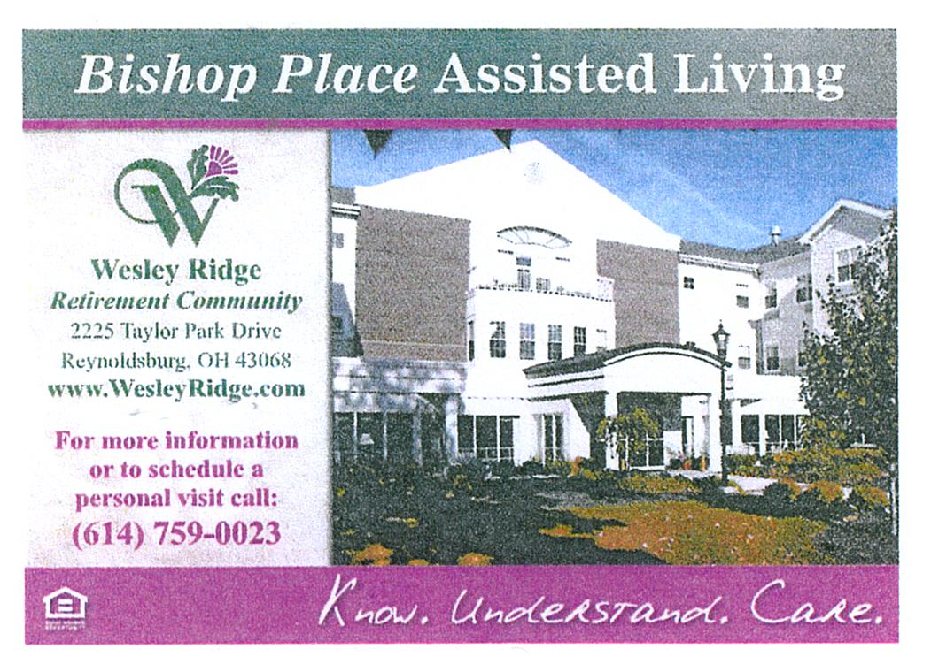

LANCASTER-FAIRFIELD PUBLIC TRANSIT
IMPORTANT INFORMATION
Exact change is required, driver are not permitted to make change. The bus makes several stops at our Senior Center every hour starting at 9:05 a.m. Groceries and bags are limited to what you can fit in your area. As always, should you have any questions or concerns:
Call (740) 681-5086 or
Email cwoody@ci.lancaster.oh.us.

UPCOMING TRIPS

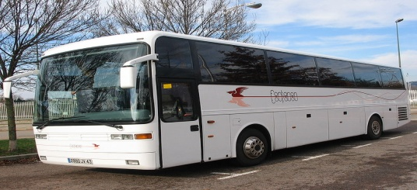

JINGLE JANGLE CHRISTMAS JUBILEE
WEDNESDAY / NOVEMBER 10th
Join us for this fun trip! The first stop is at Salt Fork Lodge where we will enjoy lunch and have time to visit their Gift Shop. After lunch enjoy the dynamic upbeat show by VIGOR with a blend of Christmas, Gospel, and Patriotic music. We will hear songs such as Rockin’ Around the Christmas Tree, Jingle Bell Rock, as well as some Gospel, “Go tell it on the
Mountain,” and “Let there be Peace on Earth.” After the entertainment we will depart for our first
stop in Dickens Christmas Village in Cambridge, Ohio. Costumed guides will take us through the Museum which is decorated for the season.

Shop the gift shop which is set up as a Christmas Bazaar.
Next, we will take a guided tour of Dickens Village and Ye Old Curiosity Shoppe. Dickens scenes are stationed on lamppost and bench, in windows on street level and in second story windows. The Victorian Village scenes are comprised of life-sized, handmade mannequins wearing authentic vintage clothing. The mannequins’ faces are sculpted and painted by local artists. The displays include figures such as Bob Cratchit, Tiny Tim, and groups of carolers, to name a few. At the Welcome Center you can put on Victorian clothing and have your photo taken. A boxed dinner will be served. The courthouse comes alive at 5:45 p.m. with 36 animated light displays and 15,000 lights outlining the building. It’s meticulously synchronized to a holiday soundtrack with a total of 30,000 lights. The cost is $140.00 per person. Payment is due at sign up.
Waiting List

PENNSYLVANIA AMISH HOLIDAY TOUR
NOVEMBER 16th – 19th

DAY 1 – Check into the Heritage Hotel for a three-night stay. We will enjoy dinner at the Esh Farm.

DAY 2 - Enjoy your breakfast at the hotel before we leave for a guided tour of the Amish Countryside including stops at an Amish Craft Farm and a Bake Shop. Lunch is on your own at Kitchen Kettle Village where you can shop the many unique
specialty shops. Then we will go to the Sight & Sound Theatre to enjoy a live performance of “Queen Esther.” Enjoy one of the most riveting Bible stories of the Old Testament as it comes to life with magnificent sets, special effects, and live animals. After the show we will enjoy a delicious dinner at the Hershey Farm Restaurant.

DAY 3 – After breakfast we will visit the Mennonite Information Center and Biblical Tabernacle where we’ll learn the unique way of life of the Amish and Mennonites. View the 17 minute documentary to learn how Mennonites differ from the Amish. We will go to the town of Lititz where you will have free time for lunch and to visit the shops, including Wilbur Chocolates. Later, we will enjoy a tour of the Julius Sturgis Pretzel Bakery. We will return to the hotel to freshen up before we depart for dinner and for an abundant musical revue at Shady Maple Smorgasbord. After dinner we will end the day at the American Music Theatre where we will enjoy a spectacular musical revue “Winter Wonderland.” The performance includes awe-inspiring music, dance, outstanding voices, warm humor, and familiar holiday cheer.

Day 4 - After breakfast we will depart for home with wonderful holiday memories. The cost is $429.00 per person for a double room and $608.00 for a single. Payment due on sign up.

Space Available

OGLEBAY PARK
NOVEMBER 30th

Join us as we travel to Wheeling Park, a sister park to Oglebay for a buffet dinner. After dinner we will go to Oglebay Park for a driving tour to see the beautiful Christmas lights and visit the gift shop for a little Christmas shopping. Sign up begins on Monday, October 4th. The cost is $63.00 per person, which includes dinner, motorcoach transportation, and all taxes and gratuities on included items. Payment due on sign up. Dinner will be around 4:00 p.m., so you might want to bring a snack for the trip home.

NEW TRIP FOR 2022

ISLANDS OF NEW ENGLAND
AUGUST 12 – 19, 2022

HIGHLIGHTS:

Providence, Newport, choice of options on tour, Block Island, Cranberry Bog, Plymouth Rock, Cape Cod, lobster dinner, Martha’s Vineyard, Provincetown, Hyannis, and Nantucket. Save $100 if booked before February 12th.

Cost: Single $4,049 - Double $3,249 - Triple $3,219. Flyer available in our office.

GOLF ANYONE?

Pickerington Senior Center is now offering you the opportunity to participate in a Senior Golf League that plays on Wednesdays and/or Fridays. You don’t have to go both days, and you don’t have to commit to playing every week. The cost each day that you choose to play is $23.00 (which includes the cart) – plus $5.00 for prize money (which is awarded daily). Starting time is 9 a.m. Call Doug Hoek at (201) 739—7995 with any questions.

FROM DEANA

REMEMBERING EVERYONE WITH WARMEST
THOUGHTS ON THEIR BIRTHDAY

(1) Robert Cubra, Nellie Nihiser; (2) Marti Dillon, Susan Mason, Candi Moore, Melodie Reed; (3) Peggie Rice, Lisa Stoklosa; (4) Bonnie Miller, Marilyn Spence; (5) Susi Mueller; (6) Faith Hoek, Gertrude Stacoffe; (7) Mary Boehm, Ann Bradford, Lilia Checca, Ellen Mastracci; (8) Julie Larson; (9) Penny Durben, Betty Kolkody; (10) Mary Ann Bowen, JoAnn Shepard; (11) Gary Kincade, Bill Morgan; (12) Linda Frazee, Kay Skibo; (13) Wayne Schultz, Larry York; (14) Margaret Centofanti, Leo Flibotte, Pureza Jacaban; (15) Betty Burk, Priscilla Ebbs; (16) Jim Barber, J. Elaine Grener; (17) Lauretta Bain, Susan Conaway, Ken Ellinger, Render Phillips, Carol Plympton, Kate Vanormer; (18) Carol Focke,
Bill Haislet, Barb Shaffer; (19) Marilyn Burkart, Jeanne Carroll, Jeri Lane, Ken Schneider; (21) Bud DeLong, Jo Ellen Gohr, Joanne Kitchen, Sharon McDougal, Donna Moore, Jerry Pocta, Carolyn Smith, Jack St. Cyr; (22) Hilda Coldsmith, Sue Graham, Robert Lloyd, Richard Smith; (23) Shirley Case, Carolyn Fenlon, Thomas Laughery, Pauline Limbach, Patty Moone, Grace O’Connell; (24) Rod Frazer, Margretta Heath, Debra Sherman; (25) Joseph Douglas, Dee Machinski, Mike Welling; (26) Schearl Budd, Martha Gravatt, Ann Harper; (27) Barb Smithberger; (28) Julia Archer, Susan Pocta, Troy Watkins; (29) Charlene Hertzer, Walter Monroe; (30) Lynn Wilcox; (31) Gordon Burke, Richard Erwin, Marianne Miller, John Samborsky.
IN LOVING MEMORY OF
Julia Archer’s daughter, Debbie Hornung
Ray Crane
Bob Emmert
MaryAnn Gravenkemper
Candi Moore’s sister, Jo Ann

MEMBERS KNOWN ILL
Grace O’Connell –
recovering at Violet Springs

HALLOWEEN PARTY
Our Senior Center, Brookdale Senior Living & Violet Springs will be hosting our 3rd Annual Halloween party here at our Center on Thursday, October 28th from 1- 3 p.m.
Snacks, games, music and prizes for the best costumes. Costumes are optional. Tickets are FREE. Sign up in our office.

“BEAT MICHIGAN WEEK KICKOFF PARTY”
MONDAY / NOVEMBER 22nd / 1- 3 p.m.

Wear your Buckeye gear and join in the fun at our Beat Michigan Party! There will be food, games and prizes. RSVP to our office by November 15th.

