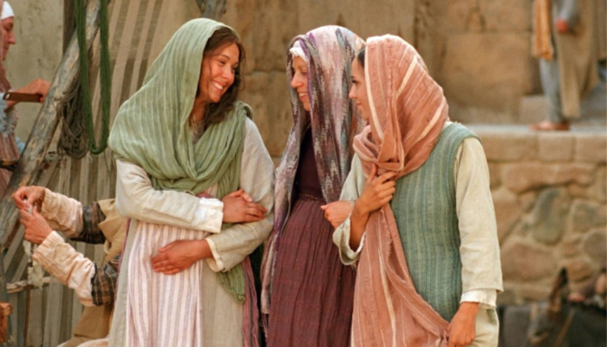
MID-MICHIGAN DISTRICT
EPHIPHANY CELEBRATION

January 7, 2023
Carson City United Methodist Church

MID-MICHIGAN DISTRICT
EPIPHANY CELEBRATION
January 7, 2022

9:30 AM Registration, Coffee, Gathering
9:55 AM Gather in the Sanctuary

*HYMN #244 Twas In the Moon of Wintertime
*HYMN #246 Joy to the World

Epiphany Celebration

Welcome and Thanks | MaryAnn Elzerman  Vice President
Welcome to Carson City UMC | WalthaGaye Leavitt  President

*HYMN #224 Good Christian Friends, Rejoice
Introduction of Speaker | WalthaGaye Leavitt
Epiphany of Women in Faith | Pastor Ian McDonald
Blessing of Ingathering | Pastor Ian McDonald
Explanation | WalthaGaye Leavitt

*HYMN #251 Go, Tell It on the Mountain
Special Music
Benediction Pastor Ian McDonald

*Stand if you are able

Special Thanks To:
Carson City United Methodist Church
and their UWF for hosting today’s event.
Pastor Ian McDonald
……………………………………………

2023 Dates to Remember

May 12-13 | Spiritual Growth Retreat  St. Francis Retreat Center
July 13-15 | Mission u  Mt. Pleasant First UMC
Sep 20 | District Annual  Mt. Hope UMC, Lansing
Oct 28 | Conference Annual  Holt UMC

PURPOSE OF UNITED WOMEN IN FAITH

The organized unit of United Women in Faith
shall be a community of women whose
PURPOSE is to know God and to experience
freedom as whole persons through Jesus Christ,
to develop a creative, supportive fellowship
and to expand concepts of mission through
participation in the global ministries of the church.

