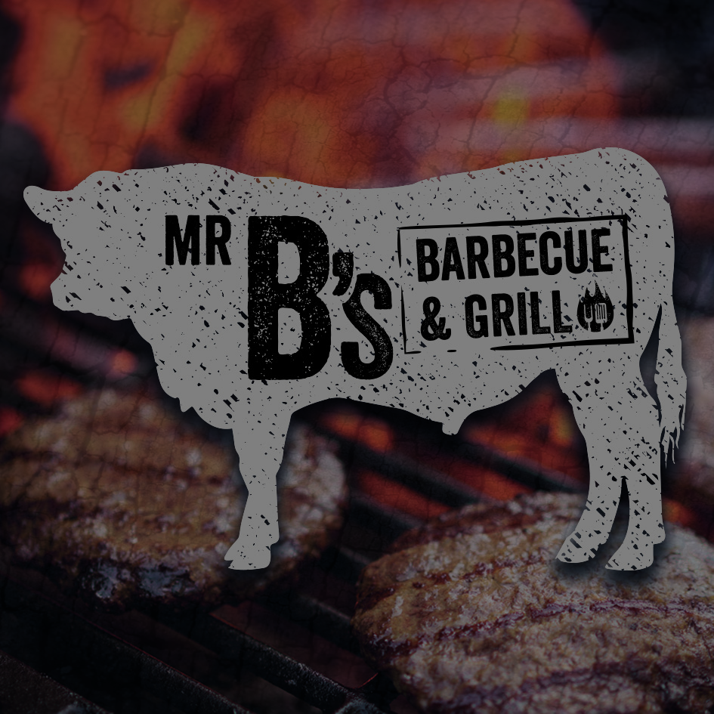
BURGER NIGHT MENU
Every Wednesday 5pm to 7pm

BURGERS
All served with hand-cut chips
CLASSIC £9.95
Beef burger, bacon, smoked cheese, lettuce, tomato, red onion, gherkin, brioche bun
SOUTHERNER £9.95 Cajun breaded chicken burger, cheddar cheese, coleslaw, lettuce, tomato, red onion, brioche bun
SWEETCORN & CHICKPEA (vegan) £9.95
Sweetcorn, chickpea & poppy seed burger topped, sour dough bun, lettuce, tomato, red onion, tomato relish

MAC & CHEESE £9.95
Panko coated macaroni cheese topped with bacon, chilli jam, brioche bun, lettuce, tomato. red onion

MISS PIGGY £9.95
Pork and chorizo burger, coleslaw, jalapeño mayo, brioche bun

LOADED FRIES
Peri peri, bacon, cheese £5
Beef chilli, cheese & sour cream £5

SMALL PLATES
Chilli beef nachos, jalapeños, salsa, sour cream £6
Pulled pork nachos, jalapeños, salsa, sour cream £6
Beer battered chicken goujons, garlic mayo £6

SIDES
Wok fried, salt and pepper chips £3
Beer battered onion rings £3
Macaroni and cheese £3
Home-cut chips £3
Coleslaw £3

