Alternative Sleeping Gear For Backpacking
(Provided by: HighCountryExplorations.com)

The most important gear I carry is the gear I need for a good night's sleep. If I don't get a good night's sleep I'm not a happy camper. If I'm going to not enjoy myself I may as well stay home. It's cheaper and easier.
—Jerry Goller, BackpackingLight, Yahoogroups.com

Central Issues Addressed in This Article
Should I use a traditional mummy bag or one of the alternatives (e.g., quilts, top bags, half bags or no bag options)? What are the alternative choices for sleeping gear where I backpack? What are the pros and cons of sleeping quilts? How important is it to think in terms of a sleeping system (as opposed to just bag and ground sheet)? What are my priorities in a sleeping system?

Alternative Sleeping Gear: Thumbnail Sketches
Sleeping systems commonly include two or more of the following elements: insulating bag or quilt, inner bag liner, outer bag cover (bivy), the clothes worn inside these components plus a sleeping pad, pillow and a protective ground sheet. In this article I purposely exclude the “shelter” aspect of sleeping systems. To include this element would unnecessarily complicate the article.
There are many possible combinations and alternatives when thinking about sleeping systems. The following sketches cover most of these alternatives. Included are all of the conventional options plus three of the most popular unconventional systems: top bags (sleep system with no bottom insulation), quilts (sleep system with no bottom), and wearable bags. Here are most of the alternatives starting with the stereotypical bedroll of the American cowboy.

Cowboy Style Bedroll: Construct a bedroll of woolen blankets supplemented with a canvas cover. Modern equivalent materials for the bedroll would likely be fleece blankets and plastic sheeting although there are those (purists?) who still use wool blankets. Early backpackers often rolled up their other gear into their bedroll, tied the ends together to make a horseshoe and slung the roll diagonally over their shoulders in lieu of a backpack. An alternative arrangement would be to lash the bedroll over the top and down the sides of a regular backpack.
Conventional Sleeping Bag: Full-length, rectangular, semi-rectangular or mummy style bag. Although most are unisex, mummy bags are now available designed more for the typical male and female shapes. More important is the availability of bags that come in different lengths and different girth measurements at the shoulder, hip and foot to better fit the intended occupant. These size variations are also valuable for those desiring to layer clothing inside the bag. Most conventional bags come with hoods and zippers. Here is fervent summation about the popular mummy bag option.

Mummy bags are generally considered the darling child of a backpacker's sleep system. Crawling into a mummy bag packed with high fill down and drawing a perfectly contoured hood around your face on a cool night is considered by some to be a religious experience. If you haven't experienced this, then you should try crawling into a Western Mountaineering Puma or Valandré Shocking Blue on a zero degree winter night. It's hard to break free from the mummy's grip. Mummies are the cornerstone category of nearly every sleeping bag manufacturer's product line.
— Ryan Jordan, “2006 Unconventional Sleep Systems
Manifesto,” BackpackingLight.com

Half bag (“Elephant’s Foot”): A traditional mummy bag reduced to half or three quarter-length and used in combination with a high-loft insulating parka. Half bags sometimes have shock cords or suspenders to keep them up. They have traditionally been used by “fast and light” alpinists (especially when a bivouac is likely) but could be used by any minimalist backpacker.

Top Bag Construction: Top bags are traditionally shaped bags (rectangular, semi-rectangular, mummy with hoods) constructed with no insulating material on the bottom side. The bottom side is often constructed as a sleeve to keep out drafts and to slide in a sleeping mat. The reasoning behind top bags is that the bottom insulation in a traditional bag gets crushed so why not save bulk, weight and cost by removing it. This arrangement allows for flopping the bag over in hot weather to sleep only under the fabric layer.

Non-symmetrical Distribution of Insulating Material. This is a compromise construction between traditional bags and top bags. A typical ratio of loft distribution in a non-symmetrical is 3:2 (i.e., 60% of a bag’s total loft in the top layer, and 40% in the bottom layer). This option is great for back sleepers and not so great for side sleepers. Some manufacturers construct bags with fewer baffles in order to shift the down insulation from top to bottom or the reverse. A further option in this format is a bag designed for use with an insulated parka where there is a greater amount of insulation in the lower half of the bag and less in the area of the parka. An example is the Feathered Friends “Vireo” bag where the bottom half is rated for 25 degrees and the top half for 45 degrees. This gives the user the option of taking a different weight insulated parka depending upon the temperatures expected or taking a synthetic parka for more dependable loft if a down bag gets wet.

Dual Insulating Materials. This is also a compromise construction, this time between traditional down and synthetic bags. The usual combination is a layer of synthetic quilting (usually polyester microfiber batting) in the outer section and a down layer next to the body. This construction is sometimes claimed to be superior in moisture management and circulation control.

Elastic Stretch Construction: With elastic seams and baffles becoming more popular, this stretch bag construction is unique enough to deserve its own category. In theory, it provides the freedom of movement of a generously cut sleeping bag while providing the warmth of a much closer-fitting, more restrictive bag. Some manufacturers build stretch only into the hip and shoulder areas. Reviews suggest that they probably work as advertised.

Sleeping Quilts: Similar to quilts and comforters used in the frontcountry, they are either rectangular or mummy in shape and provide only insulation on the top. Mummy-style quilts designed for colder weather are wide at the top and tapered down to an enclosed “foot box” at the bottom. Mummy-style quilts are often “variable girth” with adjustable straps to vary the width in the shoulder and hip areas and with a draw cord for the neck. Some have Velcro tabs to affix them to a sleeping pad. High quality mummy-style quilts are often constructed in an arc cross-section with the top shell larger in circumference than the bottom. Since quilts don’t have hoods, a warm head covering (hat, balaclava or hooded parka) is a necessity in most climates. Because of their open construction, any number of clothing layers can be worn beneath the quilt to achieve in the desired comfort range.
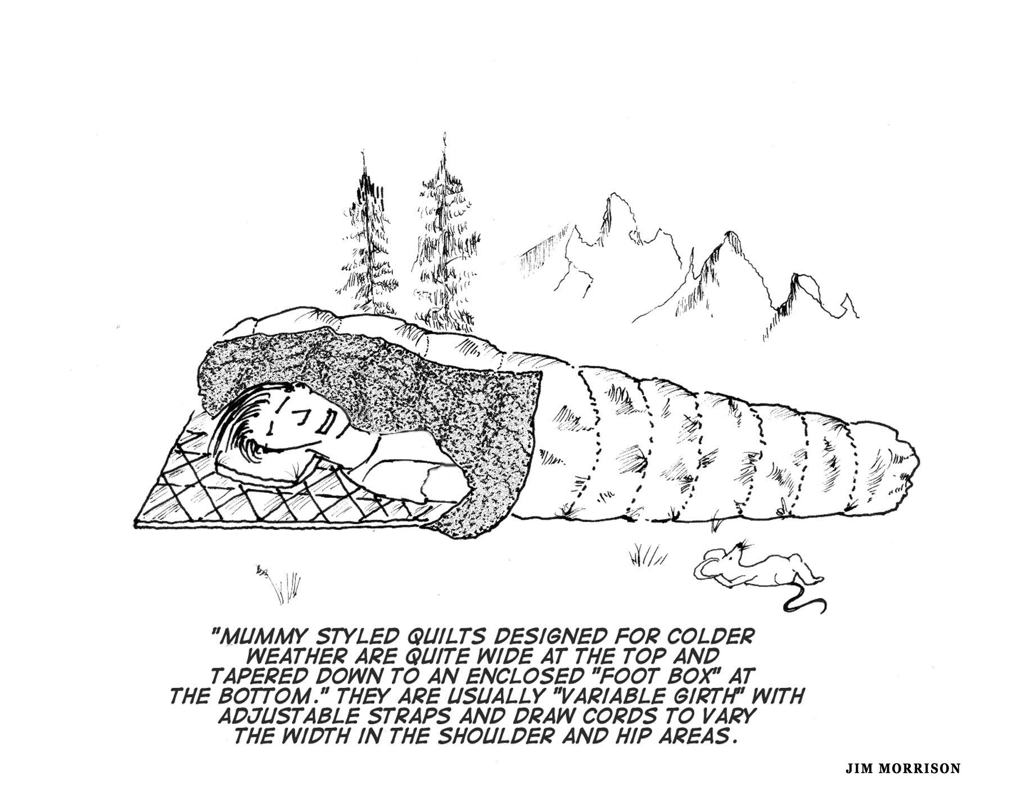

Two-Person Bags or Quilts: Several companies make double wide sleeping bags for two to share. “Fast and light” alpinists sometimes prefer this option when anticipating bivouacs. Couples involved in a close, intimate relationship commonly use a two-person bag or quilt for increased warmth, and decreased bulk, weight and cost. If you have a left-zip bag and a right-zip bag with compatible zippers, you can mate two bags together to create your own two-person bag. Sleeping so close to another person is sometimes problematic for more than a night or two.

Bag Liners: Though not ordinarily used as a separate alternative sleeping system, sleeping bags or quilts are sometimes supplemented with a separate, thin liner to increase warmth and versatility (in addition to the inside covering of the bag itself). Liners also keep the bag cleaner. They are usually breathable and are made from thin polyester, fleece, silk or cotton fabric. By creating a dead air space, all liners will have some insulating properties. In warmer temperatures, sometimes only the liner is used. In very cold temperatures, the liner is often made from a waterproof material to create a “vapor barrier” liner (VBL). A VBL is designed to keep a sleeping bag dry on multi-day trips by preventing body perspiration (as much as 1/2 cup a night) from getting trapped in the insulation. The VBL provides additional enhancements: (1) it reduces dehydration by lowering an individual’s perspiration rate once the skin senses it is in a humid environment; (2) it adds warmth to a sleeping bag by trapping an extra air layer and reducing evaporated heat loss (up to 5º); (3) it serves as an emergency bivy when out on an extended day trip or climb. Two variations accomplishing the same result are the VBL half-sack and waterproof shell clothing worn as a base layer. Some wear specially designed VBL base layer tops and bottoms. Since it is easy to get overheated with a full VBL, using the half-sack or a separate pants and jacket is a highly desired VBL option.

Outer Bag Cover/Bivy Sack: This alternative involves using a separate outer cover (“bivy sack”) to supplement the above sleeping systems in order to increase warmth and versatility. This cover or sack is in addition to the outer covering used in the bag construction. In warmer weather, this outer cover can be used by itself. On the top, the bivy sack will be either wind and water-resistant or waterproof and breathable. The bottom will be made of waterproof material to substitute as a ground cloth.

Bivy Sack Only and No Bag: A planned arrangement where one sleeps in packed clothing plus a bivouac (bivy) sack (no sleeping bag). This arrangement could include a full storm suit, insulated pants and parka plus an insulated pad to keep your body off the ground. Even though it is arguable whether this arrangement constitutes a “sleeping system,” it is definitely an option for a night or two in more temperate climates. Alpinists sometimes use this kind of a system on marathon climbs where they stop for a few hours of rest during the summer season when nights are short.

Modular Sleeping System: Probably the most common modular system is one designed for sub-zero weather camping with compatible inner and outer mummy bags. An alternative modular system is a zip-on and -off top bag that can be used by itself as a quilt or zipped onto a regular bag. A vapor barrier bag liner is sometimes added to this system. These elements can be mixed and matched depending upon the temperatures. In the 1960s and 1970s, Jack Stephenson (Stephenson’s Warmlite mail order gear) engineered one example of a fully featured and integrated sleeping system: the Warmlite Triple Bag”. Instead of buying several different pieces of gear to add or subtract for different seasons, he integrated it into the following system: two zip-on tops (thinner down summer top bag and thicker down winter top bag); two zip on bottoms (down-filled air mattress and/or a fabric sleeve for a foam pad), vapor barrier liners (VBL) on the interiors of the two down top bags. The two zip-on tops are attached by a set of double, independent zippers providing three options: thin one by itself, thick one by itself, and both together. In Stephenson’s words: “With its unique 3 in 1 design, the Warmlite Sleeping Bag allows you to sleep in comfort in ALL temperature ranges from +60F to -60F (-75F to -80F reported by hardy Alaskans).” To complete Stephenson’s modular sleeping system, an optional zip-on, double layer insect netting top is also available. In his original design, Stephenson made available as many as five zip-on tops.

Wearable Parka Bag or Quilt: A few manufacturers (e.g., Outdoor Research, Jack’s R Better, Exped, Selkbag) offer a sleeping bag or quilt that is convertible to a parka. One version is a regular sleeping bag that converts into a parka for wearing around camp and a quilt large enough for two sleepers. Convertible bags usually have zippers at the feet and arms to accomplish camp chores. Advanced parka bags feature insulated sleeves and legs, and resemble an insulated suit. Other variations on the theme are available depending upon the designer’s imagination.

Reader Participation: Acknowledging Favorite Sleeping System
Some of the fifteen sleeping systems above are variations on the same theme; others are radical departures from the norm. What are your reactions to the above analysis? First, add any sleeping systems to the above sketches that I have missed. Second, circle one or two sleeping systems that are your current favorites. Third, place the letters “EXP” by the system(s) with which you would like to experiment.

Priority Values and Sleeping Systems
Except for quilts, I will not attempt objective evaluations of the alternative sleeping systems presented above. They all have their strengths and weaknesses. Instead of a critical analysis, I have identified a wide range of values (listed below) accompanying the different sleeping systems thumbnailed above. Which are most important?

Loft and Warmth
Ventilation and Adjustability
Durability and Longevity
Roominess
Ergonomic Shape and Fit
Simplicity of Design
Quality of Construction
Quick Drying
Non-Absorbent Insulation
Weatherproof
Compressibility
Weight
Cost
Value
Highly Integrated System
Color and Styling
Technologically Advanced
Environment Friendly Components

More Reader Participation: Sleeping System Priorities
First, add any values and priorities to the above list I might have missed. Second, circle your top 4-8 value concepts when dealing with sleeping systems (excluding shelters). Third, evaluate your most commonly used sleeping system from 0-10 regarding how well it achieves your top rated value concepts. Fourth, given your top rated value concepts, identify the ideal sleeping system(s) components you would like to own (assuming different needs for different types of trips)?

In-depth Look at Sleeping Quilts
I have had a lot of experience with the quilt option. Click here for an in-depth look at my experiences.

Principles of Effective Sleeping Systems
Without question, we all perform better in both the front and backcountry with a good night’s sleep. I am convinced that all backcountry travelers can get a good night’s sleep most of the time by enhancing whatever system they are using at the time with the right sleeping tactics and enhancements. To do this, one needs to understand some basic principles:

- There is great variation between individuals and between the sexes regarding the conditions necessary for a good night’s sleep.

- The primary source of warmth while sleeping is your body furnace (i.e., metabolism); tents, sleeping bags, clothes, pads, etc., provide no warmth by themselves.

- It's much harder to get warm than to stay warm.

- Keeping the core warm will go a long way to warm extremities.

- Between going to bed at night and arising the next morning, there is often a large shift in the factors affecting a good night’s sleep: heat generating metabolism gradually slows down; ambient temperatures usually drop; sleep is deeper early on and lighter towards morning. The ideal is to have a flexible sleeping system that will handle these nightly variations.

- The minimum sleeping system should include an insulating sleeping pad, a sleeping bag or quilt, an adequate pillow arrangement and an adequate shelter for the conditions. Don't short-change these basic items.

- What you have under you is as important as what is on top of you; don't hesitate to double up pads, especially under your body core.

- The ideal is to organize several different sleeping systems to cover a wide range of conditions and then select the specific system to fit anticipated conditions.

- Even though being warm enough is usually the primary concern, being too warm is also a serious problem. Being too warm will cause sweating which will dampen and lessen the effectiveness of your insulation.

Check out the website article “A Good Night’s Sleep in the Wilderness” for numerous specifics that utilize the above enhancement principles.

Minimalist Sleeping Systems
Humans are quite adaptable and with the proper conditioning can learn to sleep out in the open without what most would consider adequate shelter and sleeping accommodations. Using tactics like those listed in the website article mentioned at the end of the previous section will allow almost anyone to sleep in moderate conditions using a minimalist sleeping system (e.g., only a bivy sack with no sleeping bag or tent) in a naturally sheltered area. Accomplishing this goal obviously depends on an individual’s willingness to experiment and to understand how to maximize a minimalist system. If this arrangement is not working, simply pack up and begin hiking (in the dark if necessary) stopping to take a nap or two during the warmth of the day.

Sleeping Systems Matrix Chart for Different Trips
How important is it to think in terms of a sleeping system (as opposed to just bag and mattress options)? Consider preparing a highly detailed spreadsheet (i.e., a matrix chart with many rows and columns) for the sleeping systems you plan to use on different types of trips. Click on this link to see the website page “Don’s Wilderness Sleeping Systems Charted” to download my personal matrix chart of options. In my example, most of the individual components (8) of a sleeping system are listed across the top of a matrix chart and the types of trips commonly taken during the year are listed down the left side (including potential emergency bivouacs). Following this recommendation assumes the following:

- there is no one perfect shelter-sleeping kit for all trips
- there is considerable variation in the type of trips taken during the year
- carried insulating and shell garments are a part of the sleeping system
- several gear options are available in the gear closet to implement one’s sleeping system of choice.

Final Thoughts on Sleeping Systems
I have provided a full range of alternative sleeping systems in this article mainly to encourage a critical evaluation of the system(s) you are currently using and to encourage expanding your gear closet with additional alternatives to cover a wider range of needs and circumstances.
In this article, I have chosen not to cover topics like sleeping bag shell fabrics, insulation materials, bag construction, temperature ratings, sleeping pads and mattresses, ground cloths, and so on. They are usually covered in other easily available source material. Besides, to adequately deal with these additional topics would often require a separate article for each.
One of the issues underlying this topic is whether to take the lightest sleeping bag possible and supplement it as needed by clothing carried or worn, or to take a warm bag that will easily handle the coldest temperatures anticipated. I have written a separate article debating this issue. It can be read by clicking on the following: Light or Heavyweight Sleeping Bag?—A Debate About Sleeping Warmth.
Finally, I hope that the information provided in this article will assist you in answering the questions posed at the beginning, especially: “What is the best sleeping system(s) for me?” For more assistance, I highly recommend the following articles:

- “Unconventional Sleep Systems Review Summary and Gear Guide Overview: State of the market report and ratings for top bags, quilts, and wearable sleeping bags,” by Ryan Jordan, Michael Martin, Alan Dixon, and Stuart Bilby

- “2006 Unconventional Sleep Systems Manifesto: A Comprehensive Primer and Market Analysis of Top Bags, Quilts and Wearable Systems.”

Both articles are available from the Backpackinglight.com website (for subscribers only). This same site maintains a “gear guide” of unconventional sleeping bags and quilts plus reviews of popular options.

Additional Issues for Reflection
- How important is it to find the perfect nighttime cocoon? How much am I willing to spend for it? Should I purchase a customized bag or quilt?

- How important is it to get a gender specific bag, especially for the typically sized female?

- Is resting and napping in a horizontal position for several hours, in place of many hours of sound sleep, sufficient in order to have good physical and mental stamina the next day? Or should I pull out all stops to get a full night’s sleep?

- After a few nights, can I learn to sleep well no matter the system used, especially if I get tired enough and I am warm enough? Can most human beings learn to get a good night’s sleep using even the most minimal sleeping arrangements if they set their minds to it and condition their bodies for it?

- If using a minimalist sleeping system, are sleeping medications or alcohol an alternative?

- Should I carry emergency bivouac gear on day hikes during the summer?

- Are there some sleeping options that are out of the question for me, that I would never consider under any circumstances?

- Are quilts and top bags primarily for moderate climates or can they be made to work in temperatures well below freezing?

- What about equipping my gear closet with several different sleeping systems, assuming I have the money and the space?

- What about making my own synthetic insulated quilt(s)? [Note: such systems are relatively easy to make even for the amateur.]

- How should I judge the warmth of sleeping bags, especially if manufacturers’ ratings are not very dependable? Is loft the main factor? How important are things like wind chill, body metabolism, body fat, etc.?

- How important and dependable are manufacturer “fill power” ratings for goose down?

- What are the best ways to increase or supplement the warmth of the sleeping bag or sleeping system(s) that I carry?

- What sleeping system works best with hammocks?

- What is the best sleeping system for couples?

- What should be my first choice regarding bag insulation material? Synthetic or down or a combination of the two (either in the same bag or in different bags)?

- Is a rectangular, semi-rectangular or mummy shaped bag my best option? Does a close-fitting or a loose fitting bag work best for me? What about the elastic stretchable "flex" bags?

- How well do “vapor barrier” liners work in sleeping systems designed for colder weather?

I am not promoting Stephenson products, only using his system as one of the most comprehensive in this alternative sleeping system model.
Personal confession—a good night’s sleep in relative comfort is too high on my priority list to actually try minimalist sleeping. I am experimenting, however, in moderate summer weather conditions with a 12 ounce, ¾” loft quilt plus bivy sack.

