REGULAR MEETING
OCTOBER 17, 2019

A Public Hearing and the Regular Meeting of the Town Board of the Town of Hampton, County of Washington and the State of New York was held at the Town Hall, 2629 State Route 22A, Hampton, New York on the 17th day of October, 2019.

PRESENT: David K. O’Brien------------Supervisor
Tamme Taran----------------Councilwoman
Donald Sady-----------------Councilman
Andrea Sweeney------------Councilwoman - absent
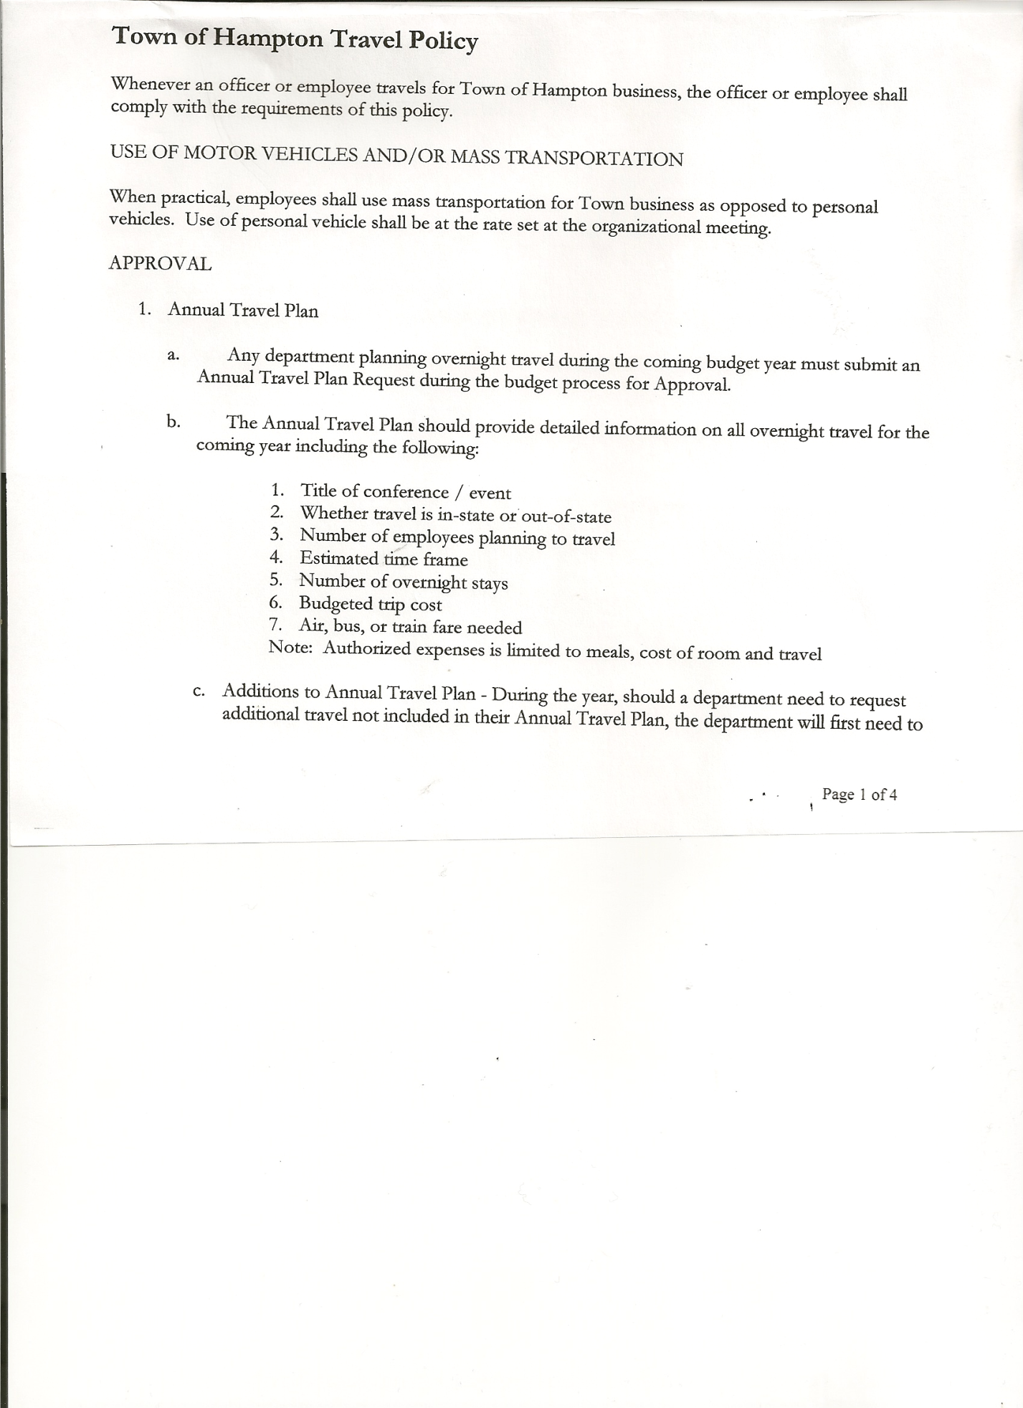
Roger Weeden---------------Councilman
Rebecca Jones---------------Town Clerk
Camilla Shaw----------------Tax Collector/Deputy Town Clerk – came at 8:25pm
Herbert Sady, Jr.-------------Highway Superintendent
Kim Perry---------------------Budget Officer/Bookkeeper

Planning Board Member(s): Bonnie Hawley, Chair, and Matthew Pratt

Also present: see attached sheet

The Public Hearing was called to order by Supervisor O’Brien at 7:15pm.

Town Clerk Jones read the Legal Notice of Public Hearing (copy attached), which was published
in Manchester Newspapers to discuss the proposed local law to override the tax levy limit.

Dianne Sofia questioned the override for the Tax Levy and why a Budget isn’t passed first.
Kim Perry, Budget Officer explained that the Town needs to notify the State of “anticipating” going over before actual budget is adopted.

All persons desiring to be heard, having been heard, the Public Hearing was closed at 7:22pm

REGULAR MEETING
The Regular Meeting was called to order by Supervisor O’Brien at 7:30pm, followed by the Pledge of Allegiance. Location of Fire Exits were given. Quorum of board members present.

RESOLUTION NO. 96-2019
APPROVAL OF THE MINUTES
On a motion of Councilman Sady, seconded by Councilman Weeden, the following resolution was ADOPTED: Ayes 5 O’Brien, Sady, Taran, Sweeney,Weeden
Nays 0
RESOLVED, that the Regular Town Board Minutes for September 19th, 2019 and the Special Town Board Minutes for October 10th, 2019 are approved.

Larry Carman, Dog Control Officer submitted his report, which was read by Supervisor O’Brien, copy of report is attached for 9/20/19-10/14/19.

Camilla Shaw, Tax Collector - Zero balance. Submitted a Bank Statement to the Board for review and signatures.

TOWN BOARD MEETING
OCTOBER 17, 2019 PAGE 2

Bonnie Hawley, Chair gave Planning Board Report…
- Continuing to work on Farm Land Ag Protection Plan
- Next meetings will be October 23rd, 2019 and November 13th, 2019@ 7:00pm at the Town Hall.

Herbert Sady, Jr., Highway Superintendent submitted his report, copy of which, is attached.

SUPERVISOR’S REPORT/COUNTY UPDATES/COMMUNICATIONS

RESOLUTION NO. 97-2019
APPROVAL OF SUPERVISOR’S MONTHLY REPORT
On a motion of Councilwoman Taran, seconded by Councilman Sady, the following resolution was ADOPTED: Ayes 5 O’Brien, Sady, Taran, Sweeney, Weeden
Nays 0
RESOLVED that, the Supervisor’s Monthly report be accepted as submitted for SEPTEMBER
08/31/19 09/30/19
ACCOUNT BALANCE RECEIPTS DISBURSEMENTS BALANCE
General Fund $ 56,945.97 $ 405.29 $ 5,872.33 $ 51,478.93
Highway Fund $ 81,546.27 $ 100,005.23 $ 11,874.49 $ 169,677.01
Equipment Reserve $ 29,849.42 $ 1.23 $ 0.00 $ 29,850.65
Fire #1 $ 20,808.00 $ 0.00 $ 0.00 $ 20,808.00
Fire #2 $ 3,878.00 $ 0.00 $ 0.00 $ 3,878.00
Cemetery $ 1,722.25 $ 1.09 $ 0.00 $ 1,723.34
Totals $194,749.91 $100,412.84 $ 17,746.82 $277,415.93
All Board Members present signed Supervisor’s Report.

Supervisors are continuing to work on County Budget.

Worked on the Tentative Budget.
- General ----Reval is the biggest increase
- Highway—had several unexpected expenditures in 2019
Looking to increase amount to maintain paving and Equipment Reserve Fund.
Losing some State money that we usually use toward paving. We should be maintaining
a mile a year.

Ambulance Service….Supervisor O’Brien will check with Whitehall vs Fair Haven for cost.

Hampton Fire District #2….discussion regarding amount requested. Agreement was made to increase to $10,000 this year. Majority of board decided to leave amount at $10,000.00.

TOWN BOARD MEETING
OCTOBER 17, 2019 PAGE 3

RESOLUTION NO. 98 -2019

MOTION BY: Councilman Donald Sady
SECONDED BY: Councilwoman Andrea Sweeney

RESOLUTION ADOPTING A LOCAL LAW TO OVERRIDE THE TAX LEVY LIMIT ESTABLISHED IN GENERAL MUNICIPAL LAW SECTION 3-C

WHEREAS, pursuant to Section 3-c(5) of the New York State General Municipal Law, the Town Board (the “Board”) of the Town of Hampton (the “Town”) has the authority to adopt a local law to override the real property tax levy limit as defined in General Municipal Law §3-c; and

WHEREAS, a budget has been prepared for the Town of Hampton for fiscal year beginning January 1, 2020 and ending December 31, 2020 that exceeds the tax levy limit as defined in General Municipal Law §3-c; and

WHEREAS, a local law to override the tax levy limit in accordance with the provisions of General Municipal Law §3-c has been prepared; and

WHEREAS, the Board scheduled a public hearing to be held before the Town Board on October 17, 2019 at the Offices of the Town of Hampton, 2629 State Route 22A, Hampton, New York 12837, to hear all interested parties regarding the adoption of the proposed Local Law; and

WHEREAS, notice of said public hearing was duly posted and then published in the Manchester Newspapers (The Granville Sentinel/The Whitehall Times), the official newspaper of the Town of Hampton pursuant to and in conformance with Section 20 of the Municipal Home Rule Law; and

WHEREAS, said public hearing was duly held and all parties in attendance were permitted an opportunity to speak on behalf of or in opposition to the proposed Local Law.

NOW, THEREFORE BE IT RESOLVED by the Town Board of the Town of Hampton as follows:

Section 1. The Town Board finds that the proposed Local Law is required pursuant to General Municipal Law section 3-c and is in the best interests of the residents, inhabitants and guests of the people of the Town of Hampton.

Section 2. The proposed Local Law, copies of which are attached hereto and made a part hereof, is hereby adopted.

Section 3. The Law shall take effect immediately upon its filing in the Office of the Secretary of State.

Section 4. This resolution shall take effect immediately.

DATED: October 17, 2019 Supervisor O’Brien AYE
Councilwoman Taran AYE
Councilman Sady AYE
Councilwoman Sweeney AYE
Councilman Weeden AYE
TOWN BOARD MEETING
OCTOBER 17, 2019 PAGE 4

RESOLUTION NO. 99-2019
PUBLIC HEARING ON HAMPTON FIRE DISTRICT NUMBER 1
On a motion of Councilman Weeden, seconded by Councilman Sady, the following resolution was ADOPTED: Ayes 5 O’Brien, Sady, Taran, Sweeney, Weeden
Nays 0
RESOLVED, to set the Public Hearing to discuss the proposed contract between the Town on behalf of the Town of Hampton Fire Protection District Number 1 and the Hampton Volunteer Fire Company for October 31st, 2019 at 7:00pm.

RESOLUTION NO. 100-2019
PUBLIC HEARING ON HAMPTON FIRE DISTRICT NUMBER 2
On a motion of Councilman Sady, seconded by Councilwoman Taran, the following resolution was ADOPTED: Ayes 5 O’Brien, Sady, Taran, Sweeney, Weeden
Nays 0
RESOLVED, to set the Public Hearing to discuss the proposed contract between the Town on behalf of the Town of Hampton Fire Protection District Number 2 and the Hampton Volunteer Fire Company for October 31st, 2019 at 7:05pm.

RESOLUTION NO. 101-2019
PAY OFF BOND
On a motion of Councilman Weeden, seconded by Councilman Sady, the following resolution was ADOPTED:
BY ROLL CALL VOTE: Supervisor O’Brien AYE
Councilwoman Taran AYE
Councilman Sady AYE
Councilwoman Sweeney AYE
Councilman Weeden AYE
RESOLVED, to pay off Bond by end of 2019, provided monies available in Highway Fund.

RESOLUTION NO. 102-2019
ADOPTION OF TENTATIVE BUDGET
On a motion of Councilman Sady, seconded by Councilman Weeden, the following resolution was ADOPTED:
BY ROLL CALL VOTE: Supervisor O’Brien AYE
Councilwoman Taran AYE
Councilman Sady AYE
Councilwoman Sweeney AYE
Councilman Weeden AYE
RESOLVED, that the 2020 Tentative Budget be adopted and becomes the 2020 Preliminary Budget for the Town of Hampton.

RESOLUTION NO. 103-2019
PUBLIC HEARING ON PRELIMINARY BUDGET FOR 2020
On a motion of Councilman Sady, seconded by Councilwoman Taran, the following resolution was ADOPTED: Ayes 5 O’Brien, Sady, Taran, Sweeney, Weeden
Nays 0
RESOLVED, to set the Public Hearing on the Preliminary Budget for 2020 for October 31st, 2019 at 7:10pm.

TOWN BOARD MEETING
OCTOBER 17, 2019 PAGE 5

RESOLUTION NO. 104-2019
SPECIAL MEETING
On a motion of Councilman Sady, seconded by Councilman Weeden, the following resolution was ADOPTED: Ayes 5 O’Brien, Sady, Taran, Sweeney, Weeden
Nays 0
RESOLVED, to set a Special Meeting for Thursday, October 31st, 2019 at 7:15pm.

The Town Clerk’s report for September 2019 was submitted to the Board. The Town Clerk had Board Members review and sign bank reconciliation statements for the Town Clerk Account and Special Clerk Account dated September 30th, 2019.

Voucher #86 on the September 19th, 2019 Highway Fund Warrant to Delurey Sales was voided. Bill was paid and on the August Highway Fund Warrant. Correct total for September’s Highway Warrant should be $6,336.42.

RESOLUTION NO. 105-2019

AUDIT OF CLAIMS
On a motion of Councilwoman Taran, seconded by Councilman Sady, the following resolution was ADOPTED: Ayes 5 O’Brien, Sady, Taran, Sweeney, Weeden
Nays 0
RESOLVED that the bills have been reviewed by the Town Board and are authorized for payment in the following amounts.
General Fund No. 132 through No. 141 $ 864.70
Highway Fund No. 92 through No. 99 $ 3,138.52
Total both funds $ 4,003.22

On a motion of Councilwoman Taran seconded by Councilman Sady, the meeting adjourned at 10:00pm All in favor Aye.

Respectfully submitted,

Rebecca S. Jones, RMC
Town Clerk

