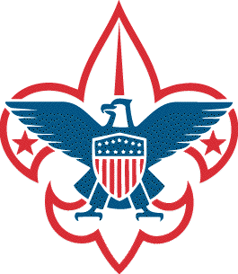
Troop 5 – Weekend Camp Duty Roster
Camp Event: |  | Patrol:
Dates/Times: |  | Patrol Leader:
Location:

 | Water | Cooks | Clean-up | Fire Tenders |  |  |  |  | Scouts Attending
Friday Night
Saturday Morning
Saturday Afternoon
Saturday Evening
Sunday
Morning
Sunday  Morning |  |  |  |  |  |  |  |  | Leaders
Water- Responsible for: Drinking/Cooking water, Clean- up water, Fire water.  Cooks- Responsible for: Preparation, Cooking, Setting up area to eat, putting away food, and updating food inventory.  Kitchen Patrol- Responsible for: Heating clean-up water, Washing/drying all dishes and utensils and putting them away.  (personal mess kits are to be washed and set in an area to be put away by their owners)  Fire Tender- Responsible for: Making fire pit, Getting/Storing wood, Building/Starting/Tending campfire. |  |  |  |  |  |  |  |  |  |  |  |  |  |  |  |  |  |  | Mr. Lueck

