How the Utah Legislature works updated for 2020

For those interested in working with the Utah Legislature to push issues and bills, I wrote up a summary that would help. I have been going to the Legislature and talking with many of the legislators for many years. I am not a lobbyist. But most legislators treat me with respect and are willing to answer questions and discuss issues and potential bills, if they make sense. They often jump at bill ideas that are in their interest range. Some legislators are very interested in bills that decrease government overreach. Other legislators are interested in rail and mass transit. I wrote an oped in November of 2016 in the Deseret News that countered Senator Jim Dabakis' opinion piece that slammed the legislature for not listening to the citizens. I fought for Healthy Utah but the legislators that I talked to were tired of 300+ emails a day with sob stories. They were so upset that they ignored the important benefits of healthcare expansion. But they were willing to listen to arguments that were quickly presented that made a good case for the issues. I watched Representative Schultz spend half an hour listening to a group of men concerned about a bill that he was sponsoring, and he tried to find a compromise and satisfy their concerns. He was supposed to be somewhere else, but he acted like he was working for them. That is what a public servant is supposed to do. My interactions with most legislators seem to support my belief that most consider themselves public servants.
I have been able to suggest bill ideas and see them implemented into law by legislators that are not in my district. Interestingly, my former senator, Jim Dabakis, wouldn’t listen to me while most other legislators will consider my arguments.
This is my lesson on basic working knowledge of the Utah Legislature.
The important dates are below. If you have not discussed an idea for a bill by February 1, there is very little chance to have your idea be considered.
Sometimes, you can add onto a bill if the suggestion is in the same area that the bill effects. Bills must be on one specific issue. For instance, several years ago, we were fighting SLC's ticketing of ADA disabled wheelchair drivers and Rep. Stratton was running a bill on wheelchair van parking. He agreed to change the bill and add that the ADA parking placard could be placed on the dashboard and not on the mirror. Unfortunately, it was done so late in the session that it missed getting approved by the Senate by an hour. That happens a lot. The bill was approved the next year. The lesson here is that legislators WILL listen to a good argument. They really do try to make Utah better.
Feb 5 Last day for the Legislature to either pass or defeat each base budget bill
Feb 6 Last day to request bills or appropriations without floor approval
Feb 29 Last day for the Legislature to present a bill to the Governor where he is required to act on the bill before the end of the session
Mar 6 last day for Executive Appropriations to complete all decisions necessary to draft the final appropriations bill
Mar 9 Any bond bill shall be made available to legislators by noon
Last day for a motion to reconsider
Last day to consider bills from own house
Mar 10 Last day for legislators to prioritize fiscal note bills and identify other programs for new funding
Last day final action must be taken on each bond bill by calendar closing time
Last day final action on general appropriations bill, supplemental appropriation bill and school finance bill by calendared closing time
Mar 11 Last day to pass any bill with a fiscal note of $10,000
Mar 12 Last day of the session

When a legislator wants a bill, they work with their staff attorneys and fiscal analysts to ensure that the proposed bill makes sense and is fiscally appropriate. Note that any bill with a fiscal note of $10,000 or more must be passed by March 10. In fact, any bill that could cost $10,000 or more is handicapped in the last two weeks of the Legislature. If there is no or little cost, and the committee that hears the bill agrees, the bill can be placed on the consent calendar and approved quickly without debate. Of course, any legislator can circle the bill for discussion which can significantly slow it down, especially in the last few days of the session. That is why there are so many meetings behind closed doors to try to get agreement on the bills before they could get bogged down in the chambers. There is a lot of horse trading behind closed doors. Lobbyists also have a lot of influence but, in my opinion, individuals also can have influence if they spend more than a day or two at the Legislature. That will give legislators the idea that you are involved and care and are not late to the game. It tells them that you want to work with them. Most of the lobbyists' influence comes from regularly seeing the legislators. The cafeteria at lunch time (in the Senate/east building) has many legislators meeting with their constituents and others and discussing issues and bills.
If you want to make a point with your legislator, make sure that you put constituent in the subject line and add your address (to confirm it) at the end of the email. When things get rushed or busy, legislators only look at constituent emails. Their interns also go through and often pick out their constituents to ensure that the legislators are given a heads up on the voters who the legislators are supposed to be representing. The latest intern list can be obtained by asking the Policy Analyst/Intern Director Ryan Hunter. He is at 801 538 1032 or emailing rhunter@le.utah.gov.
When a bill is numbered (note that some bills are held to decrease backlash and fights until the last minute so you might see a bill increasing taxes come out at the end of the session with just a day's notice - which is a Utah State law - at least one day's notice is required.), it then goes to the chamber's rules committee which assigns the bill to be heard by a certain committee if the bill has, if needed, a fiscal note. The sponsor's chamber's Senate or House committee hears the bill first then it goes, if approved, to the floor of the chamber for three readings to ensure that it is thoroughly discussed. If passed to the next chamber, it will go through their rules committee, be assigned and then be heard by the other chamber's committee. Rules has a lot of power and some committees have a
reputation. For instance, House Revenue and Taxation is very anti-tax and fiscally conservative. If a legislator has a questionable tax bill, they may try to convince Rules to give it to a committee that is more likely to pass the bill. Rules is very hard to influence and that is why they have a lot of influence. They will take public comment, but it seldom changes their mind.
But in committees, generally, unless time is short, public comments are encouraged and asked for. A good argument in committee can make a difference.
Committee members will listen to and consider well-reasoned and short (two minutes) comments and arguments for and against a bill. The Legislature tries to have at least one public hearing on each bill. Towards the end of the session, they sometimes skip one hearing. After the bill goes to the floor, it is difficult to influence the votes, but it can be done.
A good short argument by text or email may be read by the legislators unless they have too many and then their interns will sift through the material. You can also go to the staff that man the desks next to the chambers and ask to give your legislator or legislators a note. They have little pieces of paper for that. Usually, they won't react unless you are their constituent.
The Legislature has a great website with a lot of easy to locate and valuable information. I would like to suggest that you spend some time getting used to it. The mobile/cell phone version is a little different. The information below has the screenshots.

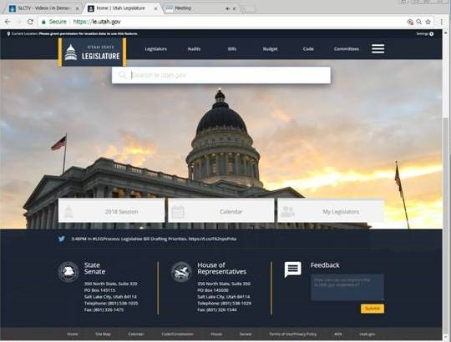
The Legislature's website is le.utah.gov. When you go to that website, you will see the image above (for a desktop). You have buttons on the picture for the 2020 session, the calendar (which I find to be the most important button), and my legislators.

If you click on the 2020 session, you will see a screen like below with quick links, scheduled hearings and trending columns.
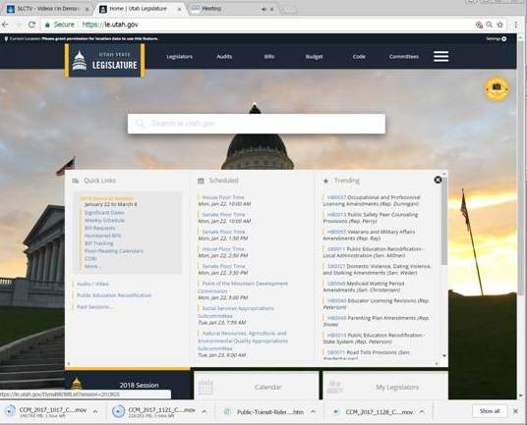
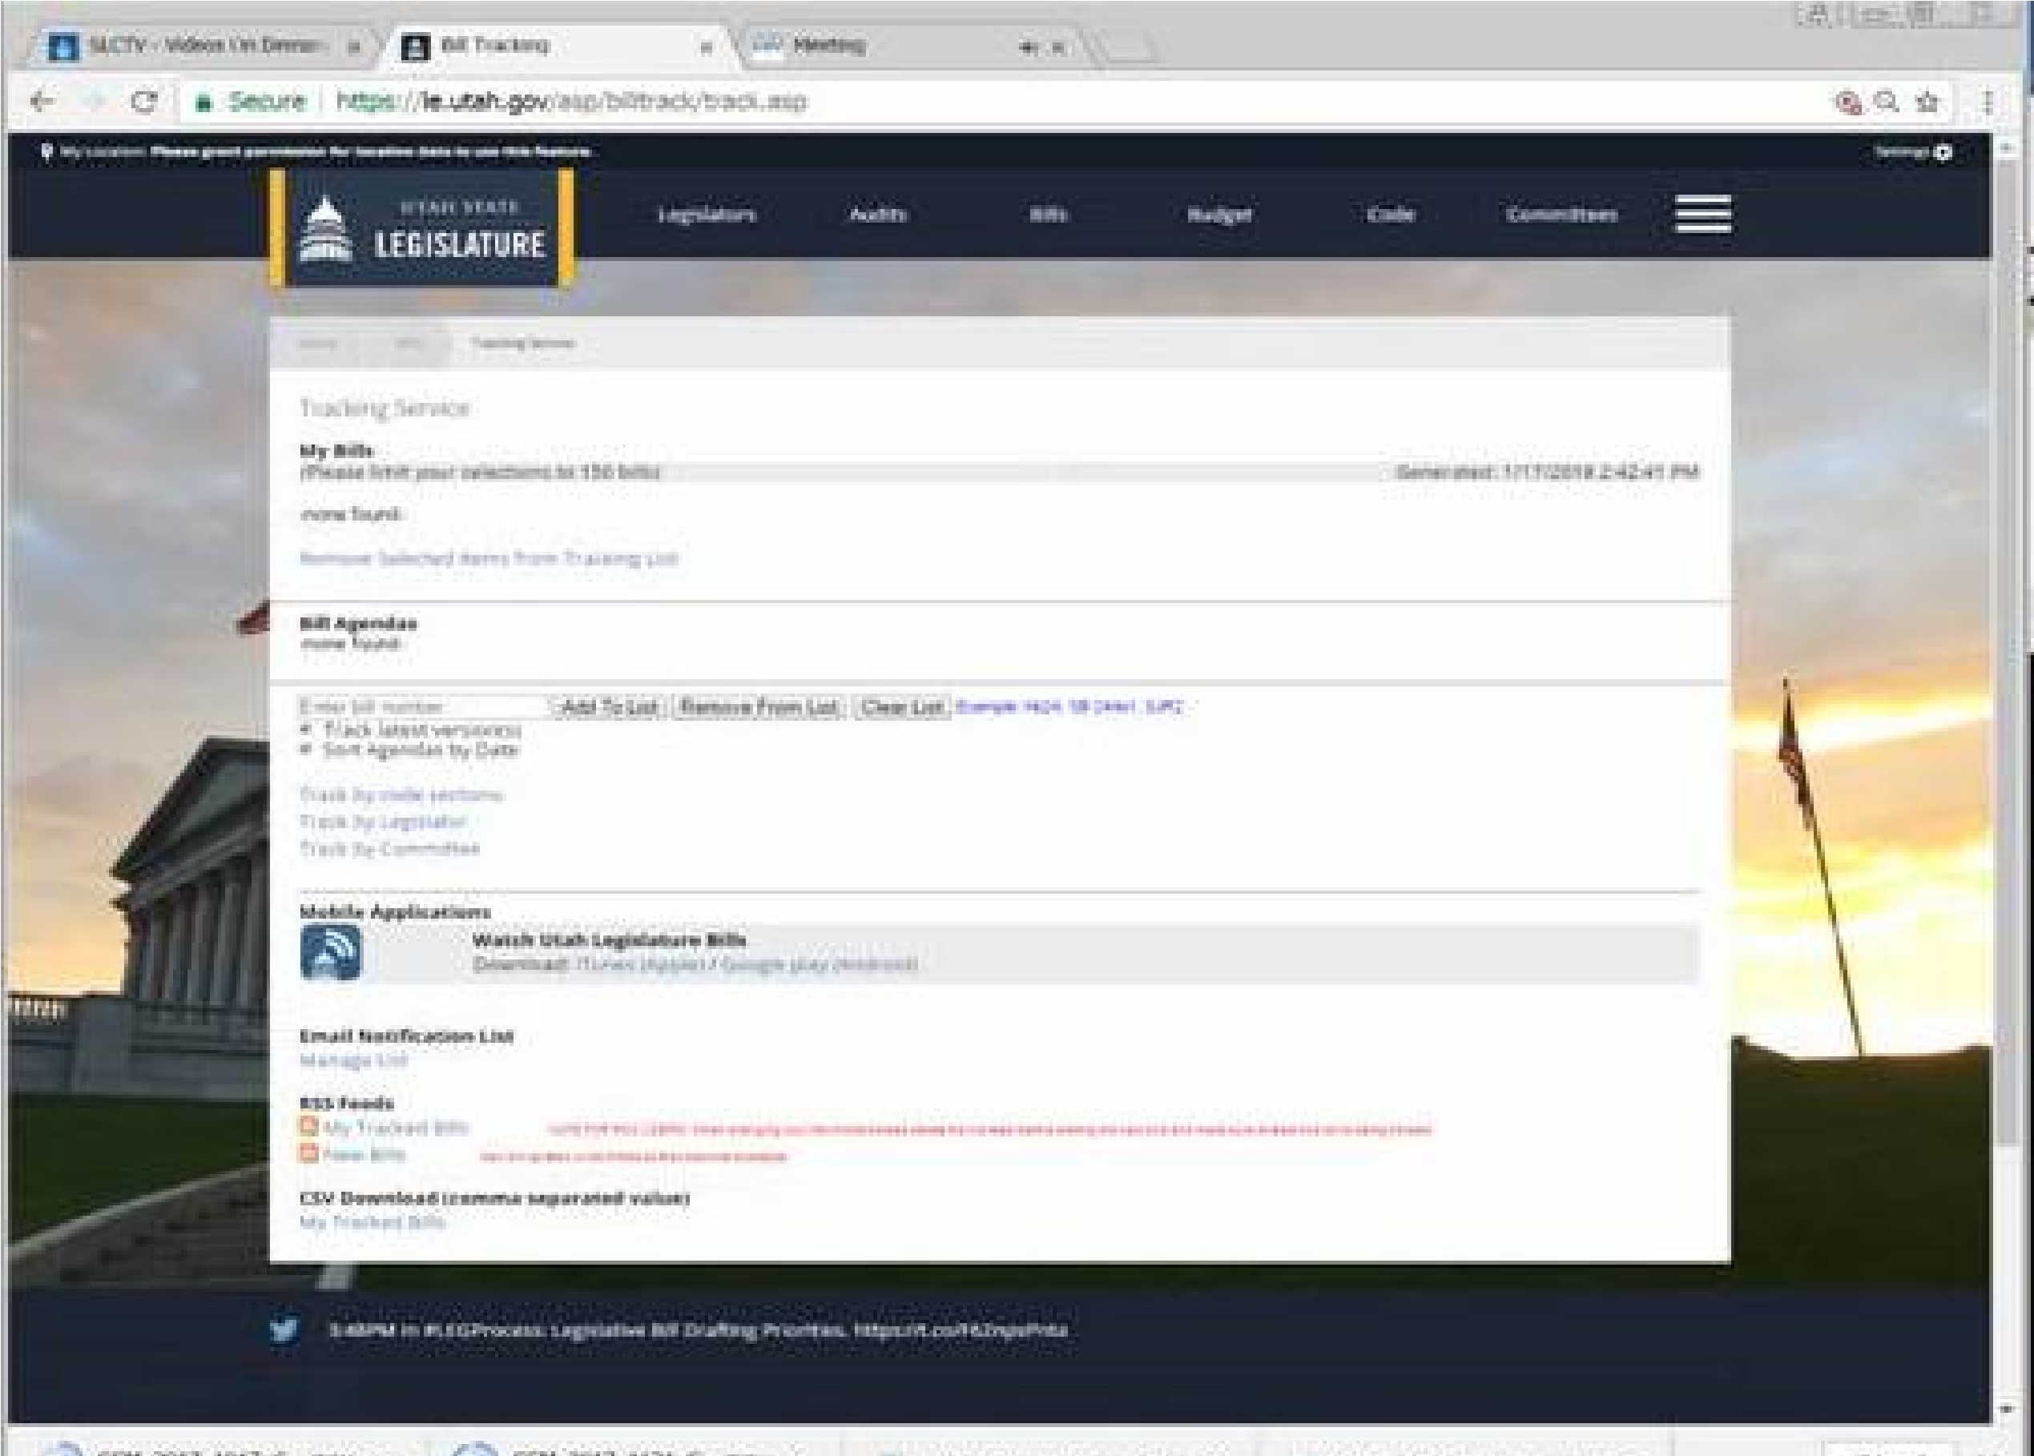
One of the best uses of the website is to track bills. You can track up to 150 bills if your mind is capable of doing so.
If you want to find a bill, you can search for the subject, the sponsor, the number or what the bill covers. Click on the menu button in the upper right hand part of the page and a drop down menu will have bills. By clicking on the Bills button (There are also buttons for Legislators with email addresses and phone numbers, Utah Code, Committees, Audits, Budget and Research and Legal), you have the option of viewing bills by legislator, subject and committee. You can also use the Tracking Service by clicking on it on the Bills drop down menu. When you get the results after clicking on a subject or legislator (View Bills page), you have the option of a series of bills that match your request. By clicking on the bill number, you can see the text of the bill and pdf downloads of the bill and the fiscal note and any new changes are available for download by clicking on the pdf symbol. You can track the status or listen to the Hearings/Debate. You can also track the bill and get email notifications by signing up (on the right of the page for the desktop version). The mobile version has the Tracking Page button above the PDF button for the Bill Text.

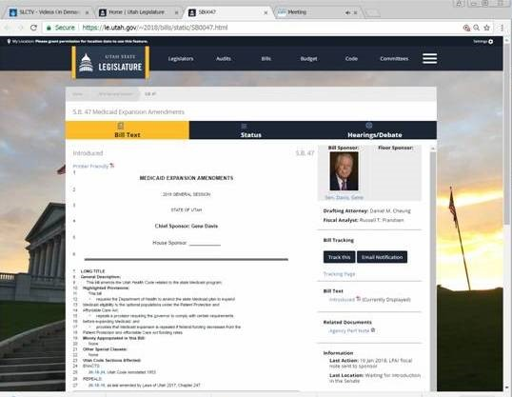
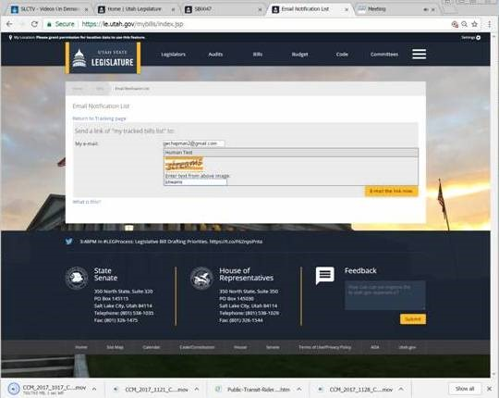
When you sign up to track a bill, it will ask for your email (seen below with a Captcha confirmation) and it will send you an email to confirm tracking or notification. You must click on the button on the email to confirm tracking. The Legislature will then send you an email every time the status of the bill changes, whether it is sent to a committee, is voted on or it passes or fails.

The website Tracking Page also has a summary of the bills that you are tracking (see below).

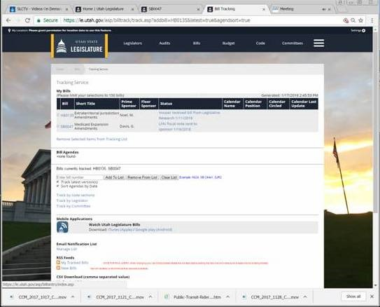
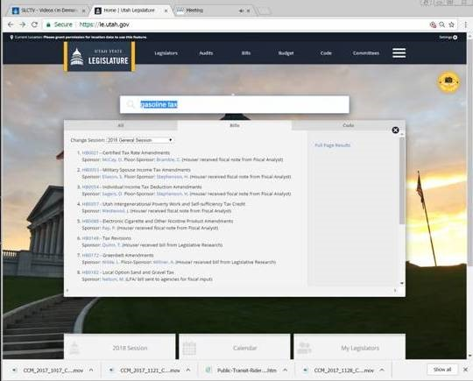
You can also find bills by searching for the subject that they could cover (see below).

If you want to see the fiscal note, for instance for the bill below (ecigarette tax), click on the right hand fiscal note button.

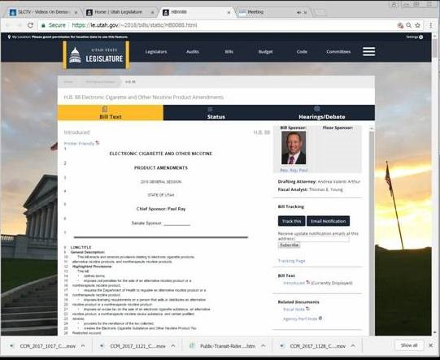
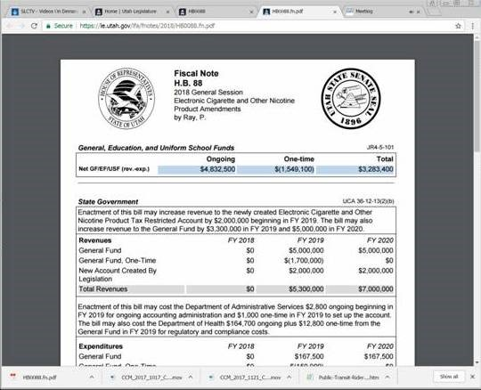
This is what you will see. It is a full accounting of what the bill will cost or gain Utah in revenue. There is a tendency in the Legislature to try to make bills revenue neutral so that it will not increase tax revenue.

You can find out a lot more about the legislators by clicking on the upper bar of items on the website which includes legislators. When you click that button, you will get a choice of House and Senate rosters. The House and Senate lay out information in a different manner but this is what they look like. It includes their committees, their background, their emails, phone and addresses. Note that Utah legislators do not hide and are very available. I try not to phone (email, to me, is more respectful and they will call me if they want to talk) but their phone number is available on the website.

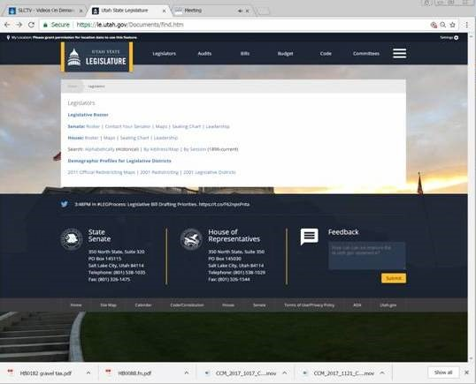
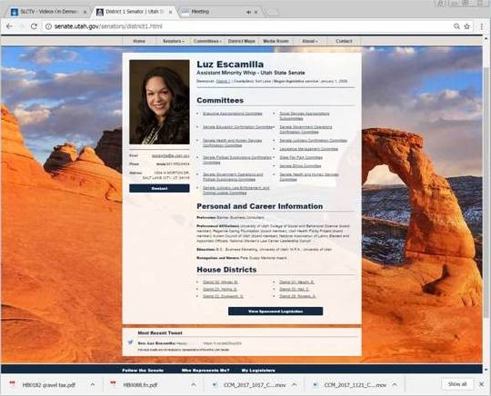
If you want to find all of the bills involving air quality, just type it into the search bar. This is what you will get.

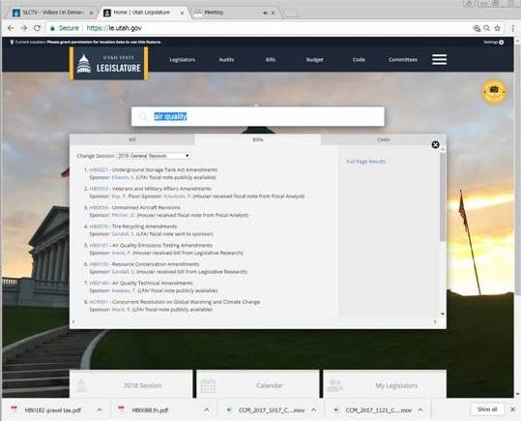
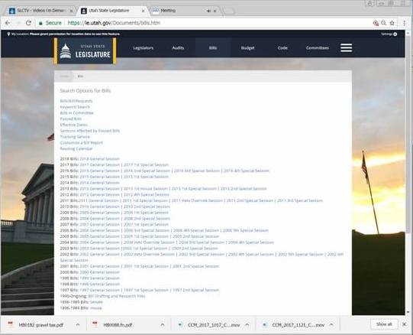
You can also search for other year's sessions' bills.
The site has other information like the items below.

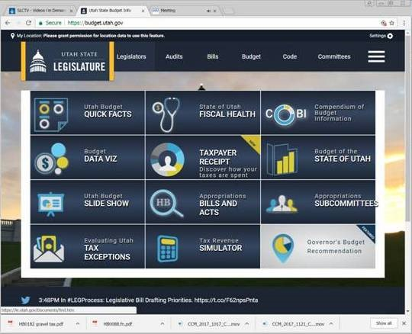
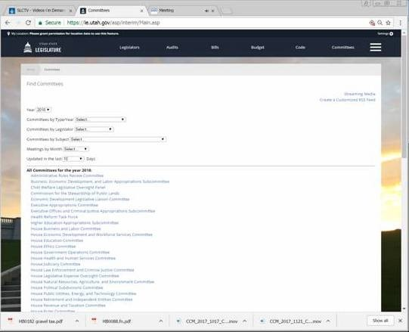
Usually, each year, I go into the bills section and look for all subjects of bills. I get a long list of bills, many may not see the light of day, they are just placeholders. But if you ask for a listing by subject, it will give an easy to read list of bills, both numbered and in process.

Once you find a bill that you want to track, you can click on the bill and the middle column above the bill's text is STATUS. Clicking on that will show the status and where the bill is assigned once it passes rules. It will note whether it has a fiscal note and where it is in process. Once you know to which committee that it is assigned, you can go to the committee page (top menu bar and on the furthest right) and click on it and find the committee that it is assigned to and find when it will meet again. That committee page will also have a listing of the agenda (for download) and items that will be presented (by clicking on the view list). I find that many of the presentations are important and informative and they can be downloaded from the item view list. You can also click on the audio view list.
Note that last year the audio was recorded as a video mp4 file. The contractor that provides the downloads as mp4 may change to mp3 which would provide a 20mb 2 hour file download instead of a 500 mb file download. We asked that the Legislature consider it to encourage more public engagement.
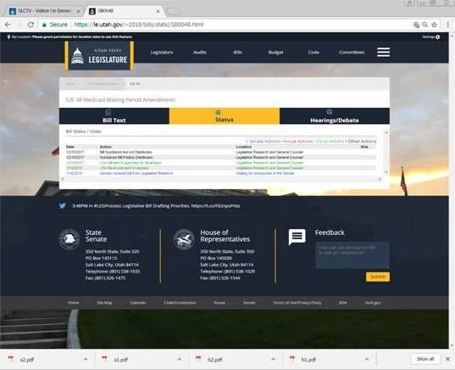
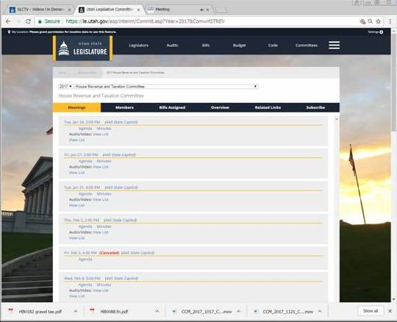
This is another view of what you can find on the committee webpage.

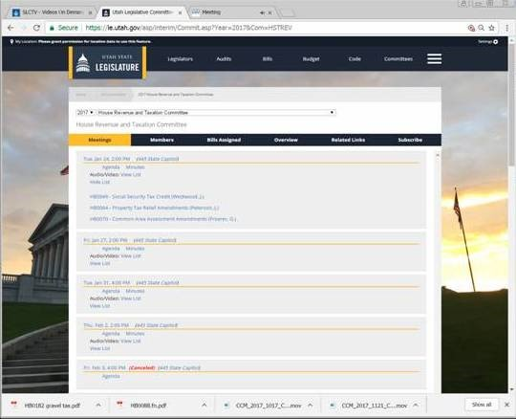
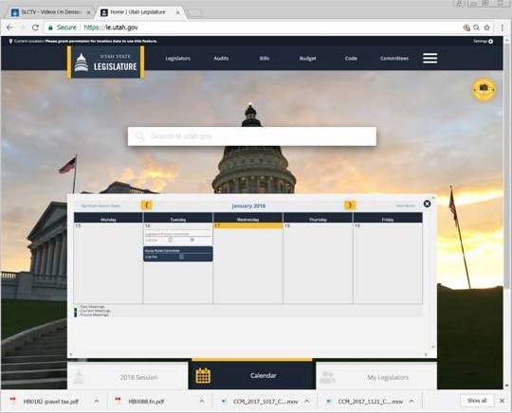
I look at the Legislature's calendar every day since I find some surprises every year. I asked several times several years ago about some bills that were promised and that I wanted to fight but we didn't know until a day before the committee hearing that the bills were going to be heard (one was dropped). A bill, with one day notice, and only one comment against it was the homeless resource center site decision that gave Mayor McAdams the full responsibility for picking the site. Only the calendar showed the bill and committee hearing the day before! Controversial bills sometimes ARE rushed through. When you click on the calendar, you will see a group of date on the week and the committee hearing and chambers meetings for each day. Clicking on the agenda (the left-hand symbol under the title of the committee will give you the pdf agenda. If you click on the committee itself, you will get all of the meetings along with a list of items (click on the view list farthest right column) to be heard at the meeting and presentations and audio recordings. Audio is also provided in real time. I have had to use it when I find several items being heard that I was interested in commenting on in different committees meeting at the same time. The Legislative staff changed their audio recordings to decrease the size of the downloads of the committee hearings. They are now about 100mb. It is convenient to listen to the committee hearings in real time or by downloading them later.

Note that public comment is encouraged generally, and you just have to show up to comment. For some contentious issues like marijuana, the chair of the committee may pass around a sign-up sheet and choose a few from each side of the issue to try to be fair. If there are many trying to speak, and you do not have a well formed and reasonable argument for or against the bill, you may hurt your case.
An exception to public comments is the appropriation committees that meet mostly at the beginning of the session. They include House and Senate legislators and public comment time must be asked for and reserved. If there is time, the chair may allow you to comment (again for 2 minutes maximum). But you must reserve the time by 1 PM the day before. If you want to comment on a Monday meeting issue, sometimes the staff will be there on Saturday. For instance, if you wanted to speak at the Social Services Appropriations Subcommittee when they discuss homeless funding (you will have to check the website to see when that is on the calendar and they only have notices going out a few days before), you MUST call Debbie Benson the day before by 1 PM at 801 326 1698 to be considered for public comment and note the agenda item that you want to comment on. Ms. Benson handles most of the appropriations committees' reservations for public comments.
I will try to update this information to put in anything that I have forgotten. I will put a note in the blog if there is an update.

And a final note, today, sometimes there are a bunch of Legislative committee hearings at the same time. If you are interested in several bills that are
in different committee hearings, the agendas under the calendar on le.utah.gov are important. You can see where they are on the agenda. Caution, since many Legislators have many bills, they often rearrange the agendas to help Legislators be more time effective.

Good luck and please participate in the 2020 Legislative session.

