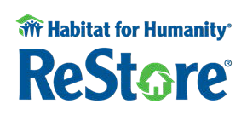
932 East Wood Street Decatur, IL 62521 (217) 330.5870

WE ARE CURRENTLY ACCEPTING THE FOLLOWING MATERIALS:

Cabinets ➔ new and used, undamaged, up-to-date with all parts (need photo for approval)
Plumbing ➔ usable fixtures, parts and supplies, used toilets under 5 years old
Electrical ➔ usable fixtures, parts and supplies
New Windows ➔ complete with unbroken, insulated glass ( or under 5 years)
Hardware ➔ knobs, hinges, locks, nails, cabinet pulls, nuts, bolts, screws, in quantity only
Lumber ➔ at least 6’ in length
Doors ➔ interior & exterior, with jambs, no broken glass (currently NOT accepting hollow core)
Roofing ➔ in full bales (minimum of 3)
Insulation ➔ full bales only
Carpet ➔ new only, rolled & labeled with size
Tools ➔ hand, garden & working power
Flooring ➔ wood, ceramic tile, vinyl (new)
Millwork/Trim ➔ usable lengths
Countertops ➔ granite, solid surface, laminate (no custom corners)
Appliances ➔ in good working order, less than 8 years old for pick up, 10yrs for drop off
Furniture ➔ not upholstered unless in pristine condition
Landscaping ➔ blocks & materials
Paint ➔ new or unused latex only
Miscellaneous ➔ masonry, sheathing siding, drywall supplies

WHAT WE CANNOT ACCEPT:
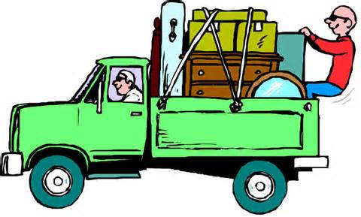
- Clothing/home goods
- Lead-based materials
- Tub surrounds used
- Paint, stain or varnish (opened)
- Toxic materials
- Used blinds
- Wallpaper
- Used carpet pad
- Lumber, drywall, styro-foam, etc. under 6’
- Used hot water heaters over 3 years
- Car accessories
- Glass
- Items that are broken or missing parts
- Used garbage disposals and trash compactors
- Electronics/computers

The lists of what we can & cannot accept will change, depending on inventory and sales.

Please always call before bringing materials to ReStore.
Please understand that if we feel that we cannot sell an item, we reserve the right to decline the donation.

Thank you very much for thinking of Habitat for Humanity’s ReStore!

