CAPABILITY STATEMENT

DUNS: 063266993 Cage Code: 0R182 FEIN: 86-0207713

J.B.’s Precision Industries is a leading provider of precision machined parts for industries including:
AEROSPACE DEFENSE COMMERCIAL MEDICAL
J.B.’s Precision Industries is certified to AS9100 Rev. C and ISO 9001:2008, and maintains a newly built 15,000 square foot facility with 11 total employees. We've been doing business for 50 years, and have built an invaluable reputation of honesty, fairness and trust in all of our dealings. We are dedicated in providing high performance products through specialized processes and innovative machining.
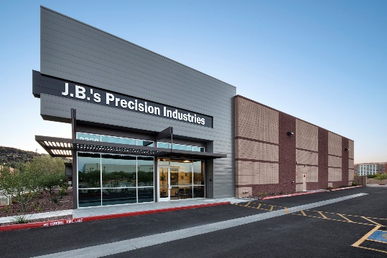

PROCESS CAPABILITIES:
4 axis milling, precision turning, R & D, prototyping, grinding, honing, glass bead, drilling, tapping, boring, facing, deburring.

MATERIAL MACHINED:
Aircraft Alloys, Aluminum, Brass, Bronze, Nickel Alloy, Plastic, Titanium, and Stainless Steel.

PROGRAMMING:
Mastercam X9

CERTIFICATIONS:
AS9100 Rev. C and ISO 9001:2008
Woman Owned Small Business

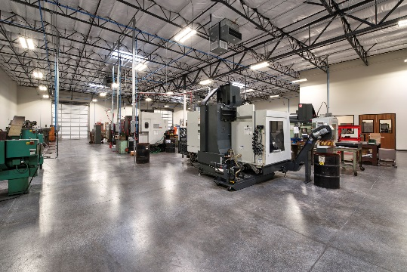

WHY WE’RE BETTER:
We provide exceptional customer service, and we are dedicated in providing high performance products through specialized processes and innovative machining.

PARTIAL CUSTOMER LIST

