Pleasants County Agricultural Youth Fair
Pie Baking Contest
September 15, 2018
Registration 10:00 a.m. – 11:00 a.m.
Barn Multi-Purpose Room

Sponsored by: ACE Home Center - Pennsboro
Chris Metz - State Farm Insurance
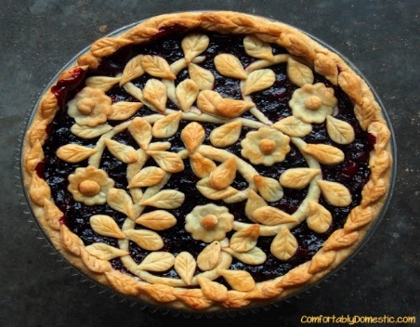
- This contest is intended for all ages, amateur bakers only.
- The pie must be entered by the person who made it in a disposable pan.
- All pies will be sold by the slice after the contest.
- Crusts and filling must be made from scratch.
- Refrigeration is available for the cream pies.
- There are 2 classes: fruit and cream. You can enter only 1 pie in each class. (No meat pies can be entered.)
- You need not be present to win.
- The judging criteria is: Overall appearance, crust, filling, and overall taste.
Originality: creative (in appearance only)
- Prizes will be awarded 1st - 2nd - 3rd places in each category and an overall prize for most original in appearance. Prizes are: 1st- $100.00, 2nd- $75.00, 3rd- $50.00 in each category and $50.00 for most creative.
- All pies must be brought to the barn multi-purpose room between 10:00 a.m. and 11:00 a.m. on Saturday, Sept. 15th, 2018. No late entries will be accepted.
- Judging will be closed.

(There is a $5.00 donation at the gate to enter the fairground.)

