Spring Newsletter 2017
Ilarion Residence

Table of Contents

Page 2 Ilarion/ Community News and Birthdays

Page 3 Amateur Hour

Page 4 Heart Cutting Story at Ilarion

Page 5 Heart Cutting Pictures and Events not to miss

Page 6 Communication between Adult Children and their Senior Parents (40/70 information)

From all of the staff at Ilarion, we hope you and your families have a wonderful Spring and Summer.

2509 Louise Street Saskatoon SK. S7J 3L7
www.ilarion.ca T: (306) 373-7011 ilarion@sasktel.net
Get fit this Spring/ Summer with Fit Over 50 Programs by the City of Saskatoon
The Health Benefits of Strength Training!
Strength training is not just for athletes or those who want big muscles. It's safe and effective for all ages and fitness levels, and provides many benefits.
Age and physical inactivity can cause our bodies to lose muscle mass. An inactive adult will lose about 30 to 40 percent of their strength by age 65, which can have a major impact on daily living.
Not only will strength training improve your muscular fitness, you'll also see other benefits, including:
- Stress and tension relief
- Risk reduction for osteoporosis and certain lifestyle diseases
- Better self- image
- Help with weight control
- Reduced fatigue and increased energy
Fit muscles also help to maintain good posture and prevent lower back pain, and can help protect the joints from shock and injury. Plus, strong muscles are more resistant to aches and pains.
For more information about locations, dates and times for all Fit Over 50 programs, please refer to the Spring/Summer Leisure Guide, call 306-975-7808, or visit www.saskatoon.ca/leisureguide
,

Ilarion News and Announcements

Spring Birthdays
Ilarion wants to wish a happy birthday to all of our tenants who celebrate a birthday in the spring.
Mar. Eva D. Bertha G. Maridell K. Betty K. Anna K. Dorothy L. Anne M. Deanna N. Steve O. Erika O. Tillie O. Donald O. Rose P. Sandy S. Morris S.  Apr. Olga C. Larissa C. Irene D. Nick D. Phyllis E. Olive G. Sally K. Alex K. Olga L. John P. Irene T. William T. Sylvia W. Marline Z. | May. Lilia C. Dorothy C. Lesya F. Stella H. Rose I. Tony J. Arthur K. Bill K. Rose O. Olga O. John P. Helen S. Sherry S. Ella T. Zennia Y.

Special Birthday Hoorah for Gladys Rowlands who turns 100 in November!

Yard Sale
There will be a multi-family yard sale on Saturday, June 3rd from 9:00 a.m. – 3:00 p.m. located in front of Ilarion. Refreshments will be on sale (Donuts & Coffee)

Birthday Parties

The Social Committee will now host a monthly Birthday Social on the last Sunday of every month @ 2:00 pm in Lower Lounge. This event will acknowledge everyone’s birthday for that month.

Tenant AGM Date Change
The new date has been set for Thursday, April 27th in the Lower Lounge at 7:00 p.m. Please ignore the date in the Activities Calendar. The minutes of the previous AGM are posted in the Post Office Mail Box Lobby bulletin board.

Community News
“Remembering When....”- Article from the Jubilee Residences News April 2017
“Watch for posters about a great presentation called Remembering When. This program is put on by the Saskatoon Fire Department and the Council on Aging. The program is approximately 45 minutes in length and uses nostalgia to incorporate the safety message in a fun engaging way. Did you know that after age 65, a person is twice as likely to be killed or injured in a fire? That number grows to three times as likely after age 75 and four times as likely after age 85. Statistics for falls are as equally disheartening; 30% of people over the age of 65 have a fall each year and that as a person ages, the likelihood of having a fall increases to be one in two over the age of 80. We know that preventing a fall or a fire is critical to ensuring that older adults remain in their home for as long as possible. This is an important presentation that we hope everyone can attend.”

AMATEUR HOUR

FRIDAY, MAY 26th AT 2:30pm
Calling all Ilarion folk! Introducing Amateur Hour at Ilarion, we invite everyone and anyone with a hobby or passion that they would love to share to step into the spotlight! Whether it be singing, joke telling, acting, playing a musical instrument, or story telling we want you to share your talent! We want to showcase our variety of talents and enjoy an evening of fun and entertainment. This can only be made possible if we have some wonderful people who are willing to be brave and courageous and volunteer to be a part of our magnificent event! We encourage everyone to participate, as it is only for fun and we appreciate anyone who has something to share. Maybe you want to get together with friends and do a funny skit or show off your dancing skills? Amateur Hour is the perfect place to do so! So don't be shy! Sign-up will be across from the mailboxes or feel free to come talk to Sophie or Dianne in our office! There will be a treat served after to celebrate all of our wonderful talent at Ilarion!

The Story of Fabric Heart-Cutting at Ilarion Residence
The Heart Pillow Project is a partnership between SaskTel Pioneers (present and retired SaskTel employees), the Heart & Stroke Foundation of Saskatchewan, the Coronary Artery Rehabilitation Group (CARG), other senior residences including the volunteers at Ilarion Residence. A similar project occurs in Regina using different volunteers.
Following heart surgery, patients are given unique heart shaped pillows to press to their chests. Pressing these pillows to the chest provides uniform, effective sternal support to aid in healing as well as pain reduction during coughing, deep breathing and moving about. The pillows are heart shaped to give a sense of comfort, as well as conveying to the patient that the hospital staff care about each patient and his/her recovery. The patients go home with the pillow as their badge of courage and treasure them throughout their lives. Previous to the use of these huggy pillows, patients were using bunched up towels or stuffed animals. One day a hospital volunteer in a Montreal hospital noticed this and came up with the idea of a heart shaped pillow. Now millions of heart patients throughout the world are given these pillows, some made by volunteers and some in factories. In 2005, when former United States president Bill Clinton underwent open-heart bypass surgery, the volunteer who came up with the idea, sent him one of the heart-shaped pillows and was rewarded with a handwritten thank you note from the former president!
To get to the heart of the matter, thirty years ago, Ilarion resident, Alice Prociuk, was asked to coordinate a project of cutting fabric into heart shapes for the Heart & Stroke Foundation of Saskatchewan, Coronary Artery Rehabilitation Group (CARG). Alice had previously had heart surgery and was known to CARG. CARG supplied the red fabric, scissors and heart shaped templates and Alice, with the help, of resident, Fred Andruschak, gathered up a group of volunteers and the project was born. Thirty years later, the project is still going strong and on March 30th, the Ilarion volunteers cut out 676 heart sheets which will create 338 pillows for patients recovering from open heart surgery. Some years more pillows are created but it is estimated that on average about 350 pillows have been created each year for 30 years producing a total of 10,500 pillows!
After the heart sheets are cut out, they go to a screen printer to have various logos stamped on them. (See photo). They then go to the SaskTel Pioneers who hand pin two heart shapes together, sew them together and stuff them. These pillows are then donated to the Royal University Hospital to be given to heart surgery patients.
Several residents at Ilarion Residence have had open heart surgery and were given these pillows. There is a beautiful plaque of appreciation hanging in the upper lounge hallway just to the right of the Board Room door. It says “CARG members wholeheartedly thank Ilarion Residence Seniors Club for many years of cutting the material for the heart pillows”. This being our 30th consecutive year, we did a “hearty party” theme with special decorations, candies and cookies baked by Glennis Proznick.
Story cont’d onto next page…

This year we had 25 women and 1 man from Ilarion plus 2 visiting students cutting out hearts. A very warm thank you to these dedicated volunteers. Thanks to Ken and the kitchen staff for supplying lunch for us out of the kindness of their hearts! Also, a huge, huge thank you to Helen Hryciw who cheerfully coordinates this project at Ilarion every year. As well, an equally heart-felt thank you to social committee volunteers, Glennis Proznick and Frances Robinson for the many hours they put in to make this project such a huge success.
Again, from the bottom of my I sincerely thank everyone involved. It makes my sing!
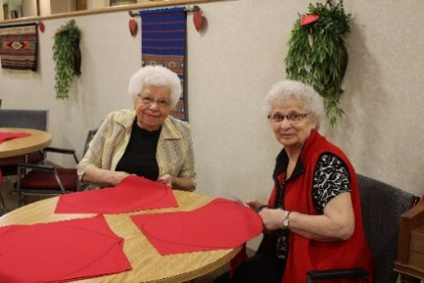
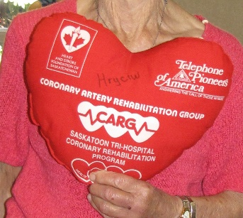
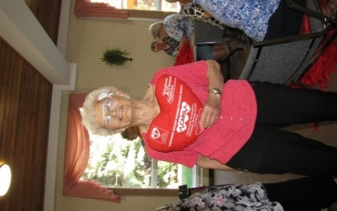
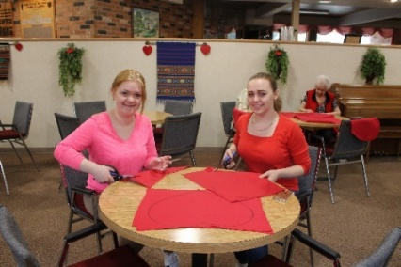
By: Gloria Zip

Events not to miss at Ilarion!
“Emergency Response Systems” Speaker – Wednesday April 26th 2:30 p.m.
Men’s Party – Thursday April 27th 1:00 p.m.
Tenant AGM – Thursday April 27th 7:00 p.m., Lower Lounge
Assisted Living Birthday Party – Friday April 28th 2:00 p.m., A.L. Lounge
Ukrainian Orthodox Senior Citizens Society AGM – Tuesday May 2nd 7:00 p.m.
Ilarion Yard Sale – Saturday June 3rd 9:00 a.m. – 3:00 p.m.
Canada 150 Celebration- Thursday June 29th
Free Noon BBQ (Hosted by the Tenant Association) – Tuesday July 25th
Free Noon BBQ (Hosted by Ilarion) – Tuesday August 29th

Communications between Adult Children and Their Senior Parents
A number of research studies done in North America indicate that the quality of communications between adult children and their senior parents leaves a lot to be desired. The findings of the study led researchers to coin the phrase 'the 40/70 rule.'
"This means that if you are 40, or your parents are 70, it's time to start talking about sensitive topics," says James Cooke of Home Instead Senior Care. "Waiting until the senior parent is 80 or older, when there is increasing likelihood of more severe health issues, can often lead to problems."
Two presentations were made at Ilarion on this topic by Karen and Ken Charyna from Home Instead on March 18 and 24. Around 30 residents and family members were present for each session. What was encouraging was the number of ‘adult children’ who attended. All who attended received a 43 page handout “An Action Plan for Successful Aging”. Copies are still available – please see Dianne if you require one.
The handout has a wealth of information on how to get the conversation going on some of the following:
- Adult children have the most difficulty talking to their senior parents about independence issues
- Independence issues include leaving their home for a retirement residence, assisted-living facility, or nursing home, as well as financial matters and driving issues
- The quality of communications is influenced by the gender of respective parties, topic of conversation, and how far the child lives from the parent
- Adult children should begin conversations on delicate topics with their senior parents sooner rather than later.
In studies done on this, respondents said the easiest things to discuss with their senior parents included end-of-life wishes, health issues, their living will, and how they will be remembered. The most difficult things to discuss included independence issues, their personal hygiene, financial concerns, and when it's time to quit driving. The sessions were informative and now is the time for action! Get the conversation going!

Thanks for reading our Spring Newsletter! If you want to contribute anything to the next newsletter, you can talk to Kim or Ken in the office!

