REGULAR MEETING
SEPTEMBER 21, 2023

The Regular Meeting of the Town Board of the Town of Hampton, County of Washington and the State of New York was held at the Town Hall, 2629 State Route 22A, Hampton, New York, on the 21st day of September, 2023.

PRESENT: David K. O’Brien------------Supervisor
Donald Sady----------------- Councilman - absent
Tamme Taran----------------Councilwoman - absent
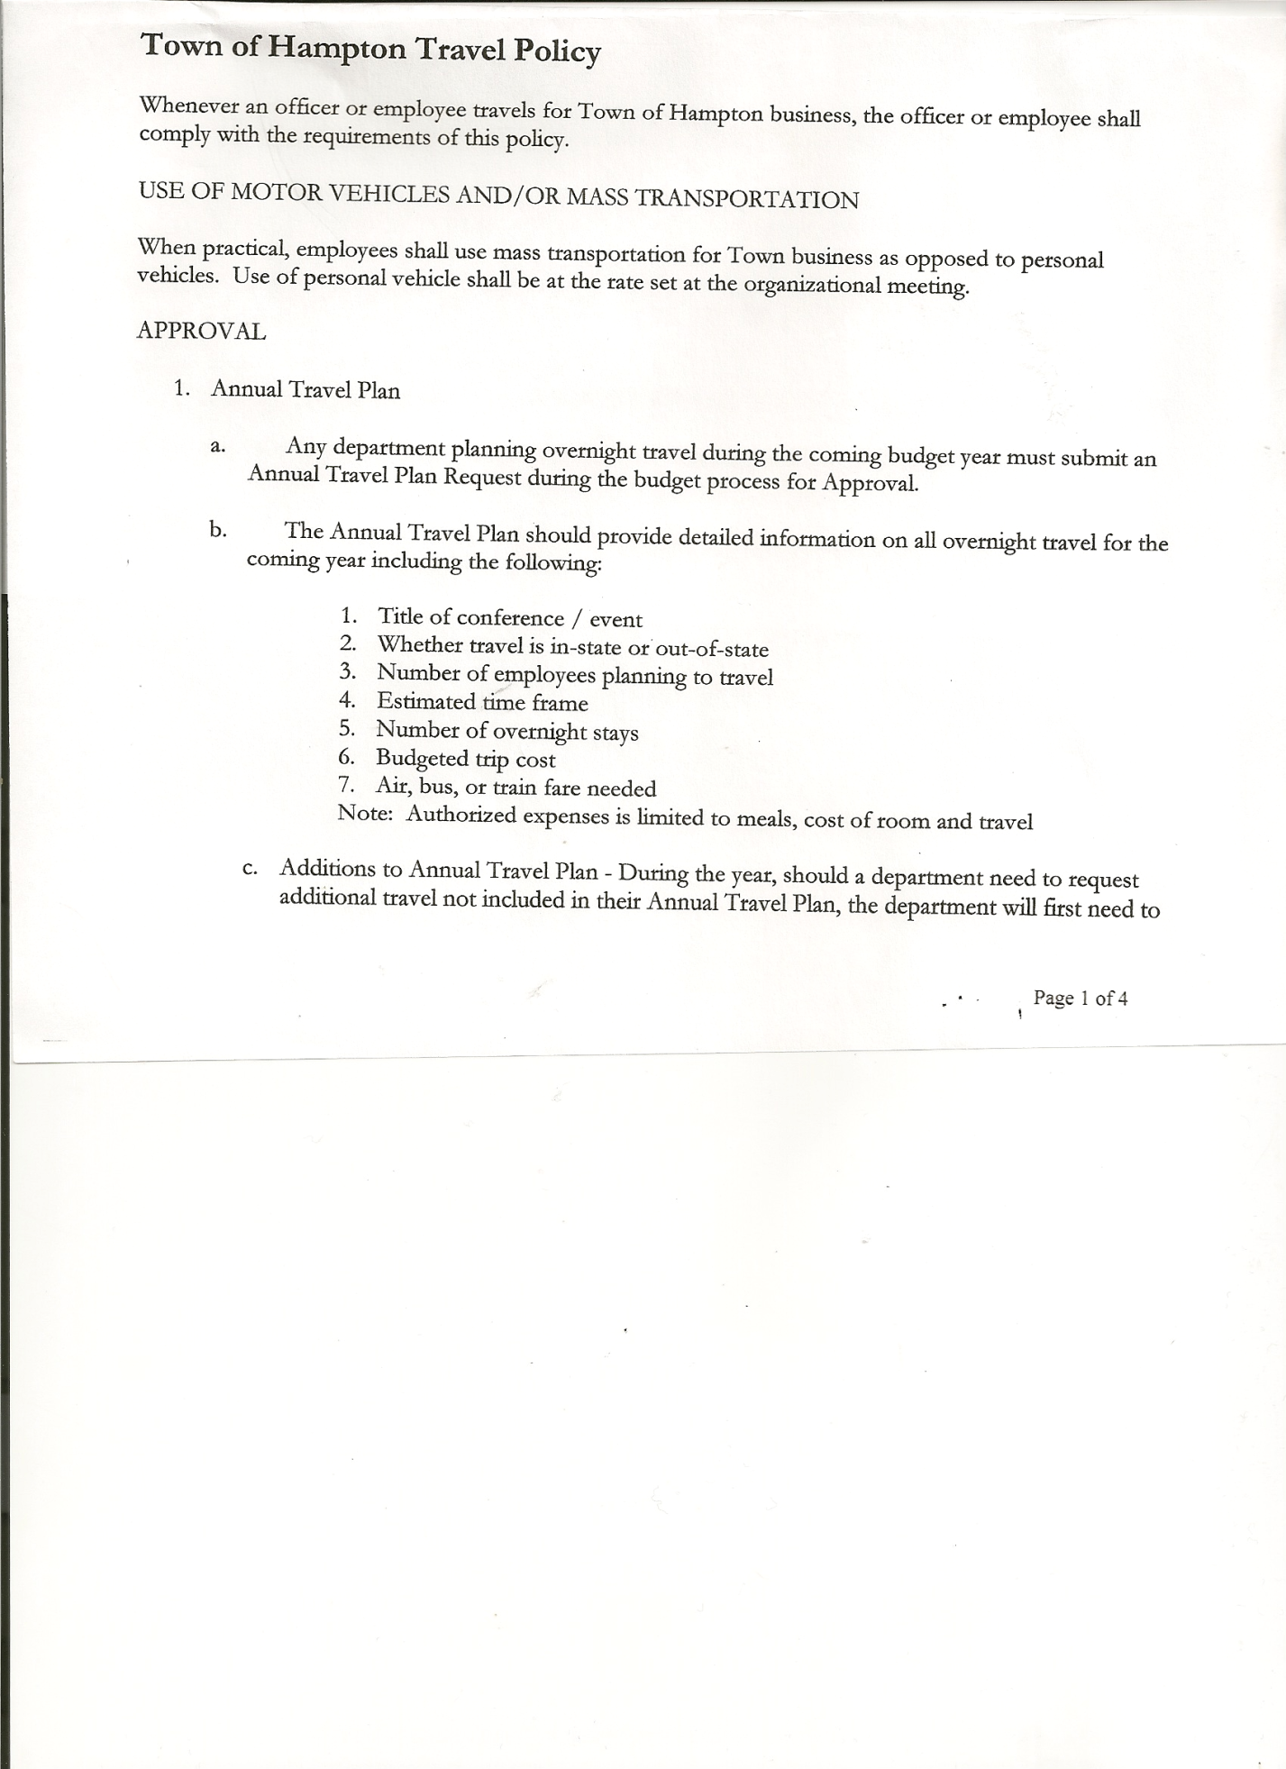
Michael Pietryka------------Councilman
Andrea Kugler---------------Councilwoman
Rebecca Jones---------------Town Clerk
Camilla Shaw----------------Deputy Town Clerk
Tyler McClure---------------Highway Superintendent

Planning Board Member (s):… Bonnie Hawley, Chair; Richard Cole and Matthew Pratt
Others present at the Town Hall: see attached sheet

The Regular Meeting was called to order by Supervisor O’Brien at 7:30pm, followed by the Pledge of Allegiance. Location of Fire Exits were given. Quorum of board members present.

Supervisor O’Brien introduced Dave Westfall, the newly hired Town Highway Employee and his wife Patti who reside on Manor Lane in Hampton.

RESOLUTION NO. 72-2023
APPROVAL OF THE MINUTES
On a motion of Councilwoman Kugler, seconded by Councilman Pietryka, the following resolution was ADOPTED: AYES 3 O’Brien, Kugler, Pietryka
NAYS 0
ABSENT 2 Taran, Sady
RESOLVED, that the Regular Town Board Meeting Minutes for August 17, 2023 are approved.

Dog Control Report….no report

Tax Collector Report…..no activity. The Town Clerk/Collector had Board Members review and sign bank reconciliation statements for the Tax Collector Account August 31, 2023.

Bonnie Hawley, Chair Planning Board…Ag Plan has been forwarded to Nan Stolzenburg for any corrections. The Town Planning Board will be holding a Public Hearing on the Ag Plan on October 11th, 2023 at 7:15pm at the Town Hall. Nan will be at the Public Hearing to answer questions.

Tyler McClure, Highway Superintendent submitted his report, copy of which, is attached.
Fuel Storage Station….as Tyler indicated in his report, Tim Garrick is willing to build the structure and pour the concrete in trade for the old 1-ton plow, this plow is of no use to the Town. The following resolution was then introduced:
RESOLUTION NO. 73-2023
HIGHWAY-TRADE LABOR FOR PLOW
On a motion of Councilman Pietryka, seconded by Councilwoman Kugler, the following resolution was ADOPTED: AYES 3 O’Brien, Kugler, Pietryka
NAYS 0
ABSENT 2 Taran, Sady
RESOLVED to trade labor to build Fuel Storage Tank structure for a used snow plow.

TOWN BOARD MEETING
SEPTEMBER 21, 2023 PAGE 2

RESOLUTION NO. 74-2023
PRE-AUTHORIZE PAYMENT OF PECKHAM BILL
On a motion of Councilman Pietryka, seconded by Councilwoman Kugler, the following resolution was ADOPTED: AYES 3 O’Brien, Kugler, Pietryka
NAYS 0
ABSENT 2 Taran, Sady
RESOLVED, to pay the Peckham bill for paving as soon as it is received. Then include said bill on the next Warrant.

Following a discussion on using Highway Reserve Account to pay paving expense and then pay back the account when we receive CHIPS money, the following resolution was introduced:
RESOLUTION NO. 75-2023
HIGHWAY RESERVE ACCOUNT
On a motion of Councilwoman Kugler, seconded by Councilman Pietryka, the following resolution was ADOPTED: AYES 3 O’Brien, Kugler, Pietryka
NAYS 0
ABSENT 2 Taran, Sady
REOLVED, to use the Highway Reserve Account to pay paving expense and then reimburse the account when CHIPS funds are received.

SUPERVISOR’S REPORT/COUNTY UPDATES/COMMUNICATIONS

RESOLUTION NO. 76-2023
APPROVAL OF SUPERVISOR’S MONTHLY REPORT
On a motion of Councilman Pietryka, seconded by Councilwoman Kugler, the following resolution was ADOPTED: AYES 3 O’Brien, Kugler, Pietryka
NAYS 0
ABSENT 2 Taran, Sady
RESOLVED that, the Supervisor’s Monthly report be accepted as submitted for AUGUST
07/31/23 08/31/23
ACCOUNT BALANCE RECEIPTS DISBURSEMENTS BALANCE
General Fund $ 71,321.95 $ 4,121.82 $ 3,988.68 $ 71,455.09
Highway Fund $201,786.40 $ 5.06 $ 21,987.80 $ 179,803.66
Equipment Reserve$149,980.34 $ 3.82 $ 0.00 $ 149,984.16
Fire #1 $ 23,185.50 $ 0.00 $ 0.00 $ 23,185.50
Fire #2 $ 7,680.50 $ 0.00 $ 0.00 $ 7,680.50
Cemetery $ 2,023.27 $ .84 $ 0.00 $ 2,024.11
Totals $455,977.96 $ 4,131.54 $ 25,976.48 $ 434,133.02
All Board Members present signed Supervisor’s Report.

NEW BUSINESS
RESOLUTION NO. 77-2023
BOARD OF ASSESSMENT REVIEW MEMBER – REAPPOINTMENT
On a motion of Councilman Pietryka, seconded by Councilwoman Kugler, the following resolution was ADOPTED: AYES 3 O’Brien, Kugler, Pietryka
NAYS 0
ABSENT 2 Taran, Sady
RESOLVED, to reappoint Charles Rountree to the Board of Assessment Review for the term
10/01/2023 to 9/30/28.

TOWN BOARD MEETING
SEPTEMBER 21, 2023 PAGE 3

RESOLUTION NO. 78-2023
TOWN HALL USE
On a motion of Councilman Pietryka, seconded by Councilwoman Kugler, the following resolution was ADOPTED: AYES 3 O’Brien, Kugler, Pietryka
NAYS 0
ABSENT 2 Taran, Sady
RESOLVED, to approve the request of Brittney Williams to use the Town Hall on Sunday, October 29th, 2023 from 2 to 4 pm for daughter’s 1st Birthday Party.

The TENTAVIVE BUDGET FOR 2024 was presented to the Town Board.

RESOLUTION NO. 79-2023
BUDGET WORKSHOP
On a motion of Councilwoman Kugler, seconded by Councilman Pietryka, the following resolution was ADOPTED: AYES 3 O’Brien, Kugler, Pietryka
NAYS 0
ABSENT 2 Taran, Sady
RESOLVED, to set a Special Meeting for a Budget Workshop to be held on Tuesday, September 26th, 2023 at 7:15pm at the Town Hall.

RESOLUTION NO. 80-2023
AUDIT OF CLAIMS
On a motion of Councilwoman Kugler, seconded by Councilman Pietryka, the following resolution was ADOPTED: AYES 3 O’Brien, Kugler, Pietryka
NAYS 0
ABSENT 2 Taran, Sady
RESOLVED that the bills have been reviewed by the Town Board and are authorized for payment in the following amounts.
General Fund No.100 through No. 110 $ 5,082.73
Highway Fund No. 96 through No. 106 $ 12,471.71
Total both funds $ 17,554.44

The Town Clerk’s report for August 2023 was submitted to the Board. The Town Clerk had Board Members review and sign bank reconciliation statements for the Town Clerk Account and Special Clerk Account dated August 31st, 2023.

RESOLUTION NO. 81-2023
MEETING ADJOURNED
On a motion of Councilwoman Kugler, seconded by Councilman Pietryka, the following resolution was ADOPTED: AYES 3 O’Brien, Kugler, Pietryka
NAYS 0
ABSENT 2 Taran, Sady
RESOLVED that the meeting adjourned at 8:26pm.

Respectfully submitted,

Rebecca S. Jones, RMC
Town Clerk

