REGULAR MEETING
JULY 20, 2023

The Regular Meeting of the Town Board of the Town of Hampton, County of Washington and the State of New York was held at the Town Hall, 2629 State Route 22A, Hampton, New York, on the 20th day of July, 2023.

PRESENT: David K. O’Brien------------Supervisor
Donald Sady----------------- Councilman
Tamme Taran----------------Councilwoman
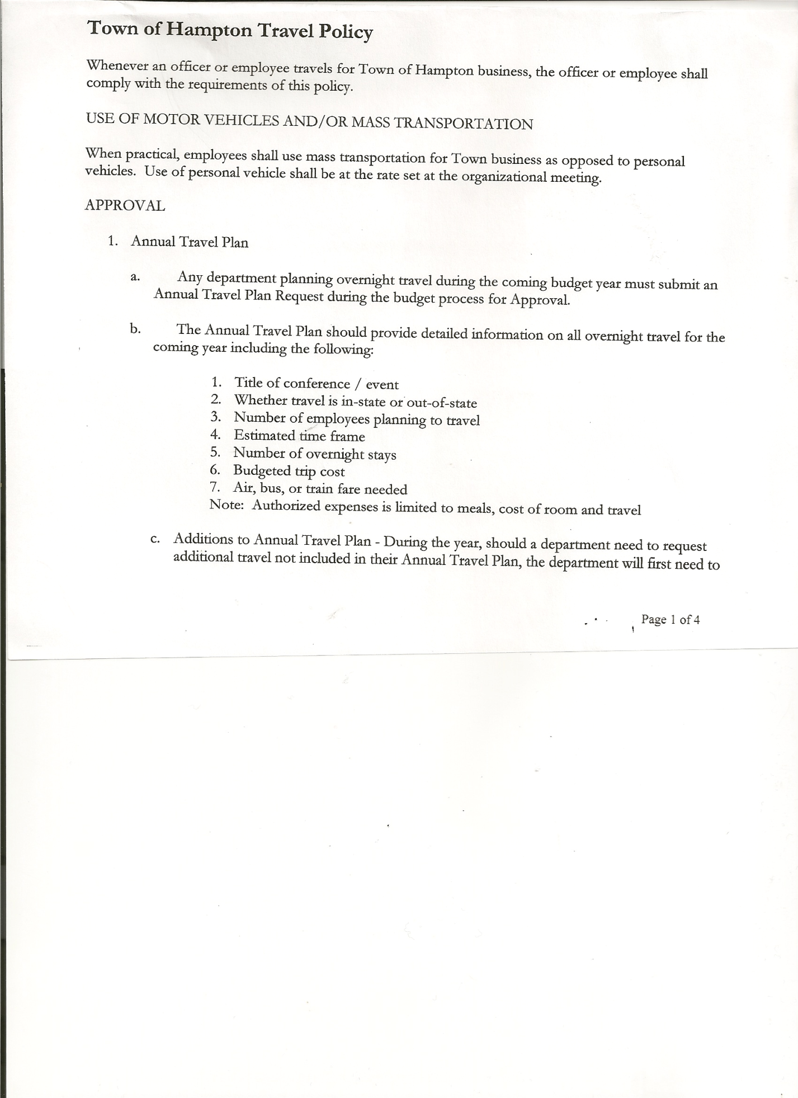
Michael Pietryka------------Councilman
Andrea Kugler---------------Councilwoman
Rebecca Jones---------------Town Clerk
Camilla Shaw----------------Deputy Town Clerk
Tyler McClure---------------Highway Superintendent

Planning Board Member (s):… Bonnie Hawley, Chair; Matthew Pratt and Rene Rountree
Others present at the Town Hall: see attached sheet

The Regular Meeting was called to order by Supervisor O’Brien at 7:30pm, followed by the Pledge of Allegiance. Location of Fire Exits were given. Quorum of board members present.

Supervisor O’Brien asked for a moment of silence in memory of Gary Heimerle.

RESOLUTION NO. 60-2023
APPROVAL OF THE MINUTES
On a motion of Councilman Sady, seconded by Councilwoman Kugler, the following resolution was ADOPTED: AYES 5 O’Brien, Sady, Taran, Pietryka, Kugler
NAYS 0
RESOLVED, that the Regular Town Board Meeting Minutes for June 15, 2023 are approved.

Supervisor O’Brien introduced County Clerk Stephanie Cronin (formerly known as Stephanie Lemery). Stephanie is running for re-election, and she wanted to attend a Town Board Meeting and let the Town Board and citizens in attendance know what she does in the County Clerk’s Office. Stephanie has been the County Clerk for 8 years, has been in the County Clerk’s Office for 18 years. Attached is a copy of Stephanie’s duties as County Clerk and her accomplishments thus far. In regard to the Shared Services LGRMIF grants, she is applying for a third one to continue digitizing vital records, hoping that Hampton will be included in this one for 2024.

Dog Control Officer, not present no report given.

Tax Collector Report…..no activity. The Town Clerk/Collector had Board Members review and sign bank reconciliation statements for the Tax Collector Account June 30, 2023.

Bonnie Hawley, Chair Planning Board…copy of the minutes of their meeting held July 12, 2023 are attached. Bonnie has spoken with two people interested in purchasing the old Flubberbusters building on State Route 4. She has reviewed the Site Plan Law with them, they need to obtain Building Permits, Health Department Inspection and Licenses from the State Liquor Authority.

TOWN BOARD MEETING
JULY 20, 2023 PAGE 2

Tyler McClure, Highway Superintendent submitted his report, copy of which, is attached.
Lake owners (Hills Pond Association) would like to do some roadside clean up, would like some vests, gloves and grabbers. Tyler will coordinate on getting some supplies for them.

Following a discussion of where to spend Highway Funds received, the following resolution was introduced:
RESOLUTION NO. 61-2023
AGREEMENT TO SPEND TOWN HIGHWAY FUNDS
On a motion of Councilwoman Taran, seconded by Councilman Sady, the following resolution was ADOPTED:
By Roll Call Vote: Supervisor O’Brien AYE
Councilman Sady AYE
Councilwoman Taran AYE
Councilman Pietryka AYE
Councilwoman Kugler AYE
RESOLVED, to accept the Agreement to Spend Town Highway Funds as submitted by the Highway Superintendent.

SUPERVISOR’S REPORT/COUNTY UPDATES/COMMUNICATIONS

RESOLUTION NO. 62-2023
APPROVAL OF SUPERVISOR’S MONTHLY REPORT
On a motion of Councilman Sady, seconded by Councilwoman Taran, the following resolution was ADOPTED: AYES 5 O’Brien, Sady, Taran, Pietryka, Kugler
NAYS 0
RESOLVED that, the Supervisor’s Monthly report be accepted as submitted for JUNE
05/31/23 06/30/23
ACCOUNT BALANCE RECEIPTS DISBURSEMENTS BALANCE
General Fund $ 77,019.00 $ 198.35 $ 5,820.51 $ 71,396.84
Highway Fund $244,171.72 $ 5.93 $ 24,387.20 $ 219,790.45
Equipment Reserve$149,972.82 $ 3.70 $ 0.00 $ 149,976.52
Fire #1 $ 46,371.00 $ 0.00 $ 23,185.50 $ 23,185.50
Fire #2 $ 15,361.00 $ 0.00 $ 7,680.50 $ 7,680.50
Cemetery $ 1,770.81 $ 251.57 $ 0.00 $ 2,022.38
Totals $534,666.35 $ 459.55 $ 61,073.71 $ 474,052.19
All Board Members present signed Supervisor’s Report.

OLD BUSINESS
Closure of Staso Road…Attached is a signed copy of the “Application For The Discontinuance of a Highway”, by Tyler McClure, Superintendent of Highways.
RESOLUTION NO. 63-2023
SHORT ENVIRONMENTAL ASSESSMENT FORM-
STASO ROAD DISCONTINUANCE
On a motion of Councilwoman Taran, seconded by Councilman Sady, the following resolution was ADOPTED: AYES 5 O’Brien, Sady, Taran, Pietryka, Kugler
NAYS 0
RESOLVED, that the Short Environmental Assessment Form is complete and to adopt a negative declaration and finding that there will be no adverse environmental impacts.

TOWN BOARD MEETING
JULY 20, 2023 PAGE 3

RESOLUTION NO. 64-2023

MOTION BY: Councilwoman Tamme Taran
SECONDED BY Councilman Donald Sady

TITLE: RESOLUTION APPROVING THE DISCONTINUANCE OF A
HIGHWAY IN ACCORDANCE WITH HIGHWAY LAW SECTION 171

WHEREAS, pursuant to Highway Law Section 171, the Town Superintendent of Highways (the “Superintendent”) has determined that public necessity requires the discontinuance of a portion of an existing highway; and

WHEREAS, that certain portion of the highway titled Staso Road, a highway by use, extending approximately six hundred ninety (690) feet from the intersection with Ballard Road to County Route 18; and

WHEREAS, said portion of Staso Road is not necessary of highway purposes as safer alternate routes along County Route 18, Ballard Road and the remaining portion of Staso Road exist, plus all adjoining parcels will retain sufficient road frontage and access along existing public highways; and

WHEREAS, the proposed alteration is an action under the New York State Environmental Quality Review Act (SEQRA); the proposed action is an unlisted action under SEQRA, and the Superintendent having previously declared itself to be lead agency for SEQRA review of the action will evaluate the potential environmental impacts of the action in accordance with SEQRA prior to taking final action the alteration.

NOW, THEREFORE BE IT RESOLVED THAT:

Section 1. The application for the discontinuance of that certain portion of Staso Road
as proposed is to be included in the minutes herewith.

Section 2. Upon due consideration, the Town Board hereby grants permission to the
Superintendent to proceed with the procedures required under Section 171
of the Highway Law of the State of New York for the discontinuance of a
highway.

Section 3. This resolution shall take effect immediately.

DATED: July 20, 2023 Supervisor O’Brien AYE
Councilman Sady AYE
Councilwoman Taran AYE
Councilman Pietryka AYE
Councilwoman Kugler AYE

TOWN BOARD MEETING
JULY 20, 2023 PAGE 4

PUBLIC COMMENTS/COUNCIL COMMENTS
Nan Stolzenburg will review the Site Plan and Subdivision Laws to see if Ag friendly.

Matthew Pratt advised the Town Board that the Fire Company reports and budget would be to them next month.

John Norton a WWII Vet of Granville, very well known to the area passed away at 99 ½ years young.
RESOLUTION NO. 65-2023
AUDIT OF CLAIMS
On a motion of Councilman Sady, seconded by Councilwoman Kugler, the following resolution was ADOPTED: AYES 5 O’Brien, Sady, Taran, Pietryka, Kugler
NAYS 0
RESOLVED that the bills have been reviewed by the Town Board and are authorized for payment in the following amounts.
General Fund No.84 through No. 92 $ 4,633.24
Highway Fund No.74 through No. 85 $ 8,859.15
Total both funds $ 13,492.39

The Town Clerk’s report for June 2023 was submitted to the Board. The Town Clerk had Board Members review and sign bank reconciliation statements for the Town Clerk Account and Special Clerk Account dated June 30th, 2023.

RESOLUTION NO. 66-2023
MEETING ADJOURNED
On a motion of Councilwoman Kugler, seconded by Councilman Sady, the following resolution was ADOPTED: AYES 5 O’Brien, Sady, Taran, Pietryka, Kugler
NAYS 0
RESOLVED that the meeting adjourned at 8:54pm.

Respectfully submitted,

Rebecca S. Jones, RMC
Town Clerk

