Data transfer procedure

- Open FZ system, if see update request then close it.
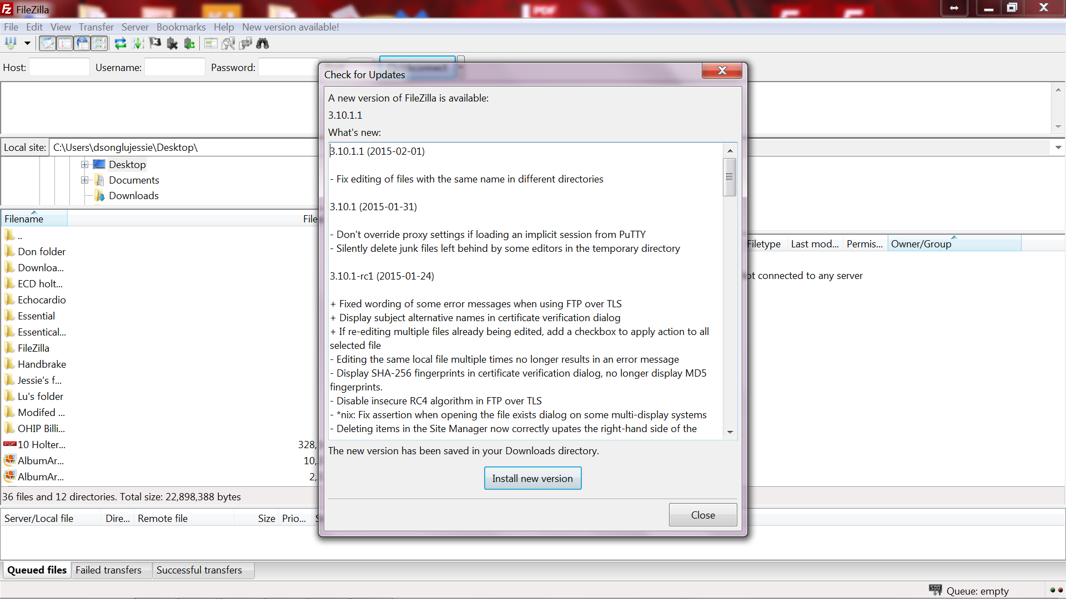

- Click the triangle besides “quickconnect” and select “eric@---“ to connect with remote site.
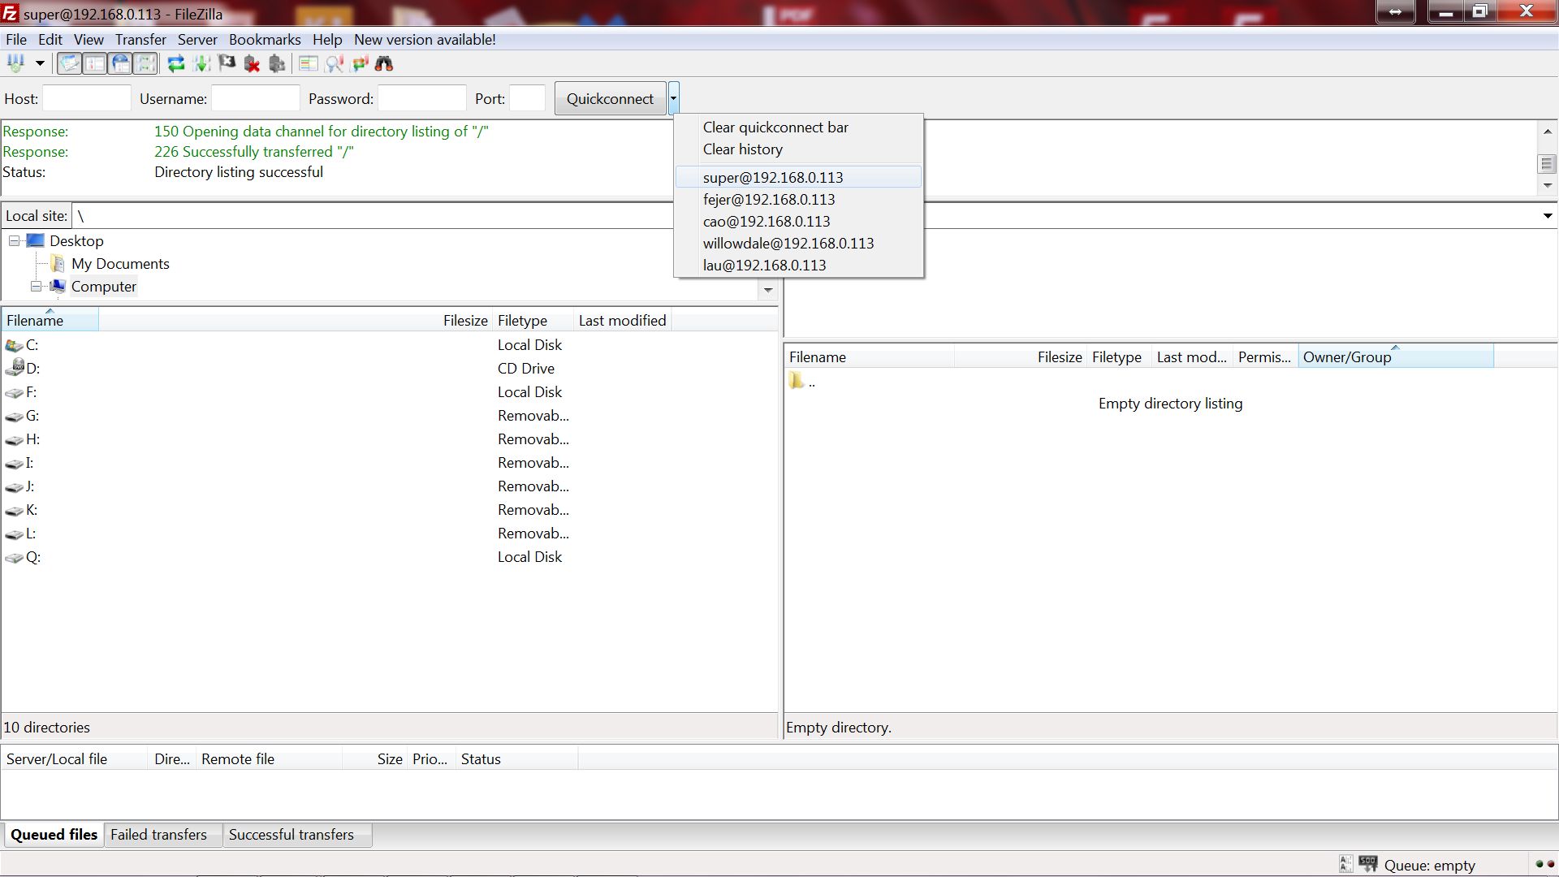

- On the right remote site: open the patient’s folder;
One the left local site: right click and select refresh the screen and open the disk with (5AF1..)

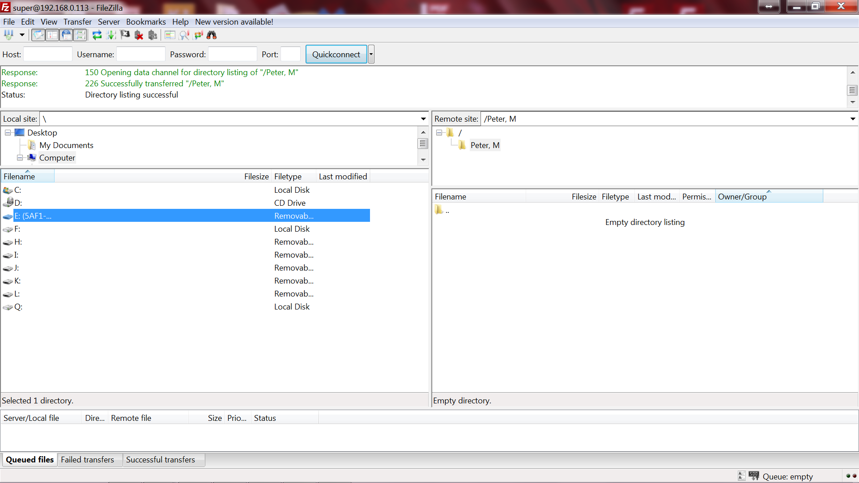

- Highlight each data( left site) and drag them to the patient’s file ( right remote site)
