3202 E. Greenway
602-485-1000
OPEN 24 HOURS / 7 DAYS A WEEK
GO TO WEBSITE @
WWW.COUNTRYBOYSRESTAURANT.COM
CLICK FACEBOOK OR TWEET BUTTON FOR SPECIAL COUPONS AND OFFERS
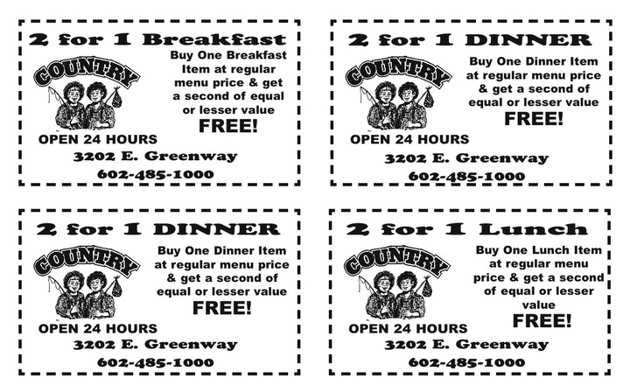
with a purchase of a drink
with a purchase of a drink
with a purchase of a drink
with a purchase of a drink

