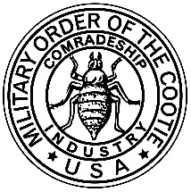
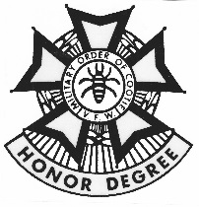
GRAND PUP TENT
Fertile Hunting Grounds of New Mexico

MILITARY ORDER OF THE COOTIE
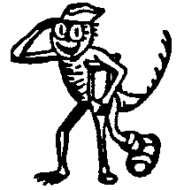
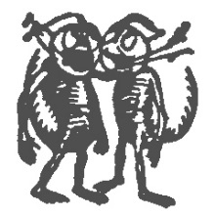
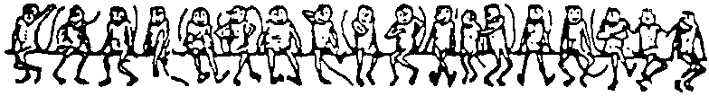
Of the United States
“The Honor Degree of the Veterans of Foreign Wars”

General Order Number 6 (2020-2021 Series) December 1,2020

- There will be a Zoom meeting on December 8, 2020 at 1800 open to all MOC/MOCA members in the Grand of New Mexico. This is not an official scratch. It is an informational meeting to make sure all Cooties and Auxiliary Cooties in New Mexico understand what is going on this year. Dress code is casual.

- Cootie of the Year will be by submission this year. If you know of a Cootie that has done above and beyond the required work, please write up as much information about them and why you feel they should be Cootie of the Year. Turn submission into Gordon Lam by March 31, 2021.

- Grand of New Mexico now has a new bank account up and running. All Pup Tents need to submit all transmittals as soon as possible to Gordon Lam from here on out.

- Mid-Winter in person Scratch has been cancelled. We will hold it virtually. Zoom invites will be sent out later this month. The Governor has ordered all non-profits to not hold in person meetings until after March 2021.

- All obligations for money have been sent out to the Pup Tents. Please submit your obligations as soon as you can. This will get you in good shape at the early part of the year.

- All Pup Tent Inspections will be done virtually. We will make this work. Please Seam Squirrels contact Inspector Eloy Howard about scheduling the inspection. Since it is virtual, I would like to see it done before Dec 31, 2020.

- The VFW Department is up on vfwnm.org. Please check it out. Also even though there is no in person Mid-Winter, please submit bios for the Mid-Winter booklet if you plan on running for a position at Convention.

- Please submit your reports if you sent a card to any veteran in the hospital or visited the hospital. I know this year has been hard to do our normal things, but please do report everything you do.

- If you have any questions, concerns, or ideas to make the Grand of New Mexico more successful, please bring them up. You can either contact myself at madecker19020@yahoo.com or 505-947-5179 or Gordon Lam at nmcootie@gmail.com

Yours in L.O.T.C.S.

Mark Decker
Grand Commander
Grand of New Mexico

