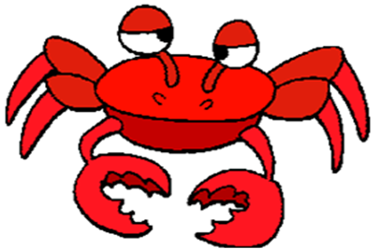
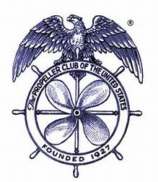
TACOMA PROPELLER CLUB
ANNUAL CRAB FEED
SATURDAY, FEBRUARY 12, 2022
FOSS WATERWAY SEAPORT
705 DOCK STREET
6:00 – 10:00 PM

SPONSORSHIP LEVELS AND VALUES

DUNGENESS - $800
Wine Toss Sponsor
8 Event tickets & 8 Drink tickets
2 Reserved parking spots
2 Bottles of wine (1 each red & white) on table
Signage
Recognition at event

KING - $500
Parking Lot Sponsor
4 Event tickets & 8 Drink tickets
Signage
Recognition at event

SNOW - $300
Dessert Dash Sponsor
2 Event tickets & 4 Drink tickets
Signage
Recognition at event

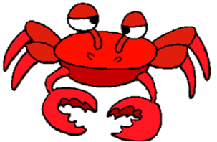
***EVENT*** - $3000
Reserved Table
8 Event tickets & 16 Drink tickets
4 Reserved parking spots
4 Bottles of wine (2 each red & white) on table
BANNER
Signage
Recognition at event
RAFFLE TICKETS

