Pleasant Township Board of Trustees Meeting Highlights
Date __June 27, 2023 Next Resolution No._ _36-----06-27-2023_ _

- Call to Order -- The meeting tonight will also be on WebEx.
- Please stand for moment of silence. --Pledge of Allegiance-----Roll Call
- Minutes to approve- Last meeting we received minutes from March 14, 2023. Are there any corrections, deletions, or additions to minutes, if there are no corrections, deletions or additions, the minutes stand approved.
- Financial Reports – Motion to pay expenditures.
- Visitors –
- Hanna Poling with the Southwest Messenger via WebEx.
- Department Reports
- Franklin County Sheriff’s Report- Sgt. Holt
  - Working on having the speed trailer in areas one being Beatty Rd, They have ordered a second one.
- Road Department- Robert Bausch
- Timberlake grant process-Resolution 36 authorizing Franklin County Engineers Office to prepare and submit an application to participate in the Ohio Public Works Commission State Capital Improvement and/or Local Transportation Improvement Program(s) and to execute contracts as required. Also authorizing Fiscal Officer, Paula Wilkins to work with Franklin County Engineers Office for the finance part of the project. Also as part of this project we must hold a meeting with residents. Robert would like to have this meeting during the next regular meeting which will be July 11, 2023, trustees agreed. Robert will put a notice together and get it out to people.
- Denton rd. railroad crossing-PUCO is sending an inspector out.
- Road and cemetery mowing
- Fire Dept. – Fire Chief, David Whiting
- Do we have the payroll problem taken care of?
- Training
  - Disaster Drill with Metro parks for Pleasant, Prairie, West Jeff and Metro Parks
- Apparatus
  - M-231 still at Brawn.
  - E-2 is in the shop for repairs.
- Staffing
  - Putting out a hiring notice for parttime
- Payroll
  - One issue
- Insurance issue

- Old Business-
  - Zoning Updates
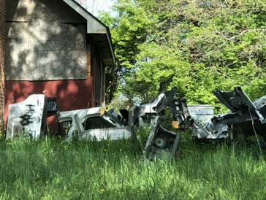
    - Kelsey Shires, Zoning Enforcement reports the owners of the party venue on Georgesville-Wrightsville were ordered to cease immediately, which they did. In the meantime, they are trying to figure out their options if any.
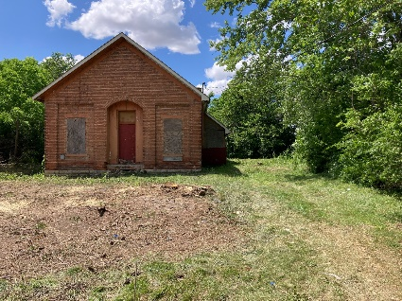
    - David Smith, Zoning Enforcement reports 3351 Georgesville-Wrightsville has been resolved and case closed.

currently
May 2023

- New Business –
  - Email for County Commissioner about renewing the following. Any reason to opt out of the Three-Year Cooperation Agreements for Participation in the Franklin County Department of Housing & Urban Development (HUD) Program? We are already part of it and we do nothing to continue. Communities that choose to remain with the county are ineligible to apply for grants under the State CDBG program while it is part of the urban county program, does this present a problem? No problems, we will stay in the program.
- Clerk Updates- Paula
- Miscellaneous correspondence
- Budget due 7-20-23
- Speaker Sheets-none
- Adjourn- 7:20 p.m.

