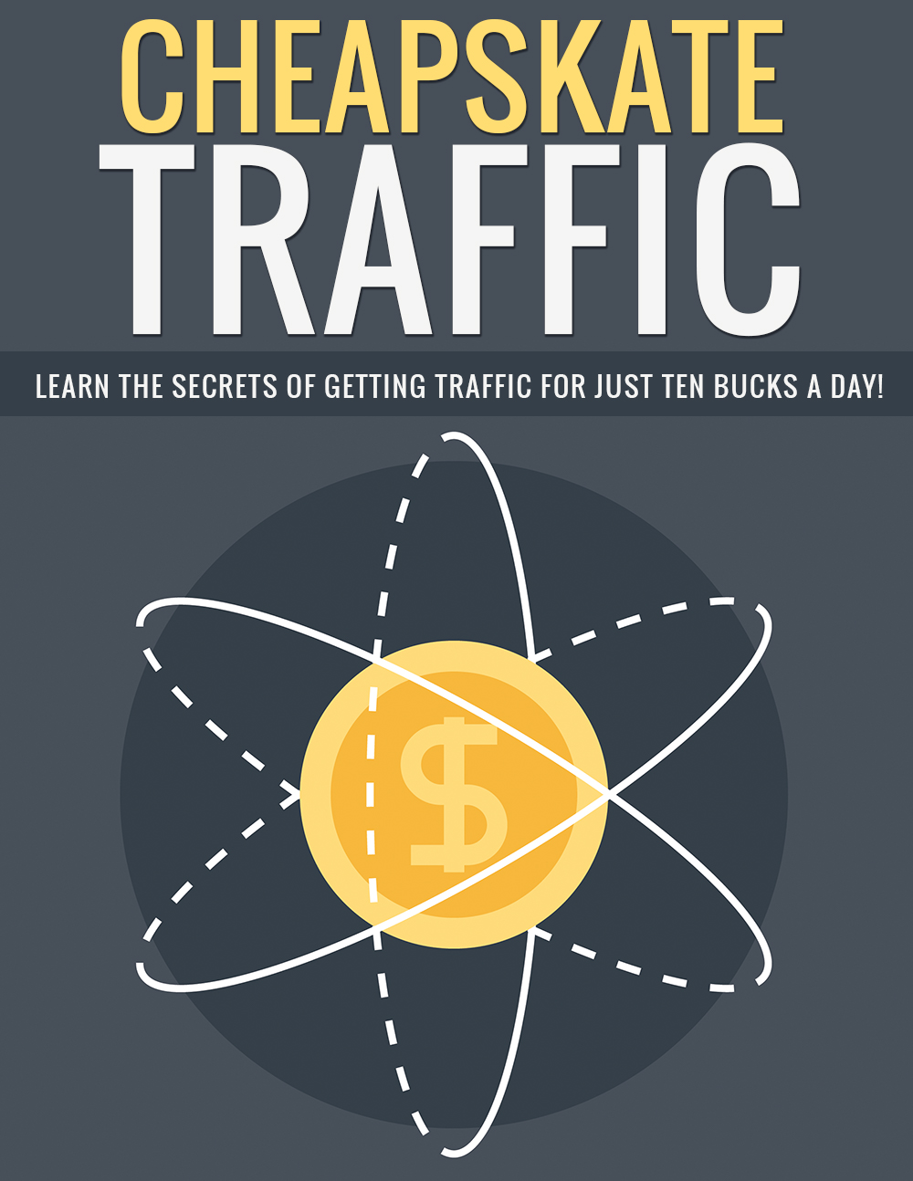

Legal

No part of this publication may be, including but not limited to, reproduced, in any form or medium, stored in a data retrieval system or transmitted by or through any means, without prior written permission from the publisher. The information contained herein has been obtained from sources believed to be reliable at the time of publication. The opinions expressed herein are subject to change without notice.
The publisher disclaims all warranties as to the accuracy, completeness, or adequacy of such information. The publisher assumes no liability for errors, omissions, or inadequacies in the information contained herein or from the interpretations thereof. The publisher specifically disclaims any liability from the use or application of the information contained herein or from the interpretations thereof.

Table of Contents

Legal 2
Table of Contents 3
Introduction 5
Three Types of Traffic 6
Strangers 6
Friends 6
Fans 6
Advertising to Strangers 8
Setting Up a Stranger Ad 9
Advertising to Friends 13
Advertising to Fans 15
Conclusion 17
Resources 18

Introduction

Everyone knows that paid traffic is the easiest, most reliable traffic. Other sources take a lot of time or effort, and many people eventually give up entirely because they don’t see results for weeks or months.

For example, using only free methods, it may take months or even years to build enough authority on a new blog to rank well in Google.

Or it might take weeks or months to build a decent following on Pinterest, Twitter, Instagram, or Facebook without spending money. Plus, it takes a lot of time to do so.

Fortunately, paid traffic doesn’t have to cost a fortune. In this guide, you’re going to learn how to use inexpensive Facebook ads to drive traffic to your offers and build your list with as little as $10 per day spent.

Where else can you begin building a real foundation for a business with only ten bucks a day?

Just ten dollars a day, which many of us spend on coffee and lunch, anyway, can help you build a platform you can use to market products for a very long time!

Let’s begin.

Three Types of Traffic

There are three main types of traffic we’re going to discuss for the purposes of this guide:

- Strangers
- Friends
- Fans

Strangers

Strangers are people you’ve never met, and who have no idea who you are or what you do. These people are not likely to buy anything from you, so marketing paid offers to them is typically a waste of your money.

Friends

Friends are people who you’ve met, and they have gotten to know you a little bit, but they aren’t yet ready to trust you fully. You can market low price offers to them, or get them onto your email list, but it’s still a waste of money to use paid advertising to sell high-dollar products to them.

Fans

Fans are people who know you and your products very well. They like you. They trust you. They’re willing to buy products you promote, even at higher prices. They may even be willing to promote your content for you by sharing it on Facebook and other platforms.

It’s important to know these three traffic types, because the methods you use and the budgets you set will be based on the type of traffic you’re targeting.

Before you get started, you might want to use the Power Editor, which only works in Chrome. (If you don’t have Chrome, download it. It’s available for all major operating systems, and it’s free.)

You can find the Power Editor here:

https://www.facebook.com/ads/manage/powereditor

You certainly don’t have to use Power Editor, but it will allow you to have a lot more words in your Facebook ads than if you use the standard ad creation tool in Facebook.

These two tools are VERY similar in terms of how they’re used, so I’ll be giving instructions for the regular editor. Remember, they’re very similar except for the fact that you can add more text to your ad with the Power Editor.

Advertising to Strangers
Budget: $6 Per Day

Strangers are people who have never heard of you, or might have heard of you but don’t remember you at all. These people aren’t likely to buy anything from you, and might not even be willing to join your email list.

Because strangers aren’t likely to take action, it’s best to provide them with significant value in order to gain some trust. If you give them good content for free, they will start to trust you a bit.

For this reason, you should never use paid traffic to advertise paid products to strangers. They’re not likely to buy anything, and you’ll just end up spending money with little to no return on your investment.

In fact, this is the biggest reason people quickly give up on paid traffic. They target cold leads—people who have never heard of them—and try to sell them products right off the bat.

Paid traffic can certainly work if you use it correctly, which means warming up cold leads in order to turn them into buyers—eventually. Not right away. They’re not likely to buy anything from you for a while, but this is a long-term game, not a get-rich-quick scheme. You want to build a real business, not just make a few bucks, right?

So… if strangers aren’t going to buy anything from you, what are they good for? Well, for the same reason everyone you know now was a stranger at one point. Even your parents were strangers until you grew to know them while you were growing up.

Strangers are just friends you haven’t met, yet. That’s as true in marketing as it is in the rest of life. If you treat a stranger right, that person can turn into a friend. Later, they may even become a very good friend. The same thing is true in marketing. If you treat someone right, and you provide them with enough reasons to trust you, they’ll begin to trust you.

Setting Up a Stranger Ad

The first thing you’ll want to do is log into your Facebook account and visit the ad creation manager. For stranger targeting, you’ll want to select “Send people to your website”.

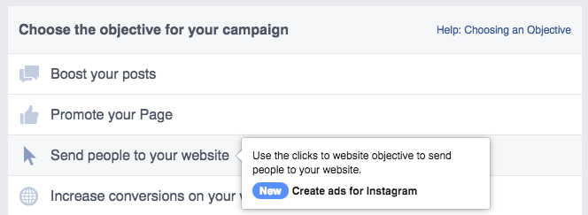

Next, enter the URL you want to send traffic to. This could be your blog, a squeeze page, etc.

When you’ve entered your URL, it will tell you that you can set up a pixel for tracking. Be sure you do this! This will be absolutely vital when you move onto marketing to friends and fans later! (Just follow the instructions Facebook gives you for setting up your tracking pixel.)

On the next page, you’ll set your budget. When targeting strangers with interests, you’ll set your budget at $6 per day.

Next, you’ll need to enter your targeting information. You won’t be able to set up a custom audience until you have an audience to use, so for now you’ll just be targeting by interest.

When you’re targeting strangers, the only way to do so on Facebook is via interest targeting. You’ll need to target based on specific interests people add to their Facebook profile.

Let’s say you want to build a list of people who want to lose weight. You could target interests such as:

- Weight Watchers
- Atkins Diet
- Overeaters Anonymous

It can be tricky to find the right interests to target, but you’ll want to spend some time on this, because it’s one of the most important elements of this method.

You’ll want to target a fairly specific audience, but not so much so that you don’t get much traffic. Your market should have a potential reach of approximately 500,000 to 1,000,000 people.

The best way to ensure you’re targeting the right interests is to make sure you’re targeting interests that prove people are truly interested in a particular market. For example, a lot of people might put the “cooking” interest on their Facebook page, but not all of those people would have a strong interest in it. Many of those people might just be casual hobbyists.

But let’s say you’re targeting chefs. The “cooking” interest is too broad. Instead, you’d want to target things that would mostly (or only) be of interest to chefs. For example, you could target some of the high-end knife brands that appeal to chefs, or you could target some of the most popular culinary schools.

In the bid amount section, you can either allow Facebook to set the price you pay, which could lead to nasty surprises if your ad doesn’t perform well. Instead, you can set the bid amount to “Manual”, and enter the price you’d like to pay. (About 5-6 cents over the suggestion is ideal.)

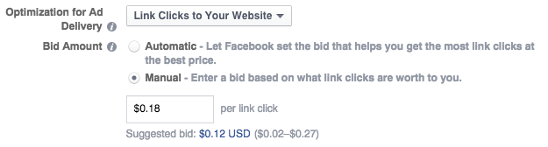

As you can see in the previous image, the suggested bid was $0.12, and I’ve written in $0.18.

Note: If you don’t see custom bidding options, there’s a section you can expand at the bottom of the ad creation page that says “Show Advanced Options.” Expand this, and you’ll see the new options.

Finally, you need to go to the next section to create your ad. You’ll need to include an eye-catching image (which must be less than 20% text to meet Facebook’s latest standards) and some text. You won’t be able to include a lot of text unless you user the Power Editor, so it’s suggested you do. The more text you use, the more you can say, and the more attention you can attract.

To review, check out the details for stranger campaigns below.

Stranger Campaign Details:

- Budget: $6 per day
- Facebook Ad Objective: Website Clicks
- Bidding Type: Clicks (bid 6 cents higher than suggested bid)
- Target: Interests (until you have 500k to 1,000,000 audience)

Advertising to Friends
Budget: $3 Per Day

Friends are people who know who you are, and may have joined your email list or liked your page on Facebook, but they don’t yet have enough trust in you to buy something expensive.

The process for setting up an ad for advertising to friends is similar to setting up a campaign to advertise to strangers, but you’ll want to set the budget to $3 per day instead of $6, and you can set your ad objective to either website clicks (as you did for strangers) or website conversion (which is like paying for leads instead of just clicks).

Instead of paying a specific amount for clicks, it’s a good idea to set the price to “best conversions at the best price” to be sure you get the most out of this type of campaign.

You can target interests just like you did for strangers, or you can use a custom audience by targeting the people who have visited your website (which requires you to have set up the tracking pixel as mentioned in the previous section) or a lookalike audience based on your Facebook fan page if you have one.

Otherwise, you’ll set up the ad the same way you did when you targeted strangers. In this case, you’ll probably want to send traffic to a squeeze page, and your ad can reference your lead magnet.

Friend Campaign Details:

- Budget: $3 per day
- Facebook Ad Objective: Website Conversion or Website Clicks
- Bidding Type: Best conversions at the best price
- Target: Interests (until you have 500k to 1,000,000 audience) or Custom Audiences

Advertising to Fans
Budget: $1 Per Day

Fans are people who know who you are and trust you. These people have probably bought something from you already, potentially several times. They may even share your content occasionally.

If you set up the targeting pixel properly, you can easily target those people by using your targeting pixel to create a custom audience.

For targeting fans, you’ll only set a budget of $1 per day. These will be website clicks, and you’ll pay about 6 cents higher than the suggested bid, just like you did for the stranger campaign.

This is your chance to get sales. Whereas you were mostly just introducing yourself and maybe getting newsletter signups with your stranger or friend campaigns, you can target products with a fan campaign. This could be a product of your own, or an affiliate product.

Remember, these people know you and trust you, so it’s time to bring out the big guns and advertise something that has a higher sales price and gets you a better commission!

Fan Campaign Details:

- Budget: $1 per day
- Facebook Ad Objective: Website Clicks
- Bidding Type: Clicks (bid 6 cents higher than suggested bid)
- Target: Custom Audiences

Conclusion

You’ve probably spent a great deal of time thinking you couldn’t afford paid traffic, or that it was too expensive to even try. You may have thought it wouldn’t convert well enough to be worth the investment. (And if you wanted to promote the wrong thing to the wrong audience, you may have been right!)

Fortunately, ten bucks a day can get you plenty of paid traffic you can then use to market multiple products to for a long time in the future. You can use it to build your platform, build your list, and make sales, but you have to keep the three types of traffic in mind.

Remember this:

- Strangers aren’t likely to buy, so you only want to introduce yourself to them and let them know a little about you.
- Friends may buy cheaper products, but it’s best to just get them on your list and provide them with value.
- Fans are those who have seen your value and are much more likely to buy more expensive products and help promote you.

If you keep these three types of traffic in mind and market to each one correctly, you’ll build traffic very affordably!

Good luck!

Resources

Here are quick links to the resources mentioned in the guide:

Facebook Power Editor:

https://www.facebook.com/ads/manage/powereditor

