Eco Orca APRIL 2024 Spring and Plants
SUNDAY |  |  | MONDAY | TUESDAY | WEDNESDAY | THURSDAY | FRIDAY | SATURDAY
 |  | 31 | 1 | 2 | 3 | 4 | 5 | 6
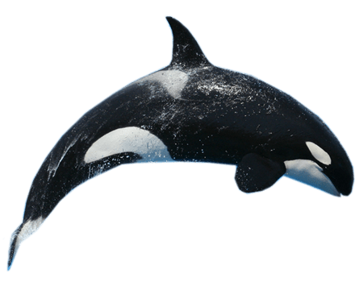 |  |  | Closed  Easter Monday | Pro-Day | Beaver Lake Trail | Bug Zoo  $8 | Sooke Pothole’s
 | 7 |  | 8 | 9 | 10 | 11 | 12 | 13
 |  |  | Taylor Beach  Sheep | Sooke Farm  3$ | C.Saanich Park Farms | Charlie’s  Trail | Ed McGregor Docks Sooke
 | 14 |  | 15 | 16 | 17 | 18 | 19 | 20
 |  |  | Rainbow  Park | Island View Beach | Compost Centre  $5 | Class Time  9-11am  Early Dismissal Day | Pro-Day | 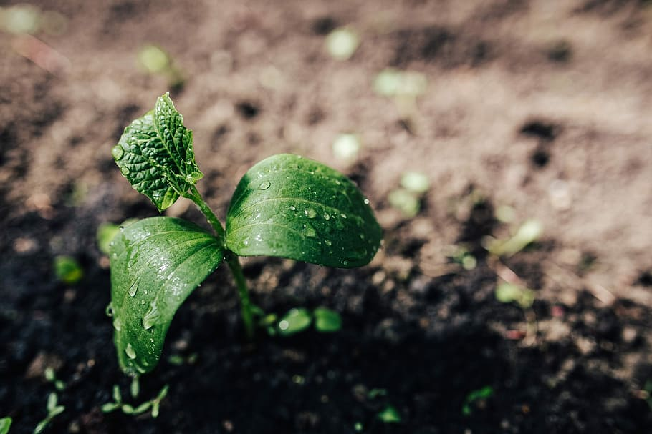
 | 21 |  | 22 | 23 | 24 | 25 | 26 | 27
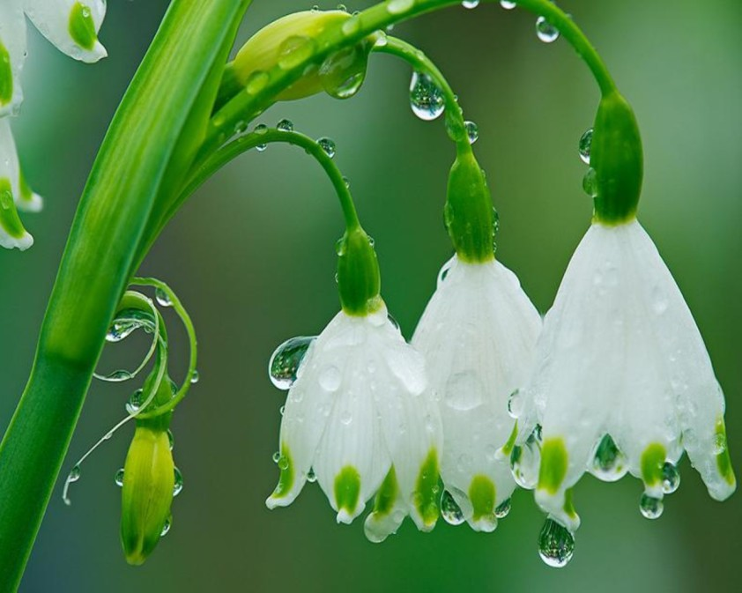  This Photo by Unknown Author is licensed under CC BY-NC-ND |  |  | Mill Hill  Trail | Humpback Watershed | Humpback Park | Colwood Creek Park | Royal Bay Park
 | 28 |  | 29 | 30 | 1 | 2 | 3 | 4
 |  |  | Goldstream Nature House | Gorge Japanese Gardens |  | 