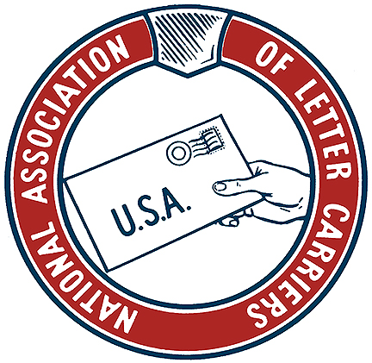
CCA
Rap Session
Wednesday,
February 12, 2020
7PM
At: Branch 1477
5369 park Blvd. Pinellas park, Florida, 33781

Agenda:
Understanding work methods,
Navigating conflicting instructions,
rights and responsibilities

Eats & Drinks Provided
PLEASE POST ON NALC Bulletin BOARDS

