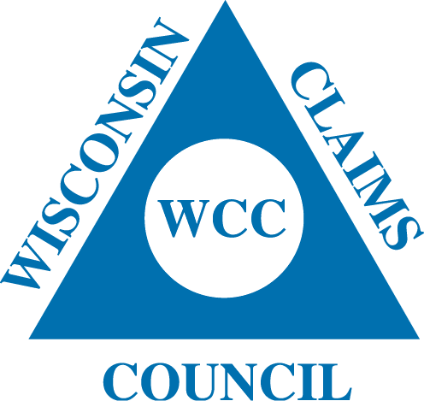
President
Jim Sutter
Society Insurance

Vice President
Axel Rathke
Acuity

Treasurer
Scott Wittliff
Acuity

Secretary
Susan McClone
Society Insurance

Stacie Grafton
Society Insurance

Michelle Harker
West Bend Mutual

Leslie Gladwell
SECURA

Executive Committee:

Jamie Loiacono-Acuity

WISCONSIN CLAIMS COUNCIL
PRESENTS
LIABILITY SEMINAR
THURSDAY, MAY 23, 2024

SECURA
1500 Mutual Way
Neenah, WI 54956

Sponsored by:
Envista Forensics
Hausch and Company

8:00 – 8:30 Registration

8:30 – 9:15 Case Law Update
Attorney Eugene LaFlamme
McCoy, Leavitt, Laskey
Waukesha, WI

9:15 - 10:15 Cyber Liability
Attorney Brian E. Middlebrook
GRSMO Gordon, Rees, Scully, Mansukhani
New York, NY
*TX and FL Adjuster CE offered* (1 credit)

10:15 – 10:30 Break

10:30 - 11:30 Premises Liability-Slip and Fall
Vanessa Rollins
Rimkus
*TX and FL Adjuster CE offered* (1 credit)

11:30 – 12:30 New Technologies in Vehicle Data / Vehicle Accident Reconstruction
Matthew Freda
SEA
*TX and FL Adjuster CE offered* (1 credit)

12:30 – 1:00 LUNCH (Included)

President
Jim Sutter
Society Insurance

Vice President
Axel Rathke
Acuity

Treasurer
Scott Wittliff
Acuity

Secretary
Susan McClone
Society Insurance

Stacie Grafton
Society Insurance

Michelle Harker
West Bend Mutual

Leslie Gladwell
SECURA

Executive Committee:

Jamie Loiacono-Acuity

WISCONSIN CLAIMS COUNCIL REGISTRATION FORM

WISCONSIN CLAIMS COUNCIL
LIABILITY SEMINAR
Thursday, May 23, 2023

SECURA
Neenah, WI

Company Name: _____________________________________________________________

Names and email addresses of Attendees: _________________________________________

___________________________________________________________________________
(Use the back of this form if more space is needed)

Insurance/Adjusting Personnel:
Number of People Attending: ________ (X) $50.00 each = $___________Payment Enclosed

Vendor Company Personnel:
Number of People Attending: ________ (X) $75.00 each = $____________Payment Enclosed

Please Make Checks Payable to: WCC or Wisconsin Claims Council

Mail to:
Wisconsin Claims Council
C/O Susan McClone
PO Box 1029
Fond du Lac, WI 54936

Deadline for Reservations: May 7, 2024
Find us on Facebook, Twitter@WIClaimsCouncil and www.wisccc.com

