"Integrity, Competence, Service"
2017 Year in Review
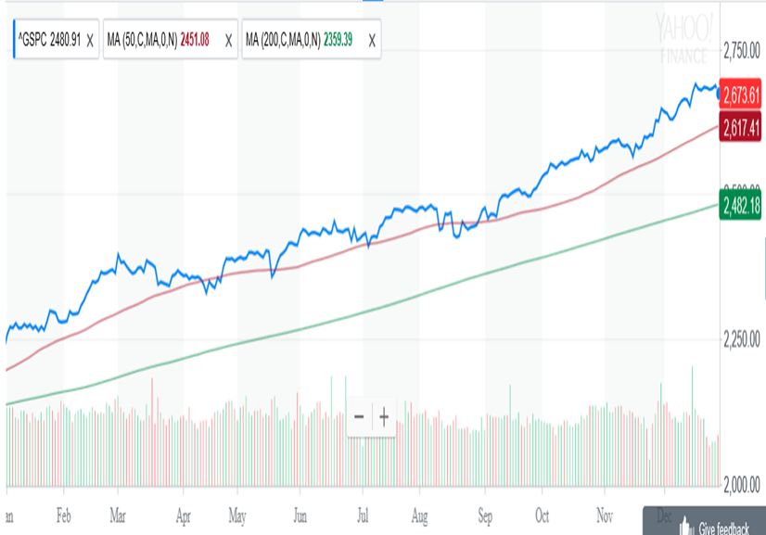
2017 was characterized by “Synchronized Global Economic Expansion”. Here in the U.S., record earnings, low interest rates and low inflation pushed the markets higher throughout the year, while expectations of tax reform drove it higher over the last half. Volatility was also low with the S&P 500 (refer to chart) having a more than one percent daily move on only eight occasions this year, while it had 48 in 2016 and 71 in 2015. This led to the S&P 500 having 62 record closes on the year and finishing out December with its first 9 month win streak since 1983. So that begs the question “What should we look forward to in 2018?” While no one can predict the future, I’d let the trend continue to be our friend. The economy will be the driving factor as we see the implications of tax reform kick in along with proposed infrastructure spending. With the S&P 500 closing the year at 2673, we’re just a little over 12 percent from that 3,000 threshold, which is not an unrealistic goal given this year’s returns.

****************************************************************************************************
2016 Year in Review
2016 started out on a horrible note with the S&P 500 suffering sharp losses through the middle of February. We then rebounded back to the 2043 level on the S&P 500, exactly where we opened the year. From a technical perspective, April brought us a major bullish “Golden Cross signal. That’s when the S&P’s 50 day moving average (red line) crosses above its 200 day moving average (green line). We continued to bounce around that 2043 level until the end of June, when we had the Brexit sell off. What was also particularly unusual was that between November 2014 and June 2016, the S&P 500 crossed the 2043 level 33 times. Talk about flat markets and trying to push a rope. We basically remained at that post Brexit level all the way thru the Friday before the November election. Since then, the markets have had a nice bullish run with all major indices making new record highs.
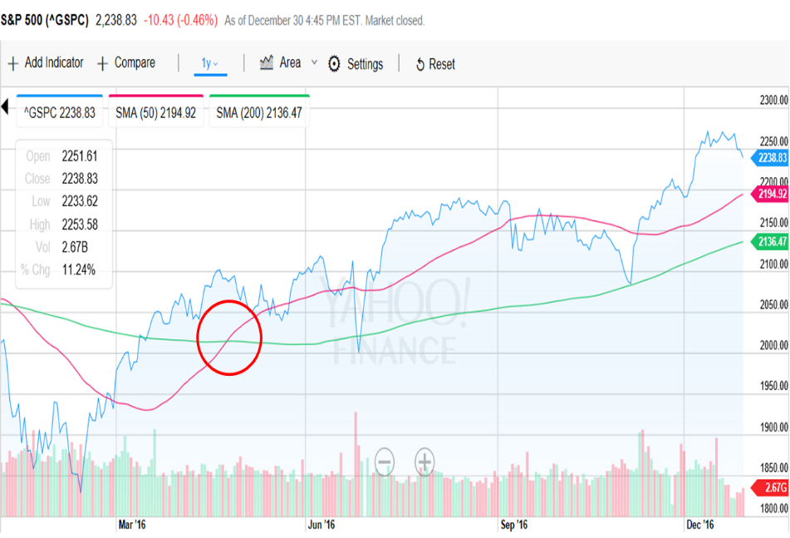
****************************************************************************************************
2015 Year in Review
Note the similarity between the 2015 and 2011 charts
As we look back at 2015, it was a frustrating year of starts and stops, with the S&P500 finishing out basically flat. In between, there was volatility especially in the August to October timeframe. As such, our strategy is optimized for trending markets in either direction. When the market was bearish in 2008, we had an annual return of over 30 percent. When the market was bullish in 2013, we also had an annual return of over 30 percent. In order to improve performance during flat years like 2015, where you have the tendency to get whipsawed, we’ve incorporated a slight adjustment in entry criteria. In the past, we would hold off on entry until the fund price was above its 50 day Moving Average (MA), which had to be above its 200 day MA. At that point we would purchase approximately 10 percent of the portfolio. After back testing, it appears it will be more beneficial to enter prior to the above criteria, but at a lower percentage. If the fund continues upward, we’ll stair step an increase in allocation up to 10 percent. If it turns downward, the allocation will be reduced. All other criteria remain the same. So what can we expect in 2016? While no one can predict the future, I’ll make a comparison to 2011 when the S&P 500 also finished flat. From 2012 thru 2014, the S&P 500 had gains of 13.4%, 29.6% and 10.7% in each of those years. It sure would be nice to see this pattern repeat and we get a trending breakout to the upside above 2100.
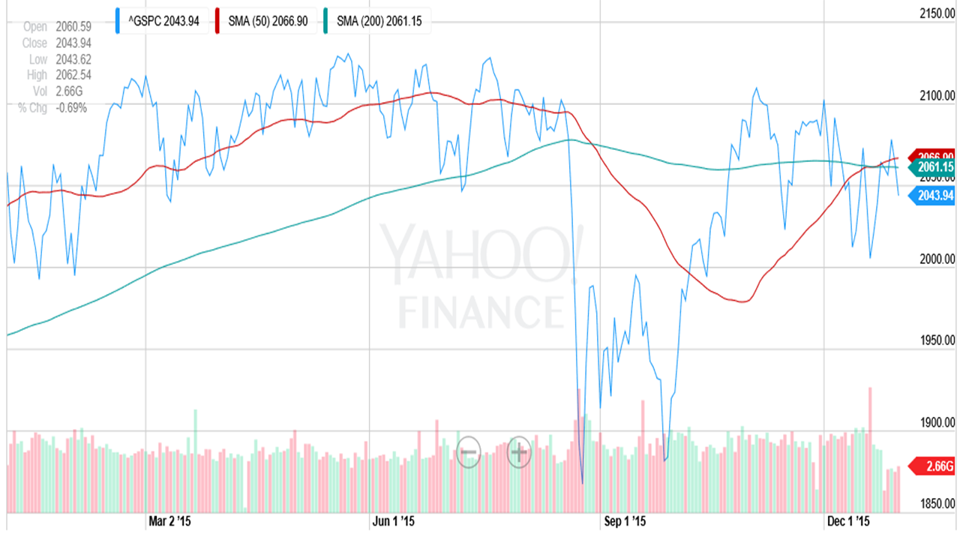
**********************************************************************************************
2014 Year in Review
On the investment side, 2014 was a good year. While overall the S&P 500 (see below chart) went up throughout the year, there were quite a few "V" shaped spikes accompanied by large and quick market moves. This happened in February, August, October (Big "V"), and mid-December. As we close out 2014 and start 2015, we’re seeing more of the same with triple digit losses and gains on the Dow. These moves can cause some concern as you are not sure if this will be a temporary down turn, or the start of something worse like the bear market of 2008. Since our investment strategy lends itself to a more cautious approach, we would decrease our exposure to stocks only to miss out on some of the gains on the upside. However, it was a positive year with ProFunds overall returns just behind the S&P 500. So what do we see looking forward to 2015? While no one can predict the future, the U.S. markets should most probably continue to lead global markets as International funds look weaker. Bonds have been a pleasant surprise, but if interest rates should increase, that will put them under pressure.
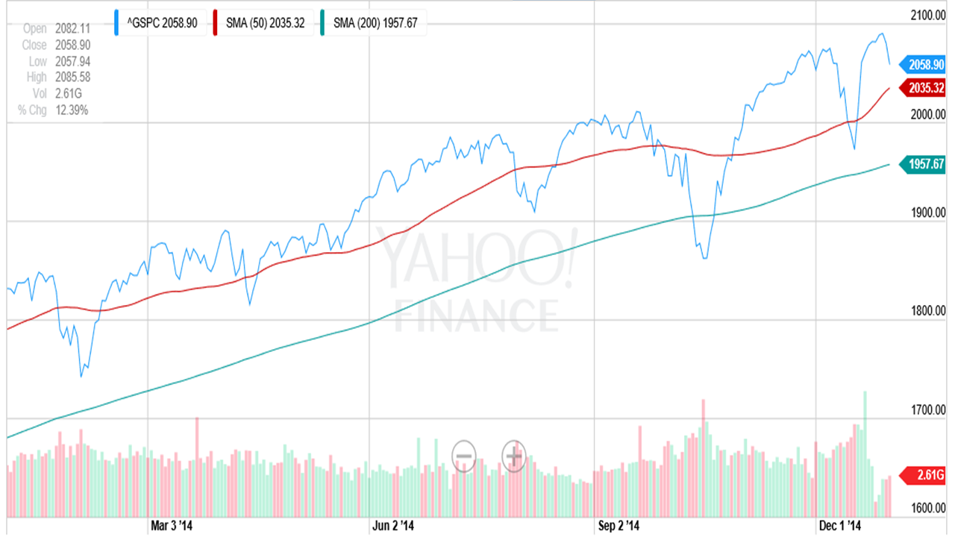
**********************************************************************************************
2013 Year in Review
Looking back, I’ll remember 2013 as the year driven again by domestic politics. Although I’ve worked in the Department of Defense for the last 41 years, I’ve never experienced a government shutdown that directly affected me. Sequestration now had new meaning, but it appears as if the recent budget deal might negate most of this in the future. Also, let’s not forget the uncertainty Edward Snowden and Obamacare threw into the situation. However, the one bright spot that we did have, which contributed to the markets performance was the Fed and their easy money “taper” policy. The impacts of this could be seen directly in the markets, the most recent being a 270 point gain in the Dow during Fed Chairman Ben Bernanke’s last press conference. This translated into positive stock market gains, with the Dow and S&P 500 hitting historic highs as we closed out the year. On the investment side, you can see how the S&P 500 performed in the last two years.
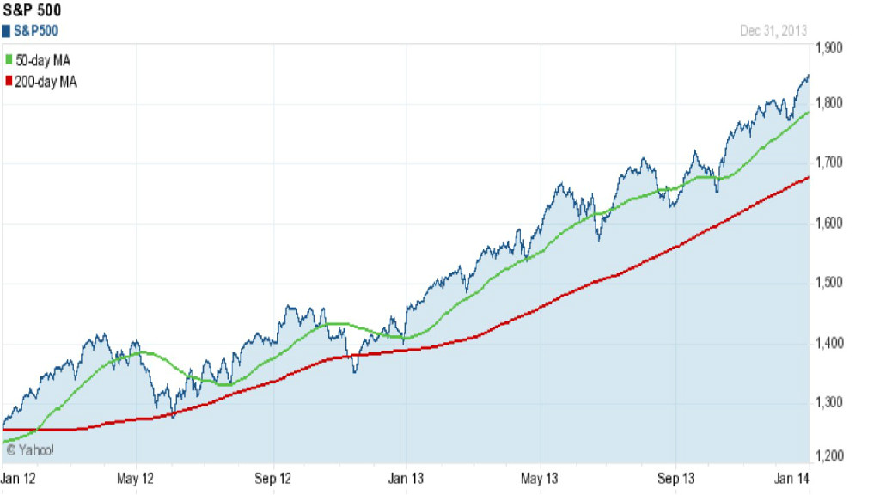
One of the best technical indicators I utilize is the 50 day Moving Average (green line) and its relationship to the 200 day Moving Average (red line). A bullish signal is when the 50MA crosses above the 200 MA, which it did at the beginning of 2012. As you can also see, that indicator continued to be bullish in 2013, which resulted in gains of over 32% in ProFunds accounts. It should also be noted that since 31 December 2007, ProFunds accounts have increased 90% as compared to 25% for the S&P 500. So what can we expect for the future? The trend is your friend. As long as this indicator remains strong, regardless of the headlines, we will continue to have to majority of funds in the stock market.
**********************************************************************************************
2012 Year in Review
Looking back, I’ll remember 2012 as the year of foreign and domestic politics. We had Greece, Arab Spring, the primaries, the election, and finished it off with the fiscal cliff. I don’t know about you, but I’ve hit the saturation point. Although now we have the debt ceiling and sequestration debates to look forward to in this first quarter. On the investment side, you can see how the S&P 500 performed in 2012 by looking at the inserted chart. Although it dipped in May and the time around the election, it was relatively bullish for the majority of the year. From a technical perspective, this was confirmed as its 50 day Moving Average (red line) remains above its 200 day Moving Average (green line).
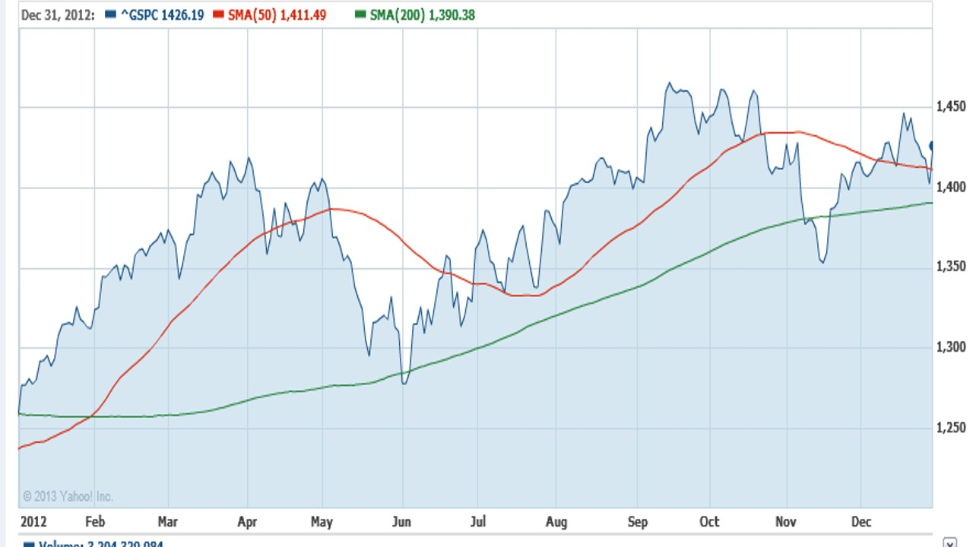
However, one number I would like you to remember is 1468, which is where the S&P 500 closed at on 31 December 2007. Then came the financial crisis and the bear market of 2008. As I’m typing this on 12 January 2013, the S&P 500 just closed at 1472. For the first time in the last five plus years, it has finally recouped what it had lost. Over that same period of time, money invested in ProFunds would have had an increase of just over 50 percent. So what can we expect for the future? As Casey Stengel once said, "Never make predictions, especially about the future". However, I will venture to say that I’ll remain cautiously optimistic as long as that 50 day moving average remains above the 200 day moving average. Also remember that the S&P 500’s historical high was 1565 on 9 October 2007. We’re only about 100 points shy of that, and I wouldn’t be surprised if we break above that level in 2013.
**********************************************************************************************
2011 Year in Review
On the investment side, I must say that 2011 was a very interesting and unique year. Although the first six months mostly followed a typical trending pattern, the last six months were challenging and frustrating. It was like being on a seesaw, going up and down but remaining in basically the same place. The 2011 chart of the S&P 500 illustrates this. Around August you can see the big drop off. Notice that the 50 day moving average (MA) green line crosses below the 200 day moving average red line, signaling a bearish market. Also notice that at the end of September, the S&P 500 makes a new yearly low of around 1100, which usually signifies a continued bearish trend. However, the S&P 500 turns around and posts one of its best months in October, drops in November, then up again in December.
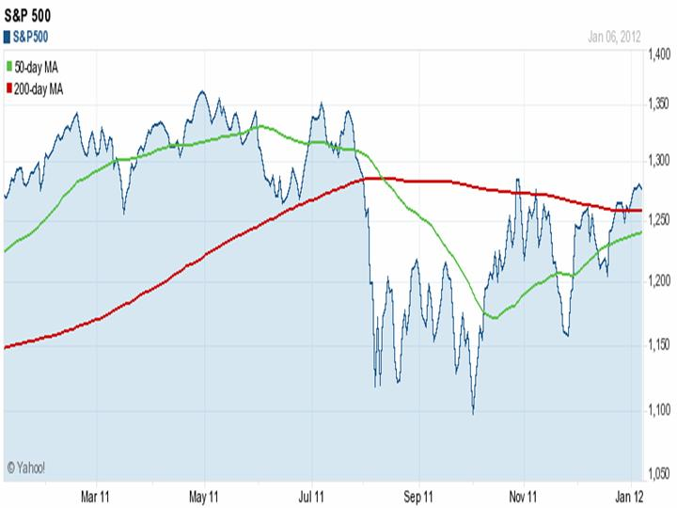
This was reminiscent of December 2007 when over a four week period the S&P 500 started at 1463, jumped to 1516, dropped 70 points to 1446, gained some back to 1498, and then dropped 108 points to 1390, which started the big bear market of 2008. There are a couple of big differences though. In December of 2007 the 50 day MA was crossing below the 200 day MA, while in 2011 it crossed about six months ago as noted above. Another is that from December 2007 to present, the S&P 500 is down about 15 percent, while a lump sum investment in ProFunds is up approximately 39 percent. No one can predict the future, but I do think 2012 will be a good year and gains will be made as the 50 day MA next crosses above the 200 day MA, probably in January.
*********************************************************************************************
2010 Year in Review
In mid-2010, I stated that “Over the last two years we have made major gains in the second half of the year, and I’m hoping that this pattern will repeat”. Well, the stars did align themselves and we had consecutive gains for the last five months of 2010. For the year, our ProFunds clients were up just over 13 percent. That makes three years in a row with double digit returns and since 31 December 2007, client's accounts are up over 70 percent. During that same three year period, the S&P 500 is down just under 15 percent, still reeling from the effects of the 2008 Bear market. As I’ve said before in these letters, one of the primary criteria I utilize to define a bull or bear market is “Crossover”. If the 50 day moving average (blue) is above the 200 day moving average (red), it is a bullish sign. If the 50 is below the 200, it is bearish.
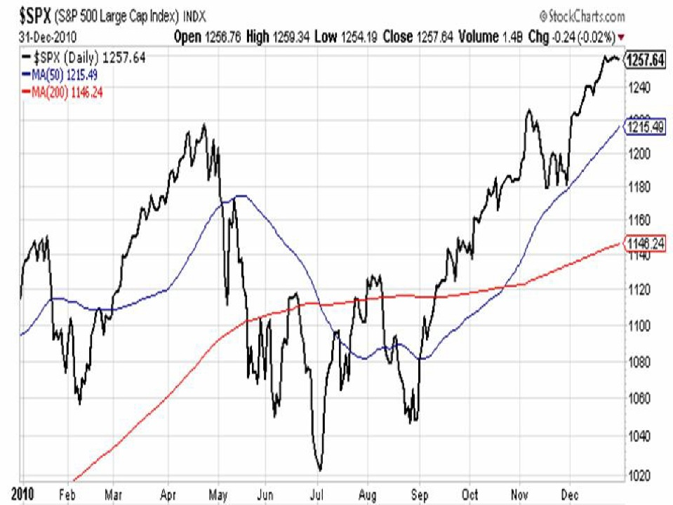
You can see on the chart of the S&P 500 that this index struggled during the first half of the year and even turned bearish during the summer given the fact the 50 (blue line) dipped below the 200 (red line). Thankfully this market rebounded and like I said earlier, our ProFunds clients saw gains in each of the last five months of 2010. The other nice thing I like about this scenario is that the end of 2010, S&P500 is trading around 1250 (refer to chart). The S&P 500’s historical high was approximately 1550 in July 2007. That 300 point delta divided by the current level of 1250 equates to a gain of approximately 25 percent. Bottom line is that I’m continuing to see a lot of potential in this market, and I think we have the opportunity for four straight years of double digit gains.
********************************************************************************************
2009 Year in Review
As we start off a new decade, we are coming off two of the most tumultuous years in financial history. Although the S&P 500 did well in 2009 and finished at 1125, it is still down 22% from the 1468 mark of 31 December 2007. However, there is good news!! Over that same two year period, our clients had double digit gains for both years and those invested in ProFunds gained just over 52%, while those in Rydex made about 37%. All told, the two year percentage difference between the S&P 500 and ProFunds/Rydex was approximately 74% and 59% respectively.

While the gains in 2008 came from investments in bearish inverse funds, the gains in 2009 came from bullish funds. Looking back to December 2007, the S&P 500’s 50 day moving average crossed BELOW its 200 day moving average signaling a BEAR market. This bearish mood persisted throughout 2008 and the first few months of 2009. In June 2009, the S&P 500’s 50 day moving average crossed ABOVE its 200 day moving average signaling a BULL market. Since that time, we’ve seen the S&P 500 increase from approximately 900 to 1125 along with the majority of portfolio gains.
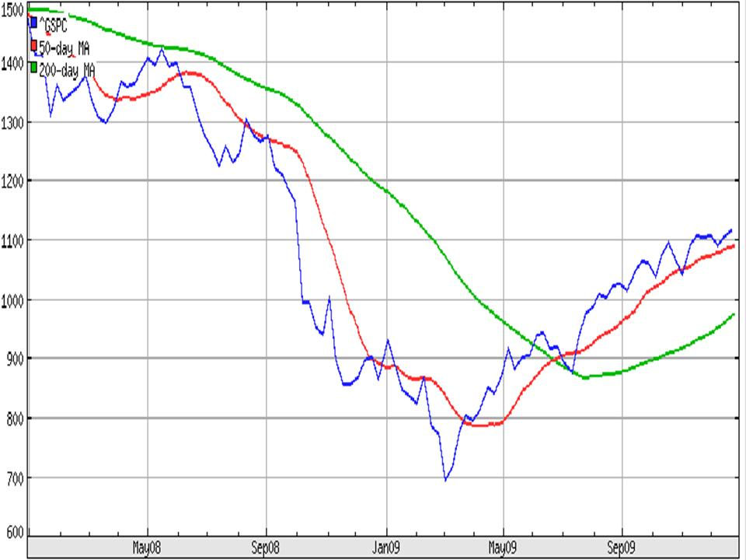
So what should we expect for 2010? One of my notable quotes is, “No one can predict the future”, and so I won’t. However, I will say that just like the S&P 500 was in a 19 month bearish phase from December 2007 until June 2009, I would expect the same to hold true for a 19 month bullish run, bringing us through the end of 2010. We should also remember that the S&P 500’s historical high was 1553 in July 2007. If we are able to return to those levels (and historically we have), that would be about a 38% gain from year end 2009.
*********************************************************************************************
2008 Year in Review
This will be hard to believe, but 2008 was a banner year for our clients. While the S&P 500 was down 38.5% for the year, those clients invested in ProFunds made just over 30% and those in Rydex made approximately 24.5%. The majority of those gains came during the month of October, when the market was falling like a disintegrating satellite. But before we get too far ahead, let's go back to October 2007.
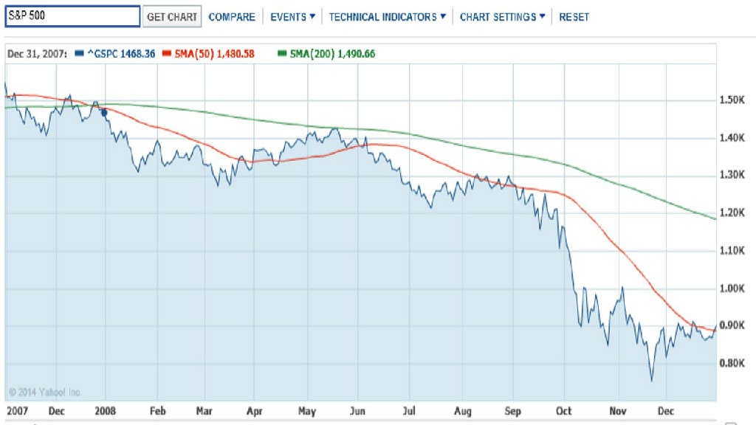
At that time, the S&P 500 had just made a new high of 1565.15. After being bullish since September 2006, the S&P 500's 50 day moving average crossed below it's 200 day moving average, signalling a bearish outlook. The S&P 500 started 2008 at 1468.35, and throughout the first six months of 2008, it meandered back and forth within about a 150 point range and was starting to look more positive at the end of May. However, the summer saw continued lower movement and the fall brought an acceleration of the downward spiral. There was also a sector rotation as evidenced by the fund's Performance Ratings. By the end of September, the majority of portfolio holdings were in Inverse funds which go up when the market goes down. The last quarter of the year was what I like to call "Taking Money Off the Table", and we finished out the year with approximately 90% of our holdings in cash. For the year, the S&P 500 is down about 38.5%, while this strategy has resulted in significant gains for my clients. If this peaks your interest, please click on the WIT (Weisert Investment Tripod) tab on the menu for more information.

