June 2018 Newsletter
First Congregational Church
An Open & Affirming Congregation of the United Church of Christ
300 Central Street, Saugus, MA 01906
781-233-3028
Rev. Martha Leahy, Pastor Rebecca Harrold, Music Director Carolyn Davis, Church Secretary
https://www.Facebook.com/uccsaugus

“Rooted in the grace of God, the mission of the Massachusetts Conference of the United Church of Christ is to nurture local church vitality and the covenant among our churches
to make God’s love and justice real.” - MACUCC mission statement

REV. MARTHA’S MESSAGE
“Making God’s love and justice real.” So often we listen to scripture being read in the church service and struggle for ways to make it real for our lives. The primary mission for any church is to believe that these ancient lessons speak to us across the years and that they can transform our lives. But transformation only comes when we can pass along what we learn to others – maybe not so much in words, but in deeds.

The Bible is full of stories of how prophets were called by God to deliver God’s word to them about how to reorient hearts and minds towards a holy goal. But the beauty of the Good Book is that there are many more stories of real people who make a difference in their little corner of the world.

And that is the task of the church, at least if we want to stay alive and vibrant. God calls to us from an ancient book but also from our neighbors, known and unknown to us. What should be our unique place in our community? What should our core ministry be?

On Sunday, June 3, we will take a second step toward “Making it Real” for our church. We will meet after coffee hour on the chancel in the sanctuary, a place where many of us have seen and felt the presence of the Holy Spirit. We will work on refining the “why” of our ministry, in hopes of crafting our own mission statement to the world, a statement “rooted in the grace of God, to make God’s love and justice real.” Please join us.

****************************************
HAVE A HOLY SPIRIT STORY? Many people felt the presence of the Spirit in our sanctuary on Pentecost Sunday. Did you feel it? Can you share your story with Rev. Martha? It would be good for others to know what you heard, felt, and saw during the worship service. You need not share your name if you don’t want, but sharing your experience might encourage another to affirm what happened to them that beautiful day. We will collect our stories to put in a book to keep near the sanctuary so that all may share in our holy moments. These are good examples of “why” we come to church. Come, share the Spirit!

******************************************
CHILDREN’S SUNDAY, JUNE 3

The last day of Sunday School for this program year is Sunday, June 3. We will set aside a special moment in our Communion service to celebrate our children and all the good work they’ve done this year. They have brought us so much joy with their enthusiasm and deep desire to know about God. Come see a beautiful display of all the projects they’ve done and let them know how proud we are of them.
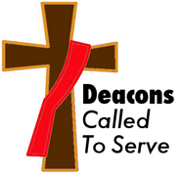

We would like to thank Mike Mascovitz for leading the worship service on May 27th in Rev. Leahy’s absence. As always, he did a wonderful job.

For those of us who missed the “Making it Real Campaign” last month, you can have a second chance on June 3rd . We hope many can join us.

The Deacons Fund and donations to the Saugus Food Pantry will continue on the first Sundays of the month. Please continue to support these endeavors

To those of us vacationing and traveling during the summer months, we hope everyone will remain safe and don’t forget your church family.

From your Deacons,
Barbara Davis, Susan Dunn, Terri Leander, Mike Mascovitz, John Gilmore, Rick Florentino

****************************************
CHRISTMAS IN JULY!
Fri., July 27, 6:30PM

In the heat of summer, it’s always good to cool off, whether it’s in a pool, at the beach, or inside with the a/c on. But, there’s another way: bring a little of December into July. How? Christmas in July, that’s how!

Rev. Martha and Rebecca want to do a fundraiser for the Music program, and this will be a fun and unique way to do it. We’d like volunteers to help us make this possible, and this is what you can do:

-Put up Christmas decorations in the hall (trees with lights, etc.)
-Bake Christmas cookies
-Buy popsicles (Fudgicles instead of hot chocolate!)
-Be a Christmas caroler
-Be Santa
-Donate/set up raffle items
-Set up a Giving Tree to collect gifts for Saugus kids in need
-Put up advertising flyers
-Collect donations for our Music program

Got more ideas? Let’s set a date to meet and talk soon. It’s going to be wonderful to hear those carillon bells ring out Christmas tunes in the middle of summer!

***************************************
MUSIC MINISTRY

The month of May was rich in musical diversity here at church. We began by going off-site to Beer & Hymns at the Dockside Restaurant in Wakefield. On Mother’s Day we were treated to duets of “Here Comes the Sun” and “Country Roads” by our Music Director Rebecca Harrold and church member Steve Rich.

On Pentecost Sunday we welcomed in worship special guest Geni Skendo, a friend of Rebecca’s and a native of Albania, who plays many genres of world music on the flute. After church, Rebecca treated us to a Women’s Day Tea & Sing-a-Long in Community Hall with lunch provided by many of our members. We netted $109 in donations for the Music program.

We want to keep the momentum going with inviting guest musicians. This means holding fundraisers to pay for them and being generous with our own donations. (One person donated to the Music Fund in memory of a loved one.) We are blessed that Rebecca has many connections in the local music scene and beyond and that her own gifts bring us to greater spiritual heights. May the Holy Spirit continue to make her presence felt in our music!

******************************************

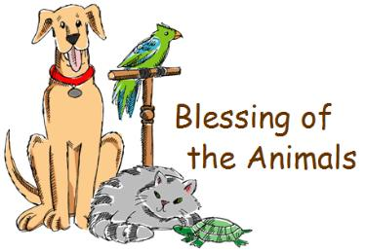
BLESSING OF THE ANIMALS
Founder’s Day Sat., Sept. 8

To kick off the fall season at church, we would like to offer the families in Saugus something special on Founder’s Day – a Blessing of the Animals outside on our front lawn! This will be a unique way to invite people to our church and to bless their beloved pets. We will dovetail this with our Heifer Project ministry and take donations to support their work. There may even be a Petting Zoo involved! We are also working on inviting a very special guest musician to the festivities.

In order to make this happen, we need a committee of volunteers to help us. Rev. Martha, Rebecca Harrold, and Terri Leander are brainstorming ideas. Please reach out to one of us so we can set a date to brainstorm ideas for this an all-church effort. What a great outreach event to host on Founders Day!

******************************************

Calling All Knitters & Crocheters! Our prayer shawl ministry continues to grow and reach far beyond our community. We have need of more shawls – big and pocket sized – to fill our inventory. Please bring them in as you complete them. And if you know anyone who knits or crochets, invite them to join us in this important ministry.

***************************************
Want to learn more about First Congregational Church UCC? We welcome any- and everyone to worship with us, and most of us have taken the step to become full members, sharing in the communal work that keeps a UCC church running. That work includes attending on Sunday, volunteering, and financially supporting our ministries. See Rev. Martha if you want to attend an introductory class. We would love to have you in full communion with us and the United Church of Christ.

**************************************

******************************************
INTO THE MYSTIC

Meditation. Yoga. Long walks in the woods. Listening to waves crashing on a beach. People are finding more and more ways to nuture their spirituality outside of a traditional church service.

We have created another place where nurture can be found – a book group called Into the Mystic.
We will read both classic and contemporary mystics across world traditions: Christian, Jewish, Buddhist, Celtic, Native American, and more. We will learn how connections to Holy Mystery are made in more ways than we may know. We may listen to poets and musicians, too, who tap into something deep within and beyond themselves for inspiration.

We will meet bi-monthly on the 2nd and 4th Wednesdays of the month, 6:30-7:30PM. Leaders will be Rev. Martha, Cyndy Turco, & Terri Leander. A starting date will be announced soon. Come, take a deep dive with us Into the Mystic.

******************************************
THE HEALING CIRCLE
Twice monthly 7-8PM
Summer dates: 7/11, 7/25, 8/1, 8/22

“The Root of Healing is in the Power of the Circle”

Need a soul-vacation in the middle of your week? Join us twice a month to practice meditation, pray, and find peace and renewal for the week to come.
This summer we have changed our schedule to accommodate holidays and summer vacations. Dates are: 7/11, 7/25, 8/1 & 8/22.

Private, one-on-one healing prayer is offered at the end of the Circle. You can also make appointments for additional conversation. Find us on Facebook!
https://www.facebook.com/healingcirclesaugus

***************************************
*****************************************
STAFF SUMMER VACATIONS
Our staff works hard during the program year and they take their vacation weeks in the summer to rest and renew their dedication to the church. This summer, Rev. Martha and Rebecca will both be away the same weeks in August, from Mon., 8/6 through Sun., 8/26. We are currently seeking a musician and a pastor to lead Sunday worship. There are many gifted people to choose from so the congregation will be well served. Names will be announced soon. The Deacons will coordinate the services along with the worship leaders. We trust in the warm welcome our congregation always extends to visitors. May God bless each of us as we find our own summer spiritual retreats.

************************************

SAUGUS ELEMENTARY SCHOOLS OUTREACH
The Saugus Faith Community, in partnership with the United Parish Food Pantry, the Saugus Public Schools, and area organizations and businesses is working on a program to provide take-home boxes of food to students in need.

Superintendent Dave DeRuosi told a recent SFC gathering that 35-40% of kids in Saugus receive free or reduced cost meals and are considered to be in the lower socio-economic/high needs categories. Their families struggle to provide basic necessities for them, including regular meals. If a child is hungry, they cannot learn in school.

Now that we know the need, what would Jesus have us do? “I was hungry and you gave me something to eat…whatever you did for the least of these, you did for me.” This is the plan: together with local businesses and organizations, we will collect the items needed, box them up, and deliver them on Fridays to the schools so families can pick them up. Details are being worked out this summer so that the program can start up in September. If you are interested in being a part of this effort, our next meeting is Wed., 6/6 @12:30 at the Roby School. RSVP to Rev. Martha for the lunch to be served.

******************************************
A Prayer for Safe Summer Travel
Psalm 121

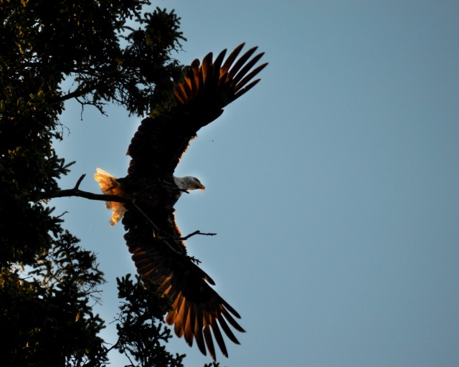
¹ I lift up my eyes to the mountains—
where does my help come from?
² My help comes from the Lord,
the Maker of heaven and earth.
³ God will not let your foot slip—
God who watches over you will not slumber;
⁴ indeed God, who watches over Israel,
will neither slumber nor sleep.
⁵ The Lord watches over you—
the Lord is your shade at your right hand;
⁶ the sun will not harm you by day,
nor the moon by night.
⁷ The Lord will keep you from all harm—
God will watch over your life;
⁸ the Lord will watch over your coming and going
both now and forevermore.

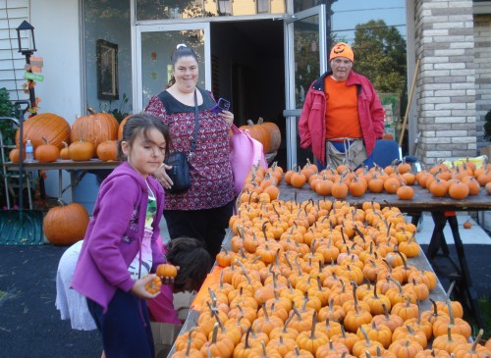
DANNY PANICO MEMORIAL
SCHOLARSHIP APPLICATION

Our church in conjunction with Pumpkin Patch is proud to support you in your quest for higher education. We will award a $500 scholarship to a student chosen by our Board of Trustees, based on your reply to our request for an essay. Our criteria are as follows:

- You must be a graduating high school senior who has been accepted to a 2- or 4-year college or trade school.
- You must submit a typed, 500-word essay telling us about your community service or volunteer experiences, and what you have learned from those experiences.

Please send your essay, including your full name, address and phone number to:

Board of Trustees, Attn: Carolyn Davis
Scholarship Program
300 Central Street
Saugus, MA 01906

The deadline for applications to be received is Sunday, June 30. We look forward to reading your essay and learning how you have made a difference wherever you have served as a volunteer.

PUMPKINS ARRIVE
SATURDAY SEPTEMBER 29
9 a.m.

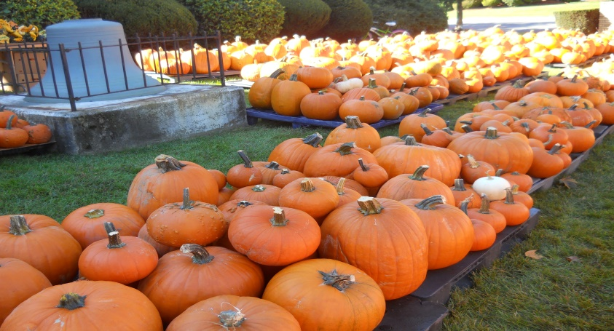
FIRST CONGREGATIONAL CHURCH UCC, SAUGUS CENTER
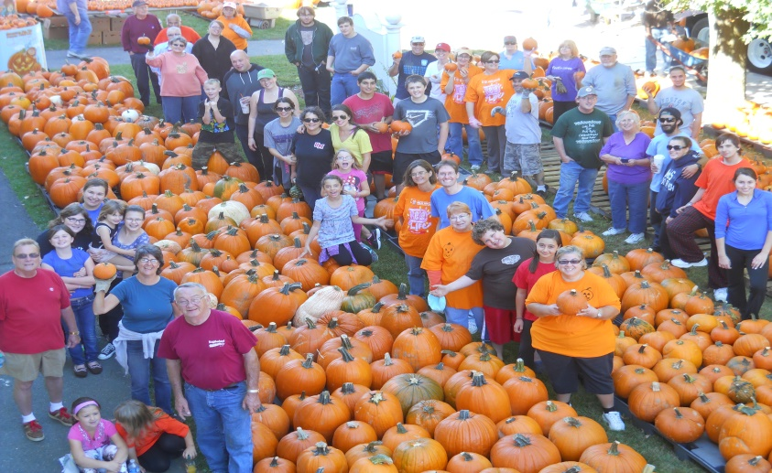
SEE YOU THERE!!!!!!!!!!!!!!
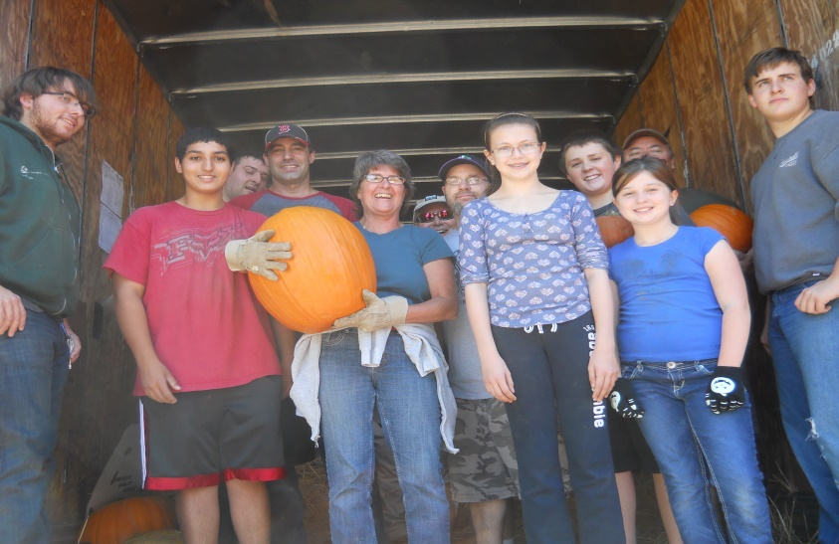

June 2018
 | Monday | Tuesday | Wednesday | Thursday | Friday | Saturday
 |  |  |  |  | 1 | 2
3  Worship, Communion & Children’s Sunday 10AM  Making it Real 11:30-12:30 | 4  Trustees 5:45PM  N.A. 7PM | 5  Chair Yoga 9:30AM  Yoga 6:30PM | 6  SFC/Superintendents Meeting 12:30 @  Roby School  Office Open 2-5PM  Healing Circle 7PM | 7  Office Open 10-3  Staff 10AM | 8 | 9
10  Worship 10AM  Church Council | 11  N.A. 7PM | 12  Chair Yoga 9:30AM  Yoga 6:30PM | 13  Saugus Clergy 12n  Office Open 2-5PM  Divorce Support 7-10 | 14  Office Open 10-3  Staff 10AM  Masons Night | 15 | 16
17  Worship & Baptism 10AM  Father’s Day | 18  N.A. 7PM | 19  Chair Yoga 9:30AM  Yoga 6:30PM | 20  Office Open 12-5PM  Healing Circle 7PM | 21  Office Open 10-3  Staff 10AM | 22 | 23  61st Anniversary  of the UCC
24  Worship 10AM | 25  N.A. 7PM | 26  Chair Yoga 9:30AM  Yoga 6:30PM | 27  Office Open 10-3PM  Divorce Support 7-10 | 28  Office Open 10-3  Staff 10AM | 29 | 30

July 2018
 | Monday | Tuesday | Wednesday | Thursday | Friday | Saturday
1  Worship & Communion 10AM | 2  N.A. 7PM | 3  Chair Yoga 9:30AM  Yoga 6:30PM | 4  Independence Day  Office closed  Healing Circle next week | 5  Office Open 10-3  Staff 10AM | 6 | 7
8  Worship 10AM | 9  N.A. 7PM | 10  Chair Yoga 9:30AM  Yoga 6:30PM | 11  Office Open 2-5PM  Healing Circle 7PM  Divorce Support 7-10 | 12  Office Open 10-3  Staff 10AM | 13 | 14
15  Worship 10AM | 16  N.A. 7PM | 17  Chair Yoga 9:30AM  Yoga 6:30PM | 18  Office Open 12-5PM  Healing Circle next week | 19  Office Open 10-3  Staff 10AM | 20 | 21
22  Worship 10AM | 23  N.A. 7PM | 24  Chair Yoga 9:30AM  Yoga 6:30PM | 25  Office Open 10-3PM  Healing Circle 7PM  Divorce Support 7-10 | 26  Office Open 10-3  Staff 10AM | 27  Christmas in July 6:30-8PM | 28
29  Worship 10AM | 30  N.A. 7PM | 31  Chair Yoga 9:30AM  Yoga 6:30PM

August 2018
 | Monday | Tuesday | Wednesday | Thursday | Friday | Saturday
 |  |  | 1  Office Open 12-5PM  Healing Circle 7PM | 2 | 3 | 4
5  Worship & Communion 10AM | 6  N.A. 7PM  Rev. Martha on vacation – back on 8/27 | 7  Chair Yoga 9:30AM  Yoga 6:30PM | 8  Divorce Support 7-10 | 9 | 10 | 11
12  Worship 10AM  Rebecca off | 13  N.A. 7PM | 14  Chair Yoga 9:30AM  Yoga 6:30PM | 15  Healing Circle next week | 16 | 17 | 18
19  Worship 10AM  Rebecca off | 20  N.A. 7PM | 21  Chair Yoga 9:30AM  Yoga 6:30PM | 22  Healing Circle 7PM  Divorce Support 7-10 | 23 | 24 | 25
26  Worship 10AM  Rebecca off | 27  N.A. 7PM  Rev. Martha returns | 28  Chair Yoga 9:30AM  Yoga 6:30PM | 29  Office Open 10-3PM | 30  Office Open 10-3  Staff 10AM | 31

BLESSING OF THE ANIMALS PUMPKINS ARE COMING!
Founders Day, Saturday, Sept. 8 Saturday, Sept. 29 @9AM
Heifer Project Fundraiser All hands on deck!

