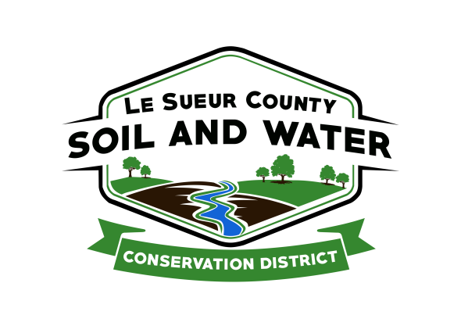

Le Sueur County Soil & Water Conservation District

Le Sueur County SWCD Tel. (507) 357-4879 Ext. 3
181 W Minnesota St Website: www.lesueurswcd.org
Le Center, MN 56057

Minutes from October 10, 2017 regular meeting of the Le Sueur County SWCD Board of Supervisors. SWCD building, Le Center, MN.

Members present: Chairman, Jim Struck
Vice-Chairman, Greg Entinger
Secretary, Earle Traxler
Treasurer, Cletus Gregor
PR&I, Glendon Braun

Others present: District Manager, Mike Schultz
District Technician, Joe Jirik
District Conservationist, Steve Breaker
Program Specialist, Sue Prchal

The Pledge of Allegiance was recited.

Secretary’s report from September 12, 2017 was read and approved.

Treasurer’s report for September 2017 was read. Motion by Entinger, second by Braun to approve as read and to pay bills.
Affirmative: All
Opposed: None
Motion carried

There will be a buffer ordinance hearing on Tuesday, October 17 in the County Commissioners room.

Mike and Jack attended governance training. Mike suggested that the board try to attend next year, very good and worthwhile training.

The storage building across the street from the office was discussed. Le Sueur County Attorney, Brent Christian will put together a purchase agreement. Also the board discussed if a ground assessment would be needed on the property.

The SWCD contribution for the TSA will increase from $2614.00 to $3319.00.

Steve gave the NRCS report. Gary Hahn will be working in Le Sueur County on projects being they are without a technician. Fall construction will be starting soon and CRP interest was discussed.

Watershed boundaries for 1W1P were given to the board.

Convention material was handed out.

There being no further business, motion by Entinger, second by Braun to adjourn at 10:25 a.m.

__________________ ______________________________________________
Date District Secretary

