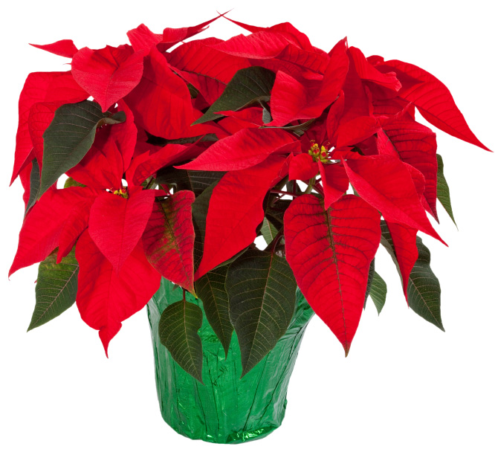Christmas Poinsettias!

We have ordered red poinsettias to beautify our worship surroundings as we approach the celebration of Jesus’ birth. These flowers are dressed in 6-inch pots, covered in green foil. They will grace our sanctuary until Christmas Eve. If you would like to buy one or more for $15.00 each, the dressed plant will be yours to keep after Christmas Eve services. Please fill out the lines below and drop in the offering plate or mail to the church with your payment.
Please list below exactly how you would like for your dedication to read in print.
Given by:
___________________________________________ _ ____

In Memory OR in Honor of (Circle only ONE, please):
__________________________________________________________________

