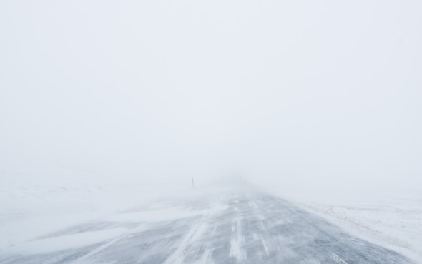
This Photo by Unknown Author is licensed under CC BY-SA-NC
Day 18. Find Something to Lean On
In A Cry of Absence, Protestant historian Martin Marty observes: “While seeking boldness and strength in the wind and the storm, a person relies on landmarks. In a blizzard, a “whiteout” can disorient, until a wanderer cannot know whether a dark object is a match cover nearby in the snow or a hut farther away on the horizon. The seeker reaches for known, locatable objects. There must be a place to lean on, to hold on.”
Reflect upon the “known locatable objects” in your life. What landmarks can you lean on?

