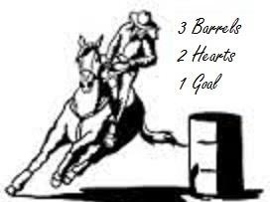

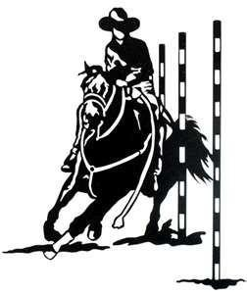
Eastern Rowan Saddle
Club
2017 Game Show
14210 Old Beatty Ford Road

Rockwell, NC

October 21st

Show Starts at 3:00 pm

1. Ride-A-Buck – Open (No Points)
2. Key Hole Race - 18 & Up
3. Key Hole Race - 12 - 17
4. Key Hole Race - 11 & Under
5. Egg & Spoon – Open (No Points)
6. Speed Ball - 18 & Up
7. Speed Ball - 12 - 17
8. Speed Ball - 11 & Under
9. Water Glass Class – Open (No Points)
10. Pole Bending - 18 & Up
11. Pole Bending - 12 - 17
12. Pole Bending - 11 & Under
13. ** JACKPOT POLE BENDING **$20
14. Big T Weave 18 & Up
15. Big T Weave - 12 - 17
16. Big T Weave - 11 & Under
17. Birangle - 18 & Up
18. Birangle - 12 - 17
19. Birangle - 11 & Under
20. Quadrangle Stake - 18 & Up
21. Quadrangle Stake - 12 - 17
22. Quadrangle Stake - 11 & Under
23. Cloverleaf Barrels - 18 & Up
24. Cloverleaf Barrels - 12 - 17
25. Cloverleaf Barrels - 11 & Under
26. ** JACKPOT BARRELS ** $20
27. Mail Bag Race – Open (No Points)
28. Hurry Scurry - 18 & Up
29. Hurry Scurry - 12 - 17
30. Hurry Scurry - 11 & Under
ENTRY FEE: $7.00 / Class or $35.00 Unlimited
**$20 JACKPOT CLASSES**

CURRENT NEGATIVE COGGINS REQUIRED

2017 General Rules
o NO late entries. You MUST be registered in class BEFORE
the class is called to arena.
o When in the alleyway you do not have to wait on the gate to be closed before starting your run. The exit gate will not be opened until the equine is stopped and under full control.
o Four (4) entries constitutes an added class (Due to the danger level, the arena race will not be add so please don’t ask)
o Any questions concerning rules and/or classes should be directed to the registration booth.

Any and all equine welcome

For more information contact:
Jamie Rabon (980) 521-6461
Jessie Hellems (704) 202-5701 or visit us on the web at: www.eastrowansaddleclub.com

WARNING:

Under North Carolina Law, an equine activity sponsor or equine professional is not liable for an injury to or the death of a participant in equine activities resulting exclusively from the inherent risks of equine activities. Chapter 99E of the North Carolina General Statute.
The Eastern Rowan Saddle Club nor its members or heirs assume responsibility in the event of accidents, loss, theft, injuries or death.
EVERYONE RIDES AT THEIR OWN RISK

EAST ROWAN SADDLE CLUB
14210 OLD BETTY FORD ROAD
ROCKWELL, NC 28138

