Pleasant Township Board of Trustees Meeting Highlights
Date __May 23, 2023 Next Resolution No._ _33-----05-23-2023_ _

- Call to Order -- The meeting tonight will also be on WebEx.
- Please stand for moment of silence. --Pledge of Allegiance-----Roll Call (Paula absent)
- Minutes to approve- None
- Financial Reports – Motion to pay expenditures.
- Visitors –
- Hanna Poling with the Southwest Messenger via WebEx.
Thank you Hanna for coming to the Dedication and Ribbon Cutting of the Little Tree Library at Ebenezer Cemetery on Saturday.
- Department Reports
- Franklin County Sheriff’s Report- No Deputy present
- Road Department- Rick Haag in for Robert
  - 5155 Norton Rd. – I heard from the homeowner today. The county trimmed it back this morning. Homeowner said it looks very nice.
  - Norton Road at Kropp Road and Grove City Road to be Closed for Intersection Improvements and roundabout. Approximate closure dates: June 5, 2023, for approximately 45 days, weather permitting.
  - Old Harrisburg pike finished
  - Mowing roads
  - Memorial day preparations, the service will be held at Oak Grove Cemetery at 1:00 p.m. West Jefferson VFW will be doing the service for us.
- Fire Dept. – Fire Chief, David Whiting
- Has the credit card on file for Go Daddy Website Builder been updated? Working on it.
- Old Business-
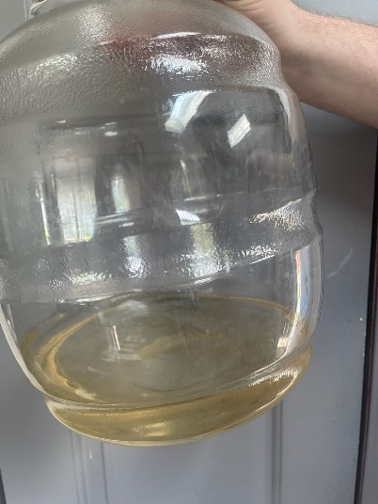
  - Last meeting we received an email complaint about no water at Community Gardens Mobile Home Park now we have one the water is brown and smells odd. I forwarded the email to Michael Santone with the Ohio EPA. He responded very quickly with, “Iron and manganese are classified as aesthetic contaminants in that they cause taste and color issues. The PWS has been sent multiple violations for not meeting treatment goals for this. The contractor has provided the owners an estimate to replace the entire water treatment system at Community Gardens. They have until May 29th to accept the bid.
  - Last meeting we received complaint about a business operating in an area zoned residential on Georgesville-Wrightsville Rd. Advertising prices for hourly rental for pool parties, weddings, etc. Last summer we had many loud music complaints for this address. FCSO was called several times. I sent this to the Zoning Dept. Received another complaint yesterday they are still advertising with additional items to rent the Shedbedz.

- New Business –
- Received this notice from David Smith, Zoning Code Enforcement: Kelsey Shires has joined our team as our new Zoning Officer, replacing Sam Morrow. Kelsey has a strong enforcement background and will be an asset to our office and your areas.
Zoning coverage will now be:
Dave Smith: Madison, Truro, Mifflin, Sharon, and Brown.
Kelsey Shires: Norwich, Pleasant, Franklin, Hamilton, and Clinton.
I will continue to work on any pre-existing cases.
- Travis Baisden contacted Burnham and Flowers TPA department. He believes he earned his full Wellness points for 2021 going towards his 2022 deductible. Our Wellness rep has since changed, and our new rep is not able to verify the points earned in 2021. The report we received shows Travis earning 275 and his spouse earning 350. His Wellness was funded $1,500 of the $2,000 max earned. We can credit the additional $500 but need your approval. Resolution___33__to give Burnham and Flowers approval to credit Travis Baisden the $500 in Wellness points earned in 2021.
- Resolution_34 to terminate the Healthiest You part of the insurance since it is included in the Atena.
- Announcements-
From Bill Dawson: It's open! The Free Little Library has been dedicated and the beautification at Ebenezer M.E Cemetery in Galloway is complete- ahead of Memorial Day!
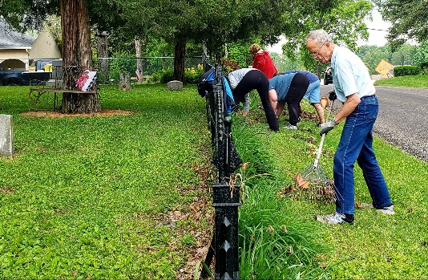
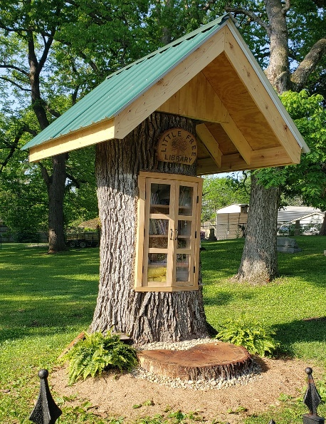
Community, good friends, neighbors, family and supporters all coming together have truly helped me with this project to Honor our Veterans and create beautiful greenspace to enjoy. The unique Tree Library made from a century old Oak turned out beautiful and functional for all to use. The Pleasant Township, Trustees came by to help dedicate and open it. Janet and Sean organized the Franklin Park Conservatory Women's Board volunteers who helped with the cleanup, The Davey Tree Expert Company, who helped take the tree down to size, was there represented by Brian Heath. My library building buddies Keith Dufrane and Paul Hern were on hand, friends and neighbors pitched in and also brought books, and of course family there too. I recieved a partial grant this year for the project through The Columbus Foundation, Franklin County Board of Commissioners and Scotts Miracle-Gro Company. Please stop by sometime to enjoy reading a book on a bench in the shade, absorb the peace of the flowers and song birds and take in the history of this early 1800's cemetery that holds dear, our veterans that served in five different wars, including the Revolutionary War. Thank you to all that helped this vision come to life, it is a labor of love that brings us together.
- Clerk Updates- Paula - absent
- Budget due 7-20-23
- Executive Session-
“I move to go into Executive Session according to Ohio Revised Code Section 121.22 (G)( 1 ) for the purpose of discussing health insurance compensation_. Do I have a second?” ROLL CALL VOTE
Reconvene
Under the Ohio Revised Code Section 121.22(G), I move to come out of Executive Session, do I have a second? ROLL CALL VOTE
- Adjourn- 8:30 p.m.

