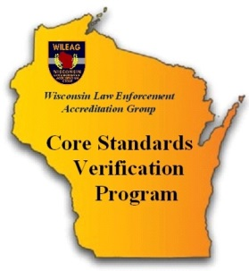
Core Standards
Verification Program

The purpose of the Agency Profile Questionnaire (APQ) is to assist the WILEAG Executive Director and Core assessors by providing a snapshot of your community and agency. Please take a moment to complete the APQ and return the completed questionnaire to the WILEAG Executive Director. Do not hesitate to contact the me with any accreditation questions or concerns.

Sincerely,

Katie Wrightsman

Katie Wrightsman
WILEAG Executive Director
262-563-3108
executive.director@wileag.info

AGENCY INFORMATION

Agency Name:
Agency Address:

Chief / Sheriff (CEO):
Daytime CEO Contact #:
CEO Email:
Accreditation Manager (AM):
AM Contact #:
AM Email:

Agency Size - Full time Employees: Total Sworn Civilian

Agency Size – Part time Employees: Total Sworn Civilian

COMMUNITY INFORMATION

Community Population:
Square Miles of Service Area:
Approximate Land Distribution of the Service Area:

Business / Commercial
Industrial
Residential
Residential Rental
Parks / Public Land
All Other
TOTAL 100%

Does the population of your service area change seasonally? No Yes
If yes, explain:

FUNCTIONS PERFORMED

Function and Standard # | Done by Agency | Under Contract Other Agency | Joint Agreement (MOU) | Not Performed
Hiring / Medical Exams 2.4.5 |  | List Agency: | List Agency:
Part-time Sworn Personnel 2.7.1 |  | List Agency: | List Agency:
Auxiliary Personnel 2.8.1 |  | List Agency: | List Agency:
Reserve Police Officers  2.8.2 |  | List Agency: | List Agency:
Officer Involved Critical Incidents  6.3.8 |  | List Agency: | List Agency:
Officer Involved Domestic Violence  6.3.10 |  | List Agency: | List Agency:
Search of Detainees 7.1.1 |  | List Agency: | List Agency:
Temporary Detention Procedures  7.2.4 |  | List Agency: | List Agency:
Inter Jurisdictional Communications 9.1.10 |  | List Agency: | List Agency:
Recruit Training 12.2.3 |  | List Agency: | List Agency:
Field Training 12.2.4 |  | List Agency: | List Agency:
Annual Training 12.2.5 |  | List Agency: | List Agency:

ADMINISTRATION

Please provide a copy of your agency organizational chart or a list / order of your organization’s functions (Word format would be sufficient). Task completed: No Yes

What is your agency’s total authorized budget for the most recent fiscal year? $

