D R A F T
EYEMED
Work Packages WORK PACKAGE 3 (WP3)
Content

WP1 Project Management and Coordination
WP2 Communication / Dissemination
WP3 Content
WP4 EU Pilots
WP5 MENA Pilots
WP6 Evaluation / Exploitation

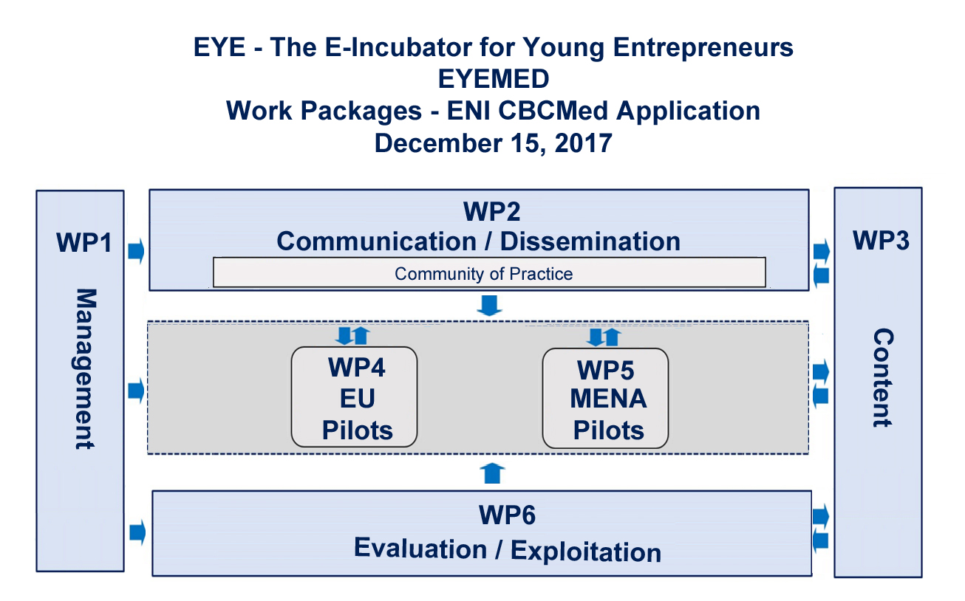
WP3 Partners:
WP Manager: PP6 Instituto Superior de Gestão
Participating partners?????

WP3 – Content / Learning Architecture

The aim of this work package is to set-up the needed conditions for the effective materialisation of the project in terms of content and learning architecture hosted on the iPortal It serves as an analytic work-package of training objectives to prepare the grounds for capacitating staff from public, private and educational institutions to facilitate a training course for their beneficiaries via distance learning methodologies supported by the iPortal platform. It is through the iPortal that students will obtain the knowledge and skills needed to become successful entrepreneurs. Engagement in the iPortal will take place between pre-incubation and post-incubation activities supported by the partners engaging in one of the EU or MENA pilots. Together, these make up the EYE – E-Incubator for Young Entrepreneurs model, and WP3 will prepare the ground for a successful implementation of the project.

WP3 is dedicated to building-up the digital education and distance learning capacities required for EYEMED implementation, giving a strong impulse to the learning needs of beneficiaries in the pilot regions, training of trainers/instructors and toward the creation of cost-effective, scalable training modules. These can be viewed as a new, experimental solution to combat unemployment by supporting beneficiaries on the path of creating entrepreneurial ventures and SMEs. The online curricula serve to hone skills needed for successful entrepreneurship.
EYE – The E-Incubator for Young Entrepreneurs constitutes a complete ecosystem to stimulate entrepreneurial learning processes, acknowledging that social, political, cultural and economic conditions of our targeted geographic areas for implementation of the model will influence the behaviours and actions of EYE participants. The EYE ecosystem is the combination of technologies and support resources available to help individuals learn the “how to’s” of entrepreneurship through online coursework complemented by pre- and post-incubation services orchestrated by the pilot partners.
WP3 covers creation of the coursework starting with the contents syllabi based on the need for learning about issues regarding the creation of a successful business, and categorizing them into modules that students can master through learning and practice. The coursework is divided into four modules taking place over a 14-18 month period:
1. CONCEPTS AND PREPARATION – Courses designed to lay the foundation for a deeper understanding of entrepreneurial success
2. COMMON COURSES – Focusing on the specifics of a successful entrepreneurial venture
3. SPECIALIZATION TRACKS – Specific needs of entrepreneurs in specialized industries, sectors or themes
4. LOCALIZED COURSES – These courses will focus on content with a country-specific or region-specific impact or control such as local laws, taxes, etc.
Coursework will be offered only in English, the Lingua Franca of entrepreneurship worldwide. Therefore, there must be an evaluation mechanism established to test the level of English beneficiaries must possess before enrolling in the programme.

The fifth module, an Internship / Consulting Project, will allow students to put their coursework learning into practice with a consulting project to work with external “clients” to address a business challenge in their field of interest. This phase of the project is contained within the work packages corresponding to the five pilots.

Discussion is needed amongst partners regarding the placement of the Digital Badge Network to be devised for EYEMED in the appropriate work package. EYE Badges package information about accomplishments, embedding it into portable image files as digital badges, and establishing resources for its validation. It includes term definitions for representations of data in Open Badges, containing detailed metadata about achievements, who earned a badge, who issued it, and what it means. Digital badges can become an important complement to the Europass in making skills acquired through the coursework more clearly and easily understood by European employers, thus facilitating the mobility of both learners and workers, and therefore could be considered for content planning in WP3. Alternatively, it can be considered for WP2 (Communications / Dissemination) or WP6 (Evaluation / Exploitation), both having good arguments for inclusion.

Following the establishment of quality common criteria for procedures, the coursework will be uploaded to the iPortal (http://iportal4languages.eu/), a virtual platform that integrates the most contemporary tools for online training, including WEB2 technology for virtual classrooms, social networks, Internet radio, mobile applications, etc. The iPortal platform connects people for interaction in the most effective way – through the Internet, which eliminates the need for students to travel to traditional brick-and-mortar learning centers and engages both students and instructors through tried and true methodologies of distance learning, and mitigates against obstacles that prevent people from face-to-face interactions. The iPortal supports a learning management system that brings together voice, video, data, and graphics in a structured online learning environment that scales to hundreds of supported users - a turnkey solution to e-learning problems. iPortal was especially designed for individual teachers and trainers to arrange group or private classes over the Internet in a state-of-the-art virtual classroom environment. Web 2.0 technology supports innovative tools for teacher-driven, student-centric solutions to people throughout the world. Use of the iPortal, with dedicated technical support throughout the term of the project, will be secured through a sub-contract with Future 21st Century Foundation, a European nonprofit organization that authorizes and monitors users of the iPortal functionalities, and will require a monthly user license.

WP3 also supports the “train the trainer”component of the project, beginning with hybrid training:
- Partner representatives will engage in distance learning for the preliminary preparation – preconditioning - before realizing mobility to participate in the kick-off meeting in Lisboa. This course will present instruction on accessing the iPortal and its tools for synchronous and asynchronous distance learning and the Learning Management System (LMS) supported by the platform, including creating accounts, organizing groups, choice of instruments, the organization of internal communication (Community of Practice), and adapting the courses to a local application in the areas where the EYEMED pilots will be implemented.
- The kickoff meeting will bring together partners to review the time schedule and work plans for the project, complete the agendas of future meetings, and cover the legal and financial aspects of the project, including discussion of project management details (i.e. reporting, schedules, documentation, etc.) and deliverables. Additionally, the kickoff meeting is meant to engender camaraderie through participation in the Community of Practice, that will serve as the primary communication mechanism between partners throughout the course of the project.
- The monitoring of the pilots are integrated in the project’s assessment and are not part of WP3 but rather integrated in the respective pilot work packages – WP4 and WP5.

Roles and Responsibilites: PP6 Instituto Superior de Gestão takes the lead as WP Manager for WP3. Partners wanting to integrate content they may have used in their training for entrepreneurship are welcomed to participate in WP3.

