2017
July
TRUE LIES
The Stuart Rod & Reel Club Newsletter
The Stuart Rod and Reel Club is dedicated to improving local fishing through by increasing angler knowledge, encouraging conservation and maximizing the fun involved in light tackle fishing in the Stuart Florida area. We hold monthly meetings on the second Thursday of each month, year-round. Please join us or contact any board member for more information on how you can become a member of the Stuart Rod and Reel Club.
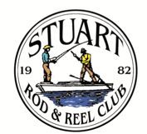

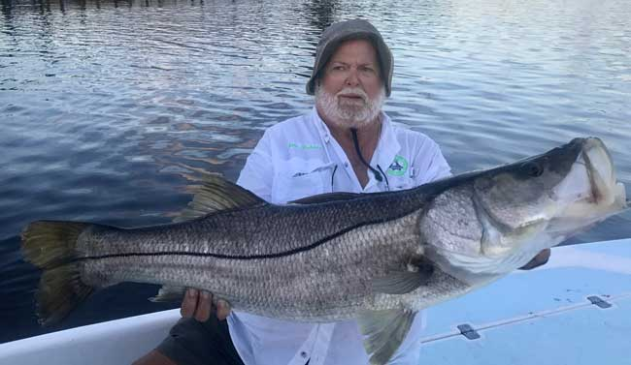
The Month of the Snook: June turned out to be SRRC’s Month of the Snook. Every photo submitted in June was of a snook. Jim Bohrer caught this huge fish in the Indian River Lagoon near Ft. Pierce. Snook transform from male to female in their lifetimes and at this size, they disperse millions of eggs.
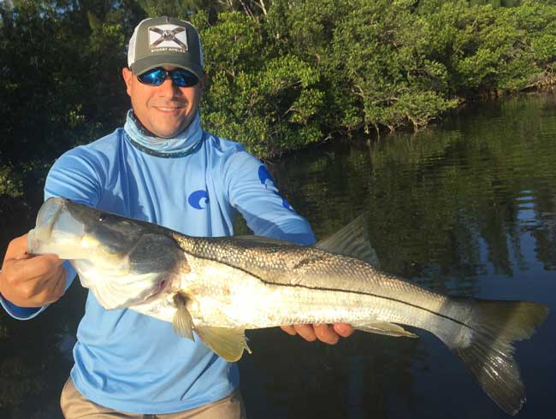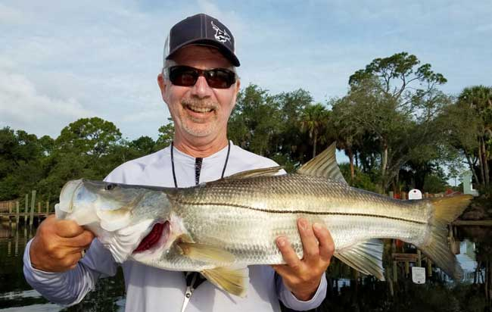

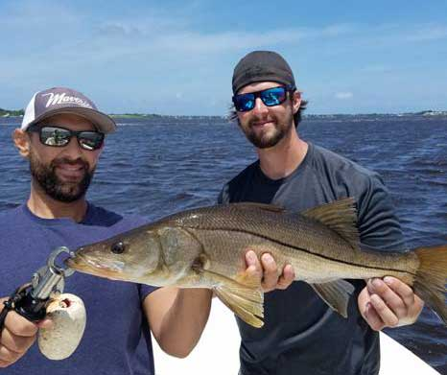
Top Left: Juan Giachino Jr caught this snook in the Indian River Lagoon
Top Right: Phillip Quick with a fine snook caught in the South Fork
Left: Keith Palant’s son Jason and Captain Joey with an ocean caught snook

Guest Speaker for the July General Membership Meeting
Captain Danny Barrow will be our guest speaker for the July meeting. Please attend to learn more about local fishing conditions and techniques.

The July tournament event is for tarpon caught on lures or flies only. No bait is allowed for eligible tarpon. Please remember NOT to bring large tarpon into your boat. It is illegal to bring a fish longer than 40 inches onto a boat! Take a photo alongside the boat gunwale and release all tarpon carefully. Look at www.fwc.gov for more tarpon regulations and restrictions. Help preserve this most precious of fish.

 |  |  | Club Officers
President | Jim Bohrer |  | halieutics@gmail.com | 301-648-2052
Vice President | Jim Bowdish |  | jlsb@crarybuchanan.com | 772-475-5068
Treasurer | Pete Noll |  | mpnoll@aol.com | 772-223-2136
Secretary and Newsletter Editor | Fred Bartlett |  | fredbart@aol.com | 913-909-9326
 |  |  | Board of Governors
Director |  | Roy Buckley | rlbuckley007@aol.com | 772-871-7008
House Committee |  | Jerry Hoge | jhoge@hogeengineering.com | 772-485-7267
Angling Committee |  | Frank Miller | frmiami2@gmail.com | 305-469-4654
Membership Comm. |  | Eric Rosenberg | erosen1031@aol.com | 772-210-5563
Meeting Speakers |  | Jim Bohrer | halieutics@gmail.com | 301-648-2052
Raffle Chairman |  | Jim Harter | pjharter@comcast.net | 772-223-0648
Conservation Coordinator |  | Jim Harter | pjharter@comcast.net | 772-223-0648
Events Coordinator |  | Bob Ruggeri | bob.ruggeri@yahoo.com | 772-285-4264
E-mail all newsletter copy and photos to Jim Bohrer at halieutics@gmail.com or to Fred Bartlett at fredbart@aol.com. Closing date for photos and copy is the 25th of the month preceding publication.

Angling Chairman’s Report

Hey, SRRC members: Here is a brief synopsis of our last outing held June 9th,10th and 11th featuring any species of fish you could catch, which included for example catfish, lionfish or you name it. Doesn't sound too exciting huh?

Phillip Quick, fishing aboard his vessel "Not So Quick" bagged 6 species including catfish, puffer, mangrove snapper, gafftop sail catfish, ladyfish and grunt, only to be bested by Eric Rosenberg, who tallied 7 species. Now listen to this: Eric fooled 3 Bonefish, only 1 of which counted for the contest, lane snapper, mutton snapper, blue runner, black drum, grunt and scorpion fish to snag top honors, all of which goes to show that there are fish to catch in the IRL especially species like bonefish which are showing up more and more frequently.

Lunch Saturday was another delightful event put on by master chef Roy Buckley who prepared great meatball subs at home with salad, etc. The weather threatened but didn't get us and we had a great turnout.
Put July 15 on your calendars for another great lunch at Shrimper’s Restaurant.

All Stuart Rod and Reel Club Outings are based purely on the Honor System. All scheduled Club Outings will be “Daylight Outings”. You can fish any of the dates listed above. Event will begin at the first safe light in the morning with lines out of the water by 1PM. Scores must be turned into the Angling Director or other board member by email, phone or verbally by 2 PM local time on the day after the event.  Natural Bait (alive or dead) is allowed except for March, May and July. Bait restriction is in effect for September.  Guests and spouses are invited to attend the food services on Saturday at Sandsprit Park. For food at restaurants, guest and spouses will be charged for their meal and beverage costs. | Family members under the age of 18 must be accompanied by a parent or legal guardian to participate in an outing. While guests are always welcome to join members during our outings, you must be a paid member of the Stuart Rod and Reel Club to be eligible to win an outing. Outing scores shall be published in the Club’s Newsletter following the Outing. Outings cancelled due to weather shall be rescheduled for the following weekend. Outing result disputes shall be settled by the Angling Director.  OUTING SCHEDULES AND RULES MAY CHANGE DURING THE YEAR.  FISHING BOUNDARIES  Boundaries will extend from the south shore of the Jupiter Inlet to the North Vero Beach Bridge.

Date | Outing/Event | Details | Host/Food Service | Rules
July  14,15,16 | Local Tarpon Outing | Most Tarpon: 3 Points for angler touching the leader, 1 point for a jumped fish. One point per jumped fish only. No natural bait allowed. | Shrimper’s Restaurant, Port Salerno 1:00PM, July 15th. | Three points for caught fish, one point for each jumped fish.
August  11, 12, 13 | Local Trout and Redfish Outing | Largest Trout & Redfish, total inch length | Sandsprit Park 1:00 PM Stuart, August 12th. | Longest total trout and redfish combined.
September  15, 16, 17 | Longest Snook | Longest Snook –Bait Restriction: Any snook caught on bait is worth ½ a fish caught on an artificial lure. 24” snook minimum length | Sandsprit Park 1:00  PM Stuart, Sept 16th. | Longest snook, minimum 24”
October  13, 14, 15 | Pine Island | Total Length in Inches: 1 Trout, 1 Redfish, 1 Snook (24” minimum on snook) | Pine Island Away  No Local Luncheon | Longest total length
November  10,11,12 | Local Redfish | Longest Overall Redfish | Sandsprit Park 1:00 PM, Nov 11th. | Longest total length
December 9 | Christmas Party | No Outing | Dolphin Bar & Fish House Jensen Beach | No Outing.

2017 TOURNAMENT OUTING SCHEDULE
Support our Advertising Sponsors
We are very fortunate to have many local businesses that advertise on our web site and provide additional sponsorship support to the Club. These businesses provide a wide range of products and services for the entire community. Whether you are looking for lodging, restaurants, fishing supplies, boat repair and restoration, guide services, legal services, or roof repair our sponsors deserve your consideration. You can learn more about these businesses by visiting our website at www.stuartrodandreel.com. Click on the advertiser’s tab and you will find a brief description of our sponsors with contact information and links to their websites. Make our advertising sponsors your priority when shopping. Please let them know that you learned about them through the Stuart Rod and Reel Club and that you appreciate their support.

Bait & Tackle  - Crowder Rods  - D.O.A. Lures  - Fish Heads of Stuart  - Snook Nook  - Treasure Coast Rod and Reel  - White's Tackle  - T & A Jigs, Inc. | Area Lodging  - Marriott - Hutchison Island Resort
Area Dining  - Big Apple Pizza  - Crawdaddy’s  - Dixie Grill  - Manatee Island Bar & Grill  - Manero’s Restaurant  - Polka European Deli  - Rancho Chico  - Shrimper’s | Guide & Charter Services  - Cajun Fishing Adventures Louisiana  - Catch 22 Charters Florida  - The Fish Intimidator Louisiana
Marine Products & Services  - C&H Trailer  - Manatee Marina  - Marine Customs Unlimited  - Marine Parts Outlet  - Master Repair  - Metco Marine Electronics  - Outboards Only  - Sailfish Marina  - Stuart Propeller  - Treasure Coast Battery & Alternator | General Business  - Capps Roofing  - Inn of the Dog  - Plaza 95 Marathon, Dairy Queen and Highway Café  Professional  - Crary Buchanan Attorneys

MEMBER’S INFORMATION
MONTHLY MEMBERSHIP MEETINGS WITH SPEAKERS: The monthly membership meeting is the second Thursday of the month. Our home port is The Quality Inn/Flanigan’s Bar & Grill located at 950 SE Federal Hwy. (US 1) Stuart, FL. We have the privilege of listening to many fishing industry and conservation leaders in the Southeastern Florida region. These experts include tackle manufacturers, tournament winning Captains and guides, television and print journalists, and academic researchers. We have a guest speaker from this pool at each monthly meeting. Speakers will address topics of interests such as how to fish for the upcoming outing’s targeted species and our diverse estuary system. This is a great way to gain additional local knowledge of this fishery. Dinner begins at 6PM with Meeting at 7 PM.

MONTHLY OUTINGS: The Club sponsors a fishing outing each month. All outings are based on an Honor System. You don’t have to keep your catch or take a picture of it either. Outings are scheduled for the weekend following the general membership meeting. Outings are usually three day events where anglers select to fish Friday, Saturday or Sunday. Most outings are scheduled from first safe light till 1PM. The targeted fish and scoring change from month to month with interesting twists such as more points for one species than another. The intent is to have fun! The winner of each monthly outing receives a Club logo embroidered fishing shirt. As part of the outing we have several lunches at restaurants along with club and family cook-outs. Additionally, the Board is encouraging members to partake of the lunch regardless of the day fished. These are no-cost events. With two away outings and the remainder based at Sandsprit Park, there is opportunity to participate without travelling around the state. Frank Miller as the Angling Committee Chairman will also consider your ideas about other outings in other parts of the state. This year’s outing schedule was developed to increase participation, emphasizing the fun of fishing. You are able to view the schedule in every edition of True Lies.

NEWSLETTER: We publish a newsletter, True Lies, each month. It is circulated by e-mail. We are constantly looking for your fishing reports, pictures, recipes, and any other Club related information for inclusion. Submitting information is easy. You can send an e-mail to Jim Bohrer (halieutics@gmail.com).

WEB SITE: The Club’s web site (www.stuartrodandreel.com) is a wealth of information. You can find the latest weather and tides, fishing tips and information on our advertisers/sponsors.

RAFFLE: An activity at our membership meetings that generates a great amount of interest is the “Raffle”. Tickets are $1 each or 6 for $5. Raffle prizes vary monthly but usually include a fishing rod, reel or combination. Other prizes have been tackle bags, boxes, pliers, lures and boating accessories. Your purchase of raffle tickets gives you a good chance of winning and helps support the activities of your club.

MEMBER DISCOUNTS: Your Club membership can help you to save some money. White’s Tackle offers a 10% store discount on all purchases. Be sure to mention that you are a current member of the Stuart Rod and Reel Club and that you appreciate the support that they give the club.

Here are some local upcoming fishing events (not SRRC club related) that you or your family members may be interested in:

Port Salerno, August 19th, 5th Annual Treasure Coast Bonito Blast Fishing Tournament

STUART FISHING AND BUSINESS COMMUNITIES COME TOGETHER IN SUPPORT OF LOCAL WOUNDED VETERANS WITH DAY OF FAMILY FUN

Our purpose is simple: we host an affordable, one-day, family friendly fishing tournament event in order to raise money for the Wounded Veterans Relief Fund https://wvrf.org. Wounded Veterans Relief Fund (WVRF) is a non-profit veteran’s organization that assists post 9/11 veterans who are in financial crisis.

Now in its 5th year, the Treasure Coast Bonito Blast (TCBB) works with over one hundred local businesses to create an event that has something to offer everyone in our community. The event includes fishing, $2,500 in prize money, dinners, live music, auction items, and a raffle style drawing for the grand prize - a customized TCBB golf cart.

Anglers have a chance to compete on Real Radio's Love Doctors, 94.3 and The Wave 97.2 for free entry to the Bonito Blast. Lucky winners will fish with Dano and Eric Hunter as they battle each other for the biggest catch.

Captain Billy Black is once again organizing volunteer boat captains who are able to host a veteran on their boat for the tournament. Last year, a total of 13 boat captains chipped in to host 40 veteran anglers who had never fished in a tournament before.
Weigh in will be at The Twisted Tuna, from 12-3 pm. Captain's Meeting, August 18th, 6 pm and Award Party, August 19th at 5 pm, at Manatee Island Bar and Grill.

TOURNAMENT DETAILS:
Entry Fee: $100.00 for 4 anglers ($25.00 for each additional person). Junior anglers (under 12) fish for free and will be recognized for their catch.
Prizes as follows:
1st Prize $1,500.00
2nd Prize $750.00
3rd Prize $250.00
There will be two calcuttas, largest dolphin and largest edible bottom fish.
This year’s event highlights include country artist Colton James https://www.coltonjames.com performing at Saturday night’s Award Ceremony with local (STUART, FL!) rising country star Jess Lee http://jessleemusic.com opening the show.
WVRF works closely with South Florida’s V.A., to ease the burdens of financial distress for post-9/11 Florida disabled veterans and their families, helping them transition back home in a productive, meaningful way. They welcome the community and beyond to come together to support South Florida’s returning wounded veterans and their struggle to regain their lives.

Website www.TreasureCoastBonitoBlast.com
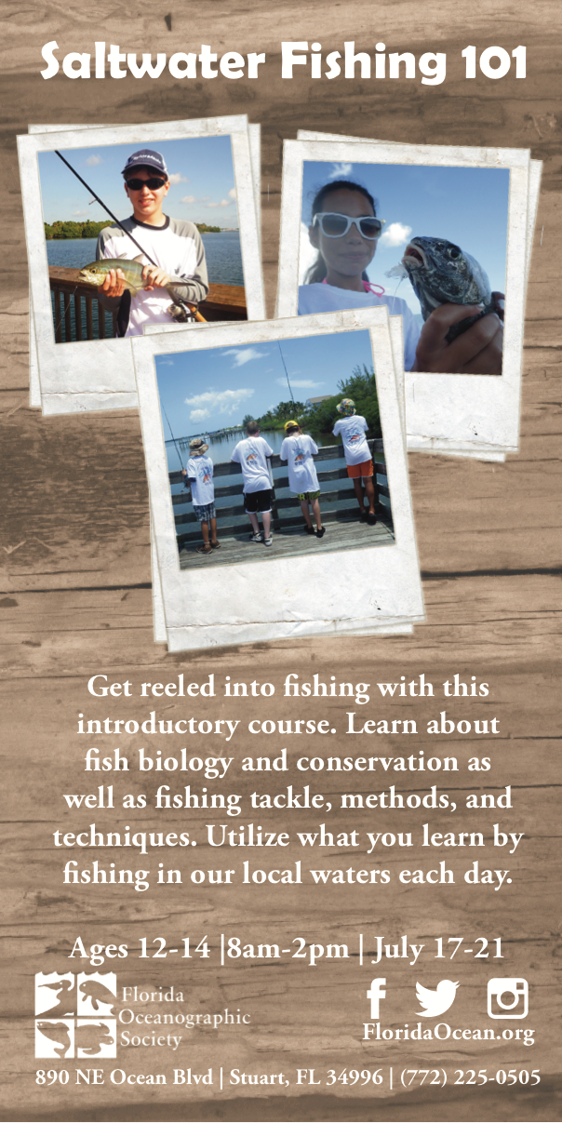
to
2017 Annual Dues
Fully paid memberships begin the first day of January, and end on the thirty first day of December of each calendar year. An individual membership is one adult 18 years of age or older. Family memberships consist of the member, their spouse or significant other and their children under the age of 18.

Individual membership for a HALF YEAR (June 1 through December) is $45

Family membership for a HALF YEAR is $55
(June 1 thru December)

Send your checks payable to:
Stuart Rod and Reel Club, Inc.
c/o Pete Noll, Treasurer
1888 S. W. Mooring Dr.
Palm City, FL 34990
Membership entitles a single person (or family as applicable) to participate in all outings and to enjoy a meal at every local outing. Members also receive an included meal (with soft drinks) at Shrimper’s and Manatee Island Grill on the appropriate dates. We hold monthly meetings with interesting speakers and share information on where and when to fish in our area.

2017 SRRC Fish
of the Month Contests
The Fish of the Month Contest will run from the day after the monthly membership meeting and end at 12 Noon the day of the following meeting. All fish need to be legal size except for Snook that must be 24-inch minimum. Natural bait (live or dead), artificial lures and flies are allowed. The member catching the most fish will be the monthly winner. The monthly winner will receive a monogrammed club hat.
Date | Species
Jan 13 thru  Feb 09 | Snapper, Bluefish
Feb. 10 thru Mar. 09 | Most Pompano
Mar. 10 thru April 13 | Most Snook
April 14 thru May 21 | Largest Trout
May 12 thru June 18 | Most Snook
June 19 thru July 13 | Most Redfish
July 14 thru Aug 10 | Most Trout
Aug. 11 thru Sept 14 | Most Tarpon Caught and Released
Sept. 15 thru Oct 12 | Largest Snapper
Oct. 13 thru Nov 9 | Largest Redfish
Nov 10 thru Dec 13 | Most Black Drum

The Winner of the Year Overall will be the person catching the most total species during the calendar year. The overall prize is a $50 gift certificate to White’s Tackle in Stuart.

