March 2017
At a glance
Full descriptions of activities in bulletin.

Sun | Mon | Tues | Wed | Thurs | Fri | Sat
26  Worship/  Financial AGM  11:15  POTLUCK  Cong. Care Speaker | 27  AA 7:30 pm  Meditation  7 pm | 28  Cards  9:30  Pancake Supper 5:30-7pm  TOPS  6:30 | 1  Ash Wednesday  Holy Rosary Cathedral  7 pm | 2  Craft/Study  1:30  Faith Formation | 3 | 4
5  Worship  11:15  Communion | 6  AA 7:30 pm  Meditation  7 pm | 7  Cards  9:30  TOPS  6:30 | 8  Soup Supper  6 pm  Lent  Service  7 pm  Faith Expl. 7:30 pm | 9  Craft/Study  1:30  Godly Play Training  6:30 pm | 10 | 11  Women’s Breakfast  8 am
12  Worship  11:15  Open Hearts Jar  Farewell for Pastor Carla 2 pm | 13  AA 7:30 pm  Meditation  7 pm | 14  Cards  9:30  TOPS  6:30 | 15  Lent  Service  7 pm  Faith Expl. 7:30 pm | 16  Craft/Study  1:30 | 17  Film & Faith | 18  Russell away
19  Worship  11:15  Russell away | 20  AA 7:30 pm  Meditation  7 pm | 21  Cards  9:30  TOPS  6:30 | 22  Lent  Service  7 pm | 23  Craft/Study  1:30 | 24 | 25
26  Worship  11:15  Potluck  Cong. Care  Speaker | 27  AA 7:30 pm  Meditation  7 pm | 28  Cards  9:30  TOPS  6:30 | 29  Lent  Service  7 pm | 30  Craft/Study  1:30 | 31 | 1

TOPS = Take Off Pounds Sensibly
AA = Alcoholics Anonymous
ANNOUNCEMENTS
February 26, 2017

306-761-0556 eastsideunited@sasktel.net
Like us on facebook (Eastside United Church)
Follow us on Twitter @Eastside_united
www.eastsideunited.ca

W
elcome to Eastside United. May our opportunities of ministry offer you rest, challenge and peace on your Christian journey.

Ministers:
Minister: Russell Mitchell-Walker
Greeting: Cathie Henderson and Jean Henders
Congregational Care Greeter: Sheri Nupdal
Prayers: Cathie Henderson
PowerPoint: Kyan Benesh
Piano: Michelle Dickie
Attendance last week: 56

Russell’s e-mail address: russell.eastside@sasktel.net

Office Hours:
Tuesday, Wednesday and Thursday from 8:30 am to 3:30 pm

Russell is in the office Tuesday through Thursday from 9 am to 4:30 pm, working from home on Friday.

Brewed Awakening Office Hours, Wednesday afternoons from 2 to 4:30 pm. At U of R Campion College for the month of March.

Scripture Reading: Luke 9: 28-45

Songs:
Come All You People/Uyai Mose MV #2
Kumbaya
It’s a Me, It’s a Me, It’s a Me O Lord
To Show by Touch and Word VU #427
Grateful MV #187 Chorus only
Spirit of Life VU #381
We Will Go with God/ Sizohumba Naye MV #223

2016 Tax Receipts are in your Eastside mail slot for you! Please help us save on postage and check for yours! We have assigned mail slots to all regular church-goers.
TODAY following potluck lunch: Congregational Care Speaker Series. Join us as we hear from Andrew Hryciw on his work with the Elks of Canada, specifically the Elks and Royal Purple Fund for Children.
Join us for Easter
Worship

April 9 Palm Sunday
A Walk through Holy Week All Ages Service
11:15 am

April 13 Maundy Thursday
Teaching Seder with Bread of Life
7 pm

April 14 Good Friday
Memorial Wake with IMCF
Featuring Creator’s Sacrifice Paintings
7 pm

April 15 Easter Vigil
At St. Paul’s Anglican Cathedral
with St. Philip Anglican
10 pm

April 16 Easter Sunday
Easter Worship 11:15 am

Celebrate BLACK HISTORY MONTH: Regina Public Library presents… An Evening Under the African Skies. Monday, February 27 from 7 to 8 pm. An evening of storytelling and entertainment!

Arcola East Senior Bridge Club: Looking for a fun way to get out and socialize with other seniors? The Arcola East Senior Bridge Club gathers for social bridge each Monday at 1 pm at the Living Spirit Centre (3018 Doan Drive). No prize money; weekly fee is $1. For more information, please contact Bill Jeske at 306-789-2430 or Alma Pockrandt at 306-789-5981 or apockra@yahoo.ca.
LSC Meditation Group: The Meditation Group will meet again at 7 pm Monday, February 27 in the East Sanctuary. Feel free to bring a friend, and dress comfortably.

St. Philip Senior Ministry Outreach card playing program, Tuesday mornings at 9:30 am in the East Sanctuary at the Living Spirit Centre. Whist and lessons to those that would like to learn. Come out and enjoy fellowship, coffee and card playing. If you need a ride call Rod 306-789-1388. Everyone is welcome.

Eastside’s Craft/Study Group Thursdays at 1:30 pm in the Multipurpose Room! Join us as we share in discussion, handiwork and coffee time following. We are just finishing up our reading and discussion of The Alchemist by Paulo Coelho and will soon begin Grounded by Diana Butler Bass. We will be placing a book order shortly. If you haven't been involved in this group in the past but would like to, please contact the office and we'll set you up! Current members will have the chance to sign up at your next gathering. This is a fun time of study, crafting, and refreshments following.
We’d love you to join our family! We are planning a Transfer of Membership service Sunday, March 12. If you are interested in being included or have questions, please let Russell know.

Ash Wednesday, Wednesday, March 1: We invite you to join our Faith Exploration group as we attend the Ash Wednesday Service at Holy Rosary Cathedral, 13th Avenue and Garnet Street, at 7 pm. For more information, please see Russell.

Death Café, Ash Wednesday, March 1 from 7 to 9 pm: Bread of Life Lutheran Church will be hosting this opportunity for conversation at the Living Spirit Centre. Facilitated by Myrna Pugh and Brent Langenberger, the purpose of this event is to help normalize the topic of death in everyday language and discussions. It is NOT a grief support or counselling session. For more information, please contact Brent at brent1048@sasktel.net or 306-533-5806.

The World Day of Prayer ecumenical service will be held on Friday March 3, at 2 pm at Holy Cross Church, 315 Douglas Ave. E with lunch to follow. This year’s service has been written by The Philippines’ World Day of Prayer Committee and the theme is “Am I Being Unfair To You?”

Next Sunday, March 5, we are excited to have Christine Lwanga joining us to deliver the reflection during our 11:15 am worship service – an extension of Black History Month! Christine emigrated from Uganda about 20 years ago and she is well-known in Regina for her involvement in a variety of social movements, including support for women, refugees, African-Canadians, and other equity-seeking groups. She was a commissioner on the Saskatchewan Human Rights Commission for ten years and recipient of a Saskatchewan Centennial Medal for community service and a YWCA Woman of Distinction award.
Understanding World Religions: Leaders from four of the large world religions will talk about their faith including origins, customs, and belief systems. Following a brief presentation you will have an opportunity to ask questions and engage in respectful and informative discussion about one of the world’s major religions over coffee or tea and treats. A different religion will be featured each week – Islam, Hinduism, Buddhism and Sikhism. Thursdays, March 2, 9, 16, 23 from 10 to 11:30 am at 2151 Scarth Street, Room 109. These presentations are FREE and everyone is invited to attend.Space is limited so call 306-585-5748 to reserve your seat today! Drop-ins also welcome if space permits. This is a program of the University of Regina’s Lifelong Learning Centre.

Lenten Soup Suppers are back! Munch Café and Catering will again be providing simple meals for us prior to our Lenten worship services on Wednesday, March 8 and Wednesday, April 5 at 6 pm. Vegetarian and meaty soup options and bread will be served. RSVP to eastsideunited@sasktel.net.

Easter is Coming!
We are beginning to prepare for our Easter Egg Hunt, our gift to the community. If you wish to help with the planning, let Russell or Terri Lynn Frederickson know. We also need egg cartons, so please bring them to the church. Thanks!

PaintNite Fundraiser - March 10, 2017, 7 to 10 pm, Lakeview United Church, 3200 McCallum Ave. Cost is $45, funds raised will be used to purchase school supplies for children in Regina and to advance international outreach to United Church partners. An artist will lead us through the steps to create “Misty Mountain Sunrise”. No previous painting experience necessary! All levels of skill welcome! Beverages will be available for purchase during the event. Purchase tickets at: https://www.paintnite.com/events/_1159993.

LSC Women’s Spirituality Breakfast, Saturday, March 11 from 8 to 10 am. This month’s special guest is Sandra Fowler. Sandra will be sharing about a recent Canadian Food Grains Study Tour to Nicaragua in which she took part. This tour included meeting with rural communities who explained their child nutrition programs, conservation agriculture and land bank programs; a visit to a United Church Mission and Service partner in Managua; and learning from academics and Oxfam workers about the history and political situation in the country; but the true joy was getting to know Nicaraguans and learning how, with the help of the Food Grains Bank, they are improving their lives and the lives of their children. Sandra is a United Church lay worship leader who lives near Eyebrow where she and her husband and daughter have a cattle and sheep operation (and is Sarah Tkachuk’s mom, too!). All women are welcome to attend – please bring a toonie to help with breakfast costs.

A Night for St. Andrew’s Gala Dinner and Fundraiser, Tuesday, April 18, 2017 at the Wascana Country Club, 6500 Wascana Parkway. Gathering 5 pm, dinner 6:15 pm. Tickets $110 (partial tax receipt), ticket deadline April 10. See Leona Martin or contact the church office if interested. This year’s fundraiser includes an address by Right Reverend Jordan Cantwell, UCC Moderator, and music by Lori Erhardt and Corinne Groff!

TIME OUT FOR BLESSINGS: A Christ-centred yoga retreat presented by Connie Moker Wernikowski of Big Fish Yoga. Friday, April 28 at 6 pm to Saturday April 29 at 5 pm. At the living Skies Retreat Centre in Lumsden, SK. This retreat will offer both active and restorative yoga; meditation; some free time for walking, resting, visiting; Christian chanting; and an intro to the First Ignation Spiritual Exercise. Cost is $193. Please complete a registration form found on any of the LSC bulletin boards, or by emailing mokerw@sasktel.net.

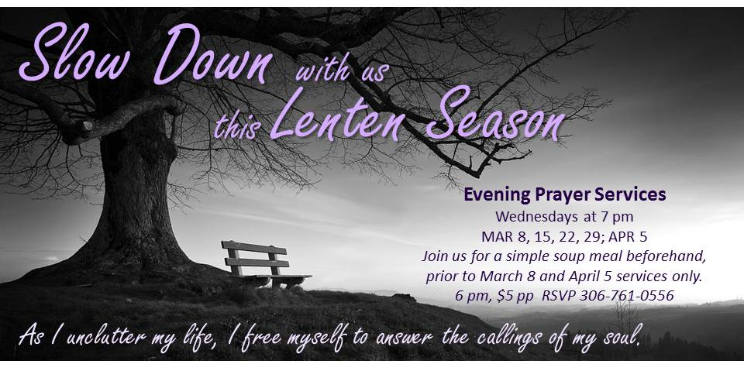

Families and friends of Eastside United are hosting this year's LSC Shrove Tuesday Pancake Supper and we will need help to do so! There is a sign-up sheet posted on the Eastside bulletin board. We're looking for donations of ingredients and time!

