REGULAR MEETING

OCTOBER 17, 2024

The Regular Meeting of the Town Board of the Town of Hampton, County of Washington and the State of New York was held at the Town Hall, 2629 State Route 22A, Hampton, New York, on the 17th day of October 2024.

PRESENT: David K. O’Brien------------Supervisor

Donald Sady----------------- Councilman

Tamme Taran----------------Councilwoman

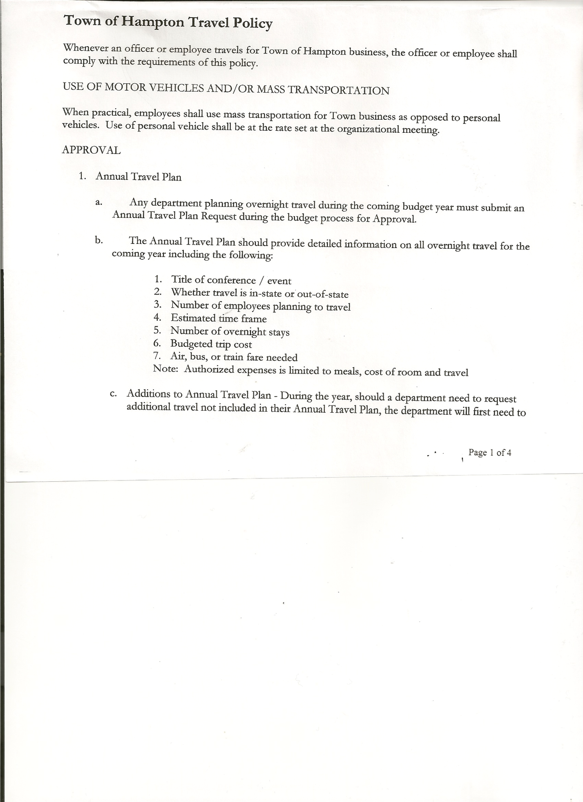 Michael Pietryka------------Councilman

Andrea Kugler---------------Councilwoman - absent

Rebecca Jones---------------Town Clerk

Camilla Shaw----------------Deputy Town Clerk

Tyler McClure---------------Highway Superintendent

Planning Board Member (s):… Bonnie Hawley, Chair; and Matthew Pratt

Others present at the Town Hall: see attached sheet

The Regular Meeting was called to order by Supervisor O’Brien at 7:30pm, followed by the Pledge of Allegiance. Location of Fire Exits were given. Quorum of board members present.

Supervisor O’Brien asked for a moment of silence in memory of Shawn Ballard (nephew of Judge Sady & Councilman Sady) and Barbara Taran (sister-in-law of Councilwoman Taran)

**RESOLUTION NO. 86-2024**

**APPROVAL OF THE MINUTES**

On a motion of Councilwoman Taran, seconded by Councilman Pietryka, the following resolution was ADOPTED: AYES 4 O’Brien, Sady, Pietryka, Taran

NAYS 0

ABSENT 1 Kugler

RESOLVED, that the Regular Town Board Meeting Minutes for September 19, 2024 are approved.

Dog Control Officer Report….currently still working on an issue on County Route 18 and one on Carver Falls Lane

Tax Collector Report….Zero balance. The Town Clerk/Collector had Board Members review and sign bank reconciliation statements for the Tax Collector Account dated September 30th.2024.

Bonnie Hawley, Chair Planning Board….Planning Board Meeting was held October 9, 2024, copy of minutes is attached. Next meeting will be November 13th, 2024 @7:00 at the Town Hall.

Tyler McClure, Highway Superintendent…submitted his report, copy of which is attached.

As stated in Tyler’s report he has located a 2025 Western Star 49X series Truck, package price of $334,025.00 and will be available early-mid Spring. Following a lengthy discussion on different options for the Town to pay for said Truck, the following resolution was introduced:

TOWN BOARD MEETING

OCTOBER 17, 2024 PAGE 2

**RESOLUTION NO. 87-2024**

**HIGHWAY-PURCHASE 2025 WESTERN STAR**

On a motion of Councilman Sady, seconded by Councilwoman Taran, the following resolution was ADOPTED:

By Roll Call Vote: Supervisor O’Brien AYE

Councilman Sady AYE

Councilman Pietryka AYE

Councilwoman Taran AYE

Councilwoman Kugler ABSENT

RESOLVED to move forward on purchasing the 2025 Western Star Truck.

**SUPERVISOR’S REPORT/COUNTY UPDATES/COMMUNICATIONS**

**RESOLUTION NO. 88-2024**

**APPROVAL OF SUPERVISOR’S MONTHLY REPORT**

On a motion of Councilman Sady, seconded by Councilwoman Taran, the following resolution was ADOPTED: AYES 4 O’Brien, Sady, Pietryka, Taran

NAYS 0

ABSENT 1 Kugler

RESOLVED that, the Supervisor’s Monthlyreport be accepted as submitted for **SEPTEMBER**

ACCOUNT 9/01/24 Receipts Disbursed 9/30/24

Citizens Cemetery $ 3,282.93 $96,749.30 $ 97,00377 $ 3,028.46

Citizens Total $ 3,282.93 $96,749.30 $ 97,003.77 $ 3,028.46

GFNB Fire, Trust & Agency $ 1,418.04 $ $ 0.00 $ 1,418.04

GFNB Fire, Trust & Agency ICS $ 33,805.00 $ $ $ 33,805.00

GFNB Health Insurance $ 2,591.23 $ $ $ 2,591.23

GFNB Trust & Agency $ 3,784.22 $11,345.37 $ 11,541.87 $ 3,587.72

GFNB General Fund $ 3,520.18 $ 9,104.63 $ 6,179.59 $ 6,445.22

GFNB General Fund ICS $ 60,969.43 $ 346.20 $ 5,000.00 $ 56,315.63

GFNB Total $106,088.10 $20,796.20 $ 22,721.46 $104,162.84

GFNB Highway Fund $ 12,638.38 $125,363.77 $ 120,640.79 $ 17,361.36

GFNB Highway Fund ICS $ 81,496.86 $ 93,914.68 $ 32,000.00 $143,411.54

GFNB Capital Reserve $ 1,005.02 $ $ $ 1,005.02

GFNB Capital Reserve ICS $ 151,890.56 $ 585.73 $ $152,476.29

GFNB Total $ 247,030.82 $219,864.18 $ 152,640.79 $314,254.21

TOTALS $ 346,401.85 $337,409.68 $ 272,366.02 $421,445.51

All Board Members present signed Supervisor’s Report.

**RESOLUTION NO. 89-2024**

MOTION BY: Councilman Donald Sady

SECONDED BY: Councilman Michael Pietryka

**RESOLUTION INTRODUCING PROPOSED LOCAL LAW**

**TO OVERRIDE THE TAX LEVY LIMIT ESTABLISHED IN GENERAL MUNICIPAL LAW SECTION 3-c**

**WHEREAS**, pursuant to Section 10 of Municipal Home Rule Law, the Town Board of the Town of Hampton (the “Town”) has the authority to adopt local laws; and

TOWN BOARD MEETING

OCTOBER 17, 2024 PAGE 3

**WHEREAS**, pursuant to General Municipal Law Section 3-c, the Town Board of the Town of Hampton has the authority to adopt a budget that requires a tax levy that is greater than the tax levy limit for the coming fiscal year by adopting a local law by a vote of sixty percent (60%) of the total voting power of the Town Board of the Town to override such limit for such coming fiscal year only; and

**WHEREAS**, a proposed Local Law has been prepared by the Town Attorney, a copy of which is attached hereto; and

**WHEREAS,** the Town Board is desirous of proceeding with the review and consideration of this proposed Local Law.

**NOW, THEREFORE BE IT RESOLVED** that the proposed Local Law is hereby accepted for introduction to the Town Board. A public hearing shall be scheduled for the consideration of the proposed Local Law to be held by the Town Board on November 6, 2024 immediately following public hearings on Fire District 1 and Preliminary Budget, which start at 7:15pm. at the Town Hall located at 2629 State Route 22A, Hampton, New York. Copies of the Local Law shall be available at the Town Clerk’s office for review; and be it further

**RESOLVED,** that the Town Clerk is directed to post and publish a notice of said public hearing in the Manchester Newspapersat least five (5) days before the hearing; and be it further

**RESOLVED**, that the consideration and proposed adoption of this Local Law is an action under the New York State Environmental Quality Review Act (SEQRA). The Town Board hereby declares that this action is a Type II action pursuant to 6 NYCRR 617.5(20) and (27) and declares that the action does not have a significant impact on the environment and the action is hereby precluded from further environmental review; and be it further

**RESOLVED**, that this resolution shall take effect immediately.

DATED: October 17, 2024 Supervisor O’Brien AYE

Councilman Sady AYE

Councilwoman Taran AYE

Councilman Pietryka AYE

Councilwoman Kugler ABSENT

**RESOLUTION NO. 90-2024**

**ADOPTION OF TENTATIVE BUDGET**

On a motion of Councilman Sady, seconded by Councilwoman Taran, the following resolution was ADOPTED: : AYES 4 O’Brien, Sady, Taran, Pietryka

NAYS 0

ABSENT 1 Kugler

RESOLVED, that the 2025 Tentative Budget be adopted and becomes the 2025 Preliminary

Budget for the Town of Hampton.

TOWN BOARD MEETING

OCTOBER 17, 2024 PAGE 4

**RESOLUTION NO. 91-2024**

**PUBLIC HEARING ON FIRE DISTRICT NUMBER 1; PUBLIC HEARING ON PRELIMINARY BUDGET FOR 2025; PUBLIC HEARING-PROPOSED LOCAL LAW TO OVERRIDE TAX CAP AND TO HOLD A SPECIAL MEETING FOR THE PURPOSE OF THE ABOVE PUBLIC HEARINGS**

On a motion of Councilman Sady, seconded by Councilwoman Taran, the following resolution was ADOPTED: : AYES 4 O’Brien, Sady, Taran, Pietryka

NAYS 0

ABSENT 1 Kugler

RESOLVED, to set a Special Meeting for November 6, 2024 starting at 7:15pm and to set Public Hearing on the proposed contract between to Town on behalf of the Town of Hampton Fire Protection District Number 1 and the Hampton Volunteer Fire Company; to set a Public Hearing on the Preliminary Budget for 2025 and to set a Public Hearing on the proposed Local Law regarding overriding the Tax Cap.

**RESOLUTION NO. 92-2024**

**AUDIT OF CLAIMS**

On a motion of Councilwoman Taran, seconded by Councilman Sady the following resolution was ADOPTED: AYES 4 O’Brien, Sady, Pietryka, Taran

NAYS 0

ABSENT 1 Kugler

RESOLVED that the bills have been reviewed by the Town Board and are authorized for payment in the following amounts.

General Fund No. 108 through No 114 $ 2,428.04

Highway Fund No. 141 through No.152 $ 12,400.91

Total both funds $ 14,828.95

The Town Clerk’s report for September 2024 was submitted to the Board. The Town Clerk had Board Members review and sign bank reconciliation statements for the Town Clerk Account and Special Town Clerk Account dated September 30, 2024.

**RESOLUTION NO. 93-2024**

**MEETING ADJOURNED**

On a motion of Councilman Sady, seconded by Councilwoman Taran the following resolution was ADOPTED: AYES 4 O’Brien, Sady, Pietryka, Taran

NAYS 0

ABSENT 1 Kugler

RESOLVED that the meeting adjourned at 9:10pm.

Respectfully submitted,

Rebecca S. Jones, RMC

Town Clerk