RSAI Legislative Update
Jan. 19, 2018
These updates are posted on the RSAI legislative web page at http://www.rsaia.org/legislative.html.

Having just completed week two of the 2018 Session, the legislature worked on bills in subcommittee this week. The first funnel deadline of Feb. 16 is fast approaching, by which time bills have to clear their committee of origin (senate files must be approved by a senate committee and house files out of house committee) to move forward. This update includes news about each of those bills in subcommittee important to schools (including HF 633 Operational Sharing), expectations of fast action on school funding and suggestions for advocacy on RSAI Priorities. Members of the House and Senate Appropriations Committees are listed for your reference. Yesterday’s ISFIS weekly SitRep Webinar shared some preliminary information on the relative investment in public education in Iowa compared to all state resources, which is shared below. Thanks for all you do to advocate for Iowa’s children. margaret@iowaschoolfinance.net
Subcommittee Action: these bills were discussed this week. Details and RSAI position follow.
SF 475 Omnibus Education Provisions: this bill was approved on party lines in the Senate last year, is now in the House Education Committee, assigned a subcommittee of Reps. Wheeler, Hanusa, T. Moore, Steckman and Nielson. The bill has seven divisions:
- Online Learning: this division allows all districts to have online learning courses, requires the courses to align with Iowa Core requirements, allows local districts to contract with private providers, strikes the limit on open enrollment into the two online academies. Although RSAI would prefer the enrollment limitation remain in place for the academies, we are in favor of all districts being able to offer these programs.
- Provides flexibility for district below 600 to work with community colleges and offer CTE courses that supplant one local course requirement. Although RSAI would prefer the enrollment threshold was higher (or allowed this flexibility to apply to all districts), we requested this flexibility and support the provision.
- Creates a student health working group to study administrative processes for health screenings. RSAI supports this provision.
- Requires a task force to study AEA services. AEAs voluntarily conducted this internal review over the last year, so have requested this mandated provision is duplicative. It may be amended out of the bill.
- Open Enrollment online academies – extracurricular fee. This provision allows a district of residence to deduct the actual cost not to exceed $1,500 for students open enrolled into an online academy for their participation in co-curricular and extracurricular activities. Connection to community and district of residence is good for students, so RSAI supports this provision.
- Requires the DE to create a bi-literate seal for graduation. Districts are not mandated to participate. RSAI supports this provision.
- Limitation on DE guidance: this provision requires that DE guidance be grounded in statute (state or federal), court rulings, or administrative rules. If not, then the guidance has no force of law. RSAI supports the intent of this provision, but requested the subcommittee members consider further requiring that DE rules must be grounded in statute.
RSAI is registered in support of SF 475. Although the House Education Committee approved this bill last year and moved it to the House calendar, since it was not debated in the full house, it was reassigned back to the House Education Committee. With this second subcommittee approval, it now moves to the full House Education Committee for consideration.
SF 128 Praxis Waiver Provisional License: this bill, as amended and approved by the subcommittee of Chelgren, Rozenboom and Bowman, creates a provision license for a teacher intern (new teacher) or teacher new to Iowa, for one year, allowing the teacher in the classroom while working to pass the Praxis test requirement. The bill, as amended, moves to the full Senate Education Committee. RSAI is registered in support.
HF 633 Operational Sharing: this bill was approved unanimously in the House last year and was assigned to the Senate Appropriations Committee. The subcommittee of Sens. Kraayenbrink, Hart and C. Johnson met and unanimously approved to move the bill forward. It goes to the full Appropriations Committee (see membership below). This bill removes a sunset provision, allowing the operational sharing incentives to continue indefinitely, and removes the limitation that each position generate weighting for no more than five years. This bill is an RSAI priority and we support it. If you are represented by one of these subcommittee members, please send them a thank you!
SF 2004 Suicide Prevention Training: this bill requires licensed/certificated school employees to receive annual suicide prevention and awareness training as a condition of licensure. The BOEE testified as the subcommittee hearing that they don’t have annual checks on licensure, so requested this requirement align with the renewal cycle, similar to mandatory reporter of child abuse training. RSAI is currently registered as undecided on the bill, will likely switch to support if amended in committee. RSAI supports the effort of the legislature to address suicide and other mental health needs of students.
SF 270 Diversity Plans and Open Enrollment: this bill was heard in subcommittee by Sens. Sinclair, Behn, and Quirmbach. The bill would prohibit the five districts that currently have diversity plans (Des Moines, Davenport, Waterloo, West Liberty and Postville) from regulating open enrollment out based on the diversity plan. RSAI is registered opposed to the bill, primarily because this bill is based on the value that parent choice is more important that other values of equity, opportunity, and community. The Subcommittee did not move the bill forward yet, pending receipt of more information.
SF 2017 Abolish the DE: this bill eliminates the state board of education, eliminates the CAR and other reporting requirements and reassigns all duties of the Department of Education to AEAs, local districts, the Department of Management and the Adjutant General. Although we often advocate to limit DE authority and support local control, this bill goes too far. It would create chaos and has so many unanswered questions: which entity would be responsible for allocating federal funds, for advocating on behalf of Iowa education with the federal government? Would all 333 districts or the 9 AEAs or the DOM be responsible for creating and enforcing an ESSA plan? How would maintenance of effort and other federal oversight requirements be met without the CAR reporting function? RSAI suggested a slower approach in granting local authority, including possible elimination of the DE role in approving dropout prevention and at-risk plans. RSAI is registered opposed to this bill.
SSA Timeline: The Governor’s budget recommendation was revealed on Jan. 9, making Feb. 8th the 30-day deadline for enactment of the state cost per pupil. Chairs of Education Committees in the House and Senate have stated their intent to work quickly to meet the deadline. We expect to see bills as early as this coming week. Gov. Reynolds recommended a 1.5% increase in the SSA for FY 2019. Stay tuned.
Advocacy Actions this week: Remembering the definition of effective lobbying as “gentle persuasion applied relentlessly”, please keep in regular contact with your legislators. Suggested actions this week:
- Send thank you notes to those approving RSAI priorities of HF 633 Operational Sharing and SF 475 Omnibus Education with addresses staffing flexibility and local control.
- Remind House members, especially those on the Appropriations Committee (listed below) that SF 455 Transportation and Formula Equality, is in their court. Remind them of the impact (use the look-up tools on the RSAI legislative page for details) and keep the urgency on getting the first step taken to solve these long-standing inequities.
- State penny extension. Use the RSAI position paper chart of property tax backed bond issues to show legislators what will happen if the sunset is not extended. Show them the needs of your district and explain how you’ve used the sales tax so far. Let us know if they are supportive of extension or have concerns.
Senate Switchboard # 515.281.3371
House Switchboard # 515.281.3221

From links above or the legislative page https://www.legis.iowa.gov/legislators , find email addresses, home mailing address and home/work phone numbers for you legislators.
- Connect with parents to recruit advocates (Parents for Great Iowa School web site for supports www.p4gis.org)
Appropriations Committee Members:

Representatives
- Pat Grassley (R, District 50), Chair
- Ashley Hinson (R, District 67), Vice Chair
- Chris Hall (D, District 13), Ranking Member
- Bruce Bearinger (D, District 64)
- Brian Best (R, District 12)
- Wes Breckenridge (D, District 29)
- Timi Brown-Powers (D, District 61)
- Dave Deyoe (R, District 49)
- Cecil Dolecheck (R, District 24)
- Dean Fisher (R, District 72)
- David E. Heaton (R, District 84)
- Lisa Heddens (D, District 46)
- Jake Highfill (R, District 39)
- Daniel A. Huseman (R, District 3)
- John Landon (R, District 37)
- Norlin Mommsen (R, District 97)
- Jo Oldson (D, District 41)
- Walt Rogers (R, District 60)
- Kirsten Running-Marquardt (D, District 69)
- Mike Sexton (R, District 10)
- Rob Taylor (R, District 44)
- Todd E. Taylor (D, District 70)
- Phyllis Thede (D, District 93)
- Cindy Winckler (D, District 90)
- Gary Worthan (R, District 11)

Senators
- Charles Schneider (R, District 22), Chair
- Tim Kraayenbrink (R, District 5), Vice Chair
- Joe Bolkcom (D, District 43), Ranking Member
- Nate Boulton (D, District 16)
- Mark Chelgren (R, District 41)
- Mark Costello (R, District 12)
- Jeff Danielson (D, District 30)
- William A. Dotzler Jr. (D, District 31)
- Julian B. Garrett (R, District 13)
- Thomas A. Greene (R, District 44)
- Dennis Guth (R, District 4)
- Rita Hart (D, District 49)
- Craig Johnson (R, District 32)
- Mark S. Lofgren (R, District 46)
- Liz Mathis (D, District 34)
- Matt McCoy (D, District 21)
- Amanda Ragan (D, District 27)
- Ken Rozenboom (R, District 40)
- Tom Shipley (R, District 11)
- Jack Whitver (R, District 19)
- Dan Zumbach (R, District 48)

The Priority of PK-12 Public Education: This week, our data highlight is about all state resources available, from which education is funded, and how much of those resources are dedicated to PK-12 public education.
According to the National Association of State Budget Officers’ annual State Expenditure Report, “Iowa Elementary and Secondary Education for FY 2017 was 16.4% of total state spending.” They count all resources available to states and then compare, with the plains state’s region averaging 19.9% and national average of 19.4%, both well above the Iowa metric.
In the ISFIS Situation Report webinar yesterday, Larry Sigel made an effort to replicate that estimate. The following chart is a picture of the relative portion of investment for education compared to all state resources. This is preliminary and more information is still pending as we find other funds held by the state, but so far. . .
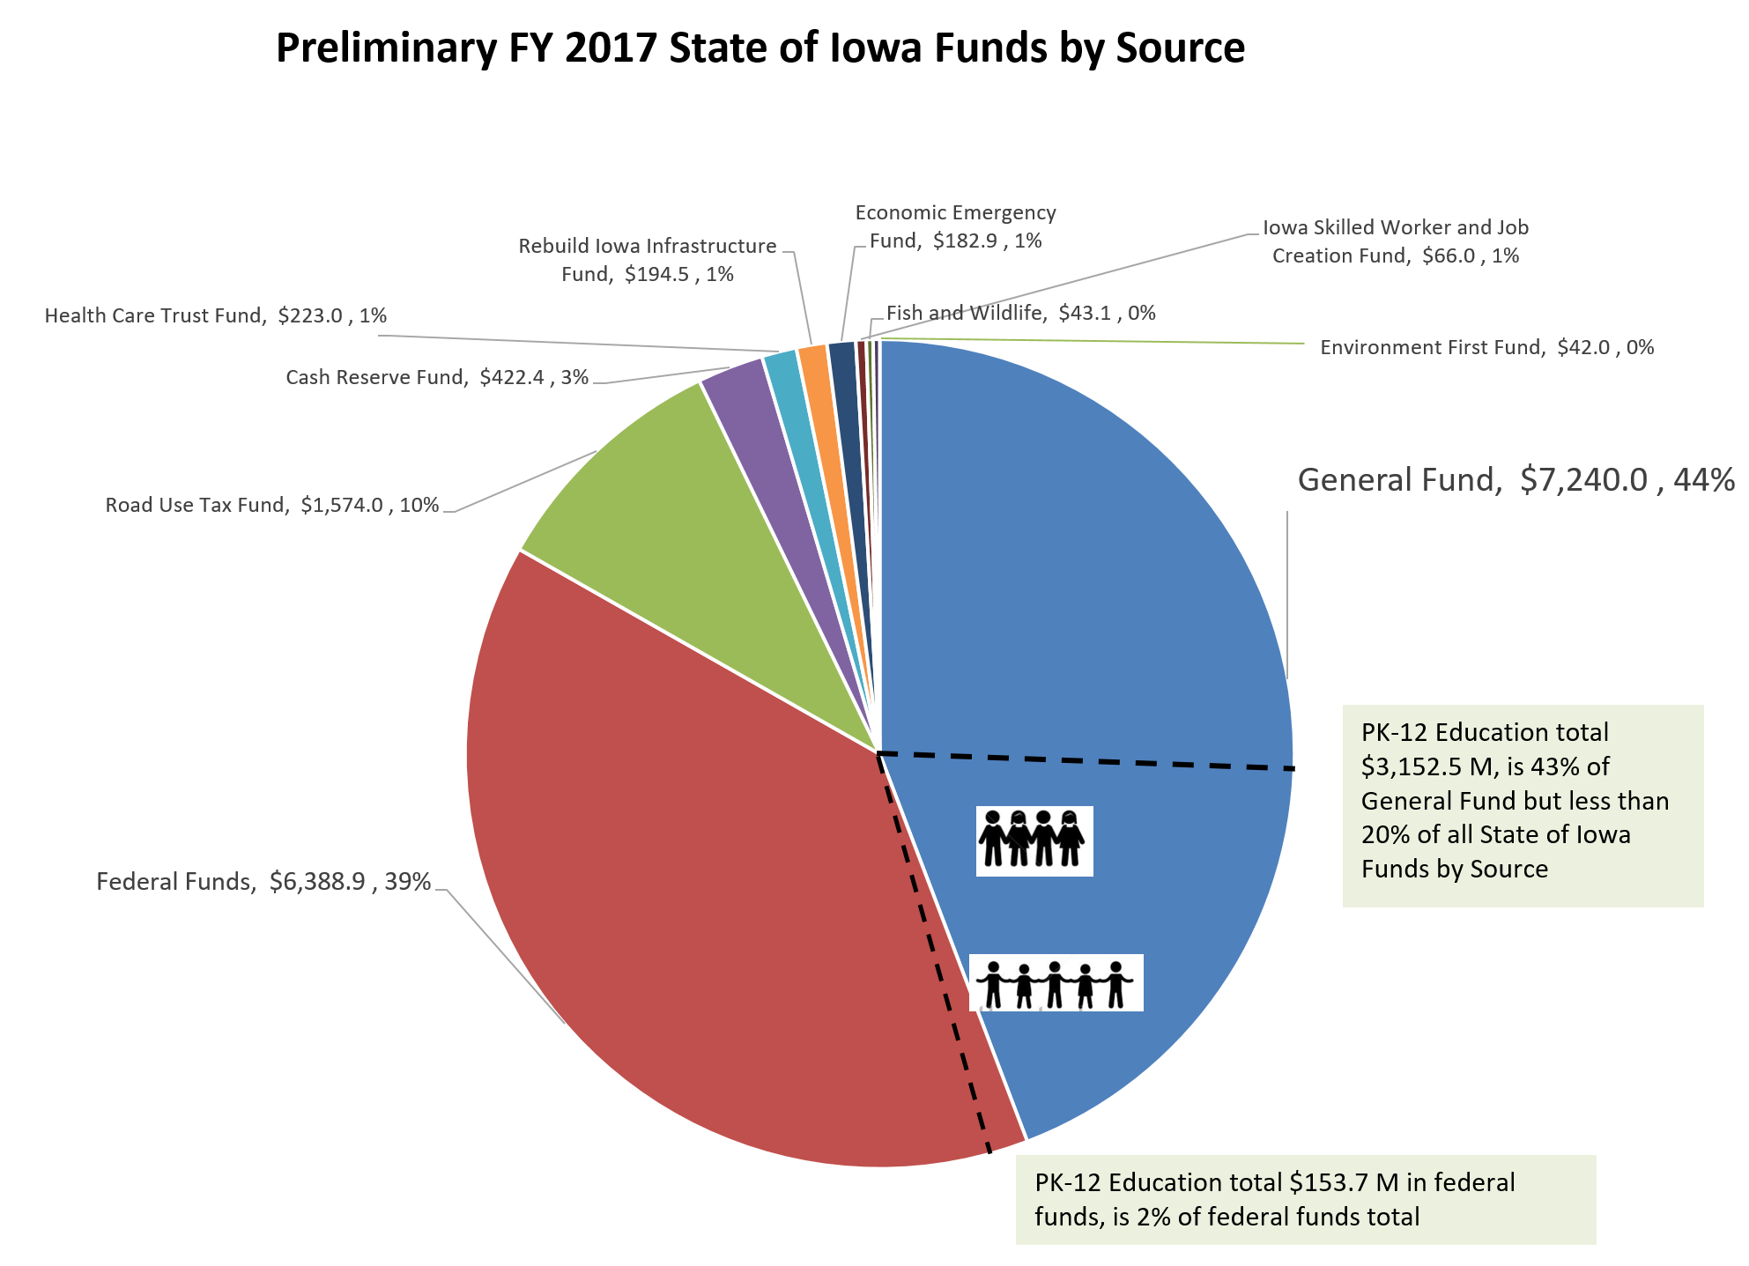
RSAI Contacts
RSAI Professional Advocate, margaret@iowaschoolfinance.com 515.201.3755
Robert Olson, Chair, Clarion-Goldfield/Dows, Superintendent, robert.olson@rsaia.org ,
Paul Croghan, East Mills and Essex Superintendent, pcroghan@emschools.org ,
Lee Ann Grimley, Springville, Board President, leeann.grimley@rsaia.org ,
Dennis McClain, Clay Central Everly, Superintendent, dmcclain@claycentraleverly.org
Laurie Noll, Fairfield, Superintendent, laurie.noll@fairfieldsfuture.org
Dan Smith, Harmony, Board President, dan.smith@rsaia.org
Duane Willhite, Superintendent, North Fayette Valley, dwillhite@nfv.k12.ia.us

