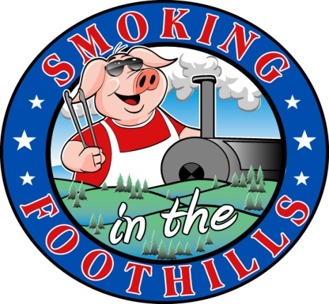
Smoking In The Foothills
Barbecue Competition And Festival
October 20th & 21st 2017
Historic Downtown Lenoir, NC
This competition is a Kansas City Barbecue Society Sanctioned (KCBS) sanctioned event. This competition will offer some world class barbecue and also give the public a chance to see how a professional barbecue pitmaster cooks barbecue. World Champion Pitmasters will be in competition at the event. Prizes will be awarded in a variety of categories with dozens of opportunities to take home cash prizes and trophies. The festival will also offer a wide variety of activities for the public including; Live entertainment, arts & crafts, beer garden, 50/50 raffle, People’s Choice Tastings, as well as kid’s activities.

Event Profile
- Attendance Will Be In The Thousands
- Kansas City Barbecue Society (KCBS) Sanctioned Event
- North Carolina Governor’s Proclamation designating this a North Carolina Championship Event
- Plenty of free parking
- Live Entertainment
- Arts & Crafts
- Beer Garden
- A Poker Run featuring the Blue Knights and Red Knights
- Kid’s activities and inflatables
- Cornhole Tournament
- A variety of delicious Barbecue and other festival favorites

Sponsorship Levels And Benefit Summary
Title Sponsor of the Festival (King Of The Pitmaster) $7,000
- Title Sponsor for Smoking In The Foothills
- Banner Above The Stage During The Event (The Most Prominent Placement of Any Banner and It Will Be Prominent In The Photos Of The Event.
- Several Banners On Festival Grounds
- Several Promotional Spaces At The Festival
- Year Long Link To Your Website From Every Page On The Festival Website
- Corporate Logo on All Printed Material (posters, magazine ads, business cards for the festival and any and all media for the festival)
- Corporate Tag Included On All Radio Ads, PSA’s and live Interviews
- Access to the Cook’s Lunch and Social Held on Friday of the festival
Named Sponsor of the Festival (Pitmaster) $5,000
- Identified as Pitmaster Sponsor for Smoking In The Foothills
- Banner At Stage During The Event-Will Be Prominent In Photos Of The Event
- Free Promotional Booth space at the festival
- Year Long Link To Your Website From Your Company Logo On The Festival Website
- Corporate Logo on All Printed Media (posters, magazine ads)
- Corporate tag included on all radio ads, PSA’s and live interviews
Major Festival Sponsor (Whole Hog) $2,500
- Identified as Whole Hog Festival Sponsor
- Year Long Link To Your Website From Your Company Logo On The Festival Website
- Prominent Display Of Your Company Banner on festival grounds
- Free Promotional Booth space at festival
- Corporate Logo on All Printed Media (posters, magazine ads)
Festival Sponsor (King Of The Brisket) $1000
- Identified as King Of The Brisket Grill Sponsor
- Year Long Link To Your Website From Your Company Logo On The Festival Website
- Free Promotional Booth at the festiva
- Company listed on All Printed Media (posters, magazine ads)
Contributing Sponsor (King Of The Backyard Grill) $500
- Identified as King Of The Backyard Grill Sponsor
- Free Promotional Booth at Festival
- Year Long Link To Your Website From The Festival Website
Friend of the Festival (King Of Sauce) $250
- Identified as King of Sauce Sponsor
- Free Promotional Booth at Festival
- Year Long Link To Your Website From Festival Website

Custom Sponsorships Are Available. We Will Work With You To Taylor A Sponsorship Just For You. This Festival Would Not Be Possible Without Our Sponsors.

