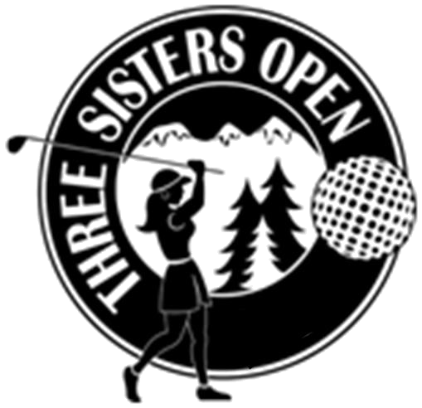
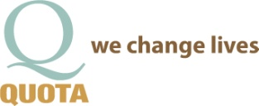

Presents the 2017 Three Sisters Open

Dear Sponsor, January 25, 2017

We are very pleased to announce the 23rd annual Three Sisters Open Golf Tournament. This year’s event will be held Saturday, June 17, 2017 at Widgi Creek Golf Club. We appreciate your continued support, and in return, we offer you excellent advertisement opportunities plus partnership with a great nonprofit organization.

About the Program: The women from the Leadership Bend Class of 1994 founded the Three Sisters Open, and five years later, Quota International of Central Oregon joined forces to host this exciting community event. The goals for the two organizations are to:
- Award scholarship to women who wish to further their education through the Bend Women’s Scholarship Fund, and
- Support community organizations and provide funds for the deaf, others with hearing and/or speech impairments, and disadvantaged women and children through Quota.
Each year we have managed to exceed our goals thanks to businesses like yours.

This event is one of the ways we are able to financially support many worthwhile community programs and disadvantaged individuals. Since 1995, the Bend Women’s Scholarship Fund has awarded 196 scholarships, and Quota has provided support for many community programs such as Central Oregon Regional Program, Volunteers in Medicine, Healthy Beginnings, Saving Grace, and High Desert ESD, providing auditory testing, amplification equipment and hearing aids for local residents. Your support for this event will allow us to respond to the numerous requests we receive throughout the year.

Our tournament is open to 144 women golfers, and we have attracted participants from Oregon, Washington, Idaho, and California. It truly has become the tournament that women golfers look forward to each year.

Your participation as a sponsor is vital to the success of this event. Please take a few moments to look over the attached Sponsorship Opportunities and determine which type of sponsorship level your business desires. Please fill out the form titled “Secure Your Sponsorship Today” and attach your check. If you have any questions, please contact me at 541-408-6328 (Tess).

Sincerely,

Nancy Blankenship Tess Tompos
2017 Quota TSO Chair 2017 Quota TSO Co-Chair, quotatess@bendbroadband.com

www.quotaofcentraloregon.org

Quota International of Central Oregon
PO Box 1372 • Bend, OR 97709
Nonprofit 501c3 Tax ID #52-2453073

