GAM BOOK SWAP!

The GAM "Library" is sponsoring the 2014 Conference Book and Resource Swap!
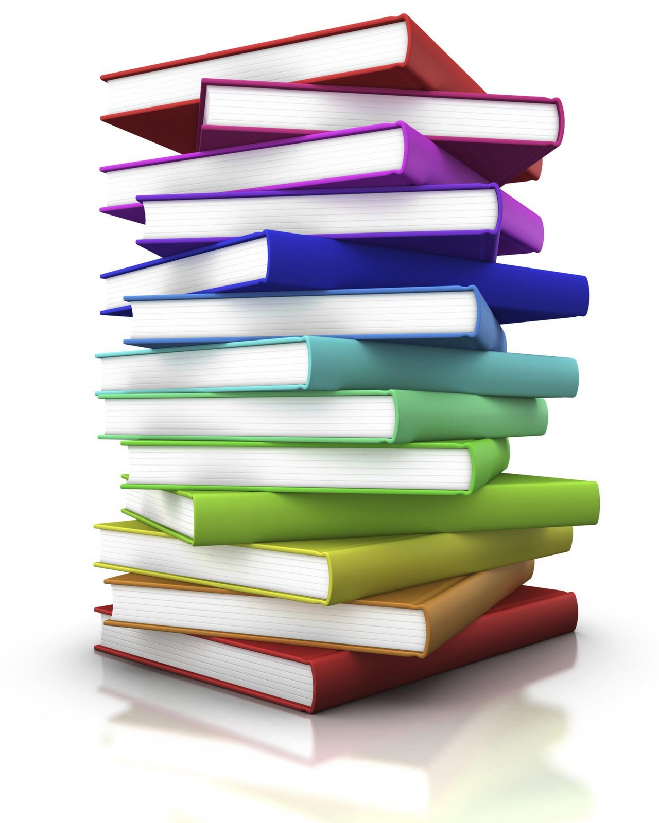
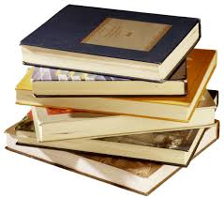

Easy as 1…2…3!!

Here's how it works...
1. Drop off your books as a donation to the members of GAM.

2. If you see a resource that you would like, we ask you TAKE the resource and LEAVE a small monetary donation in the provided box.
.
3. Any books/resources left over will be either sold or donated; all proceeds will go to GAM.

Questions? Direct to 2014 GAM Librarian Brian Stuhlman, at stuhlmanbrian@yahoo.com

