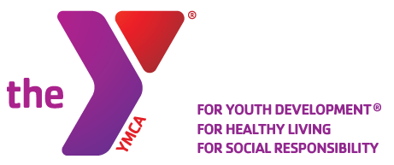
The YMCA of Acadiana Medication & Medication Administration Policy.

The YMCA of Lafayette Louisiana Inc. (DBA The YMCA of Acadiana) reserves the right to refuse administering any medication that would present a conflict of faith, conscience, or morality for our staff.
The YMCA of Acadiana requires a full medical explanation of the medication and its effects on the child for which the medication is requested.
The YMCA of Acadiana requires a full release of liability from the parents/guardians in writing sign by both parents or guardians.
The YMCA of Acadiana requires any medication that has been agreed to be administered by our staff must be secured in a locked metal box. 2 keys must be distributed to the YMCA staff.
The YMCA is not responsible for the loss of any medication.
The YMCA will not possess or administer any schedule 2 medication.
The YMCA will not possess or administer any medication that has a possible side effect to the person administering the medication.
The YMCA requires written approval from our C.E.O. Dennis Doc Stepanek II in order to possess or administer any medication to your child.
Approval of the administration of any medication will be granted on a case-by-case bases.
Failure to provide all information concerning medication or illness of your child will result in immediate dismissal of your child from the YMCA of Acadiana program.
HELP US HELP YOUR FAMILY! WE NEED A FULL UNDERSTANDING OF ANY & ALL MEDICAL CONDITIONS!

THE YMCA STAFF IS NOT TRAINED or CERTIFIED to ADMINISTER any MEDICATION.
Parents signature ______________________________
Date ____________________

