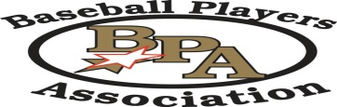
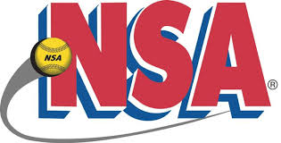

INDIANA NSA/BPA HALL OF FAME
NOMINATION FORM

Application Date: ___________________ Program: _____NSA Slow Pitch
_____ NSA Fast Pitch
_____ BPA Baseball

Nomination: ___________________________ Category: _____ Coach/Manager
Last First Mid Int _____ Player
_____ Umpire
Address: ___________________________ _____ Director
___________________________ _____ Park
_____ Meritorious
Phone: ________________________ _____ Sponsor/Org.

Gender: _____ Male _____ Female Started with NSA/BPA: _______ years

Reason for Submitting: ____________________________________________________
________________________________________________________________________
________________________________________________________________________
________________________________________________________________________
________________________________________________________________________

Sponsor’s Name: ___________________ Sponsor’s Phone: ____________________

Qualifying Statement: A thorough statement supporting the nomination of this individual or group MUST be submitted with this nomination. Please ensure that all minimal requirements are met.

SEND all documentation with this application. Applications will not be processed without all required documents.

All nominations will be reviewed by the Indiana Hall of Fame Committee prior to the Hall of Fame Banquet, and be announced at the current banquet.

Send all documentation, including application to:

Cindy Birnell, IHOF Secretary
PO Box 43
Winimac, IN 46996
clbirnell@gmail.com

