BRIMPSFIELD PARISH COUNCIL
AGENDA OF EXTRA-ORDINARY MEETING of
Brimpsfield Parish Council to take place at
The Village Hall on thursday 9th June 2022 at 7.30pm
The Chair of Council to open the meeting
- Record of attendance to be recorded (anticipated) Parish Councillors Tom Overbury, Roger Lock, Claire Jardine, Michael McWilliam, Jane Parsons, Archie Larthe, District Councillor Julia Judd,
- Apologies for absence to be recorded
- Declarations of Interest on items on the Agenda to be invited -
- Council to approve the minutes of the Parish Council Meeting held on the 17th May 2022
- Public Session: at the discretion of the Chair of the meeting up to 15 minutes will be set aside and Members of the public will be invited to speak at this point
- County and District Councillor will be invited to present report at this point
- Planning applications - planning applications received since last meeting to be discussed

application | address | summary | Received /sent to Cllrs | Closing date | PC comments
22/01381/LBC  And  22/01380/FUL | Brimpsfield house | Additional details for information only | 31/5/22 | 1/6/22 | For information
22/01491/OUT | Birdlip View | dwelling | 19/11/21 | 1/6/22 | Deadline Extension sought and approved  Previous application  21/04236/PLP  2/12/21  Council objected and submitted comments as approved at December meeting (see attached)
21/03856/FUL amendments noted at last meeting- | The Mill House | erection of a single storey rear extension, | 21/10/21 | DC Judd has requested a full committee decision | Discussed 14th April and January 22- Council agreed not to submit comments
22/01532/FUL | Stokesley House | Single storey side extension | 17/5/22 | 8/6/22 | None received
other planning matters
22/00297/FUL | Single storey side extension and demolition of single storey garage | 1 Old Rectory Brimpsfield Gloucester – permitted

- Date of next meeting to be confirmed as 19th July 2022 at 7.30pm-

21/04236/PLP -previous comments submitted

Brimspfield Parish Council OBJECT to this application on the grounds that this application would be an over-development of the site and re-iterate the comments of Birdlip and Cowley Parish Council namely
Design
- Highway access and parking
- Over development
- Privacy light and noise
Comment:Cowley and Birdlip Parish Council as the Parish most impacted by this area, Objects to
this application.
Over-development/Overcrowding of the Site
The site is considered too small to allow a further residential property. The existing property on the site, Birdlip View, is a 5 bedroom cottage on 3 floors which has recently obtained permission to replace the existing ground floor extension without impact to any other residential properties and install a new car port in the front driveway. The rear garden is small and if this development is
permitted it will have a detrimental impact on Birdlip View which will have little or no rear outdoor space.
The surrounding area which has been known as 'Catchbar' or Parsons Pitch is approximately hal fa mile outside the centre of Birdlip and represents a small hamlet of 6 properties which are appropriately spaced on both sides of the route of what was originally Ermin Street. This development would give the impression of overcrowding and have a negative impact on the historic character of this area and an adverse impact on the vista of Hawcote Hill viewed from the south of the development.
Overshadowing of adjacent Properties
The proposed development will overshadow both Birdlip View and Rose Cottage opposite, particularly as the site slopes upwards from the road towards Hawcote Hill to the South and upwards towards Parsons Pitch in the East. This will place the proposed property in an elevated position that will overshadow Rose Cottage opposite. Birdlip View has been constructed perpendicular to the road and as a result will overlook the proposed development which will be in close proximity
Highway safety
Cirencester Road narrows considerably at the location of the site and there are no public footpaths in this area. Any on street parking would cause an obstruction to the commercial vehicles who readily need access to the Brewery and other industrial units at the end of Cirencester Road which is a cul-de-sac. Any parking for residential vehicles would need to be provided with what is an already a constrained site and it is noted that the road has become busier in recent years with the many patrons to the Clavell and Hind brewery.
Contrary to CDC Local Planning Policy DS3
SMALL-SCALE RESIDENTIAL DEVELOPMENT IN NON-PRINCIPAL SETTLEMENTS
1. In non-Principal Settlements, small-scale residential development will be permitted provided it:
- demonstrably supports or enhances the vitality of the local community and the continued availability of services and facilities locally;
- The availability of services and facilities are already unable to support this development particularly in terms of the lack of public transport, lack of further capacity in the water and sewage system and no local shop, children's play area or community sports facilities
- The Parish Council does not support new development to the South or east of the main high street of Birdlip Village to restrict further traffic on the already congested local roads. In particular the Parish Council does not support any new development that increases traffic near the village school as there is no specified and safe parking or school drop off area.
- complements the form and character of the settlement; and
The form and character of this development will have an adverse impact on the group of 6properties in this hamlet to the east of Birdlip. In particular it will have an adverse impact on the form and character of Birdlip View which is a heritage property believed to be built in the mid19th century.
- does not have an adverse cumulative impact on the settlement having regard to other developments permitted during the Local Plan period.
There is an adverse cumulative impact on the area of Birdlip as a whole due to the recent residential development at the Kelland's site, the recent decision on planning to permit 4 furtherresidencies at Blacklaines Farm and the permission to build 4 new homes at High Green Farm

Draft minutes of ANNUAL MEETING OF THE COUNCIL
HELD AT 7PM ON 17TH MAY 2022
IN THE VILLAGE HALL
Welcome and introductions –
Election of Chairman took place
Following a Nomination/seconded – Cllr Overbury was duly elected signing of acceptance of office papers
Election of Vice-Chairman took place – Following a Nomination/seconded – Cllr Parsons was duly elected signing of acceptance of office papers signing of acceptance of office papers
Attendance recorded as Parish Councillors Tom Overbury, Roger Lock, Michael McWilliam, Jane Parsons, Heather Eaton, Claire Jardine, District Councillor Judd & 1 member of the public
Apologies recorded Parish Councillor Archie Larthe
County Councillor Joe Harris did not attend
Declaration of Interest for matters on the agenda were invited- none
Public Participation was invited – none at this point
No Report received from County Councillor Harris
Report received from District Councillor Judd (this was deferred to the Parish Assembly which immediately follows this meeting)
Minutes of the previous Parish Council Meeting held on 14th April 2022 approved following minor amendments – Chair to sign updated copy
Council reviewed structure of committees/working groups and any delegation of authority to those committees
Common Land working group -no delegated authority– members Tom, Roger, Jane, Archie & Heather
Road Safety working group – no delegated authority – members Claire and Michael

Council agreed delegation to Clerk of authority to make submission of comments on planning matters where no meeting of the Council is able to be held
Council deferred changes possibly required to standing orders or financial regulations pending new publications
Council considered if any changes are required to the asset register – none
Council reviewed representation on outside bodies -none
Council considered if any changes are required to insurance policy for the coming year - none
Council considered if any changes are required to banking mandate - still in process for electronic banking – Clerk to chase
Council deferred any changes possibly required to its Complaints, Freedom of Information or Data protection policies procedure -pending new publication
Council confirmed it wishes to continue with its standard contracts for grass cutting and payroll,
Council confirmed it wishes to renew its subscription to GAPTC
Council approved the financial reports and payment list as attached
Council approved its AGAR completion and delegated to the Chair of Council to sign the appropriate forms
Council agreed that its meeting schedule shall remain as 3rd Tuesday of May, July, September, November, January, March commencing at 7.30pm
Any other business for information
Planning items since received and Council asked for an additional meeting on Monday 6th June at 7.30pm

Meeting closed at 19.38

Approved Minutes of Extra Brimpsfield Parish Council meeting
held on 14th April 2022 at 7.30pm
In the Village Hall
Welcome and introductions
Attendance recorded as Parish Councillors Tom Overbury, Roger Lock, Michael McWilliam, Jane Parsons, Heather Eaton, Claire Jardine & 1 member of the public
Apologies for absence received – Parish Councillor Archie Larthe & District Councillor Judd
County Councillor Joe Harris did not attend
Declaration of interests on matters on the agenda were invited -none
Public session – no comments at this stage as member of the public wished to speak on item 8
Minutes of the previous meeting approved and minor amendments were approved by Council
An opportunity was given for District and County Councillors to speak to the meeting regarding the proposed Boundary Review and its possible implications – not in attendance
Council considered and approved its response to Boundary review consultation – details distributed via email and as attached - Discussion points
Following 2 roadshows /information sharing by CDC, Council considered the boundary relating to Brimpsfield Parish area

There are some dwellings which are close geographically to Birdlip
It was noted that Birdlip & Cowley Parish Council is intended to split

Public consultation and the lack of communication by CDC and the member of public noted that he was not informed on the matter until he received the agenda of this meeting. He asked for his disappointment in the lack of consultation and publicity for this review

The member of public felt that the original map lines were not correctly drawn on CDC documents

Member (Chair) of the Parish Council had contacted the “affected” homeowners on the evening of the roadshow to make sure that they were aware. Other members contacted the public subsequently
CDC officer discussion point was raised by Parish Councillor as one of the quoted feed -back was disputed
Deadline date for feedback was discussed as the CDC meeting in May 2022 is due to make a decision.

Effect on electoral roll and individual contributions to annual precept was noted
Effect on postcode /house valuations was discussed

The Council specifically looked at Blue dotted line and accepted that this dwelling to move to Birdlip

Other properties discussed as listed on post-it note
Gowanlea/Blacklaines Farm House – had expressed a wish to be in Birdlip Parish
Haregrove /Leveretes
Church View Bungalow, Blacklaines House, Cranmore
Blacklaines Cottages 1, 2- had expressed an interest in Brimpsfield
Blacklaines Farm

Boundary within NDP’s (future) was noted

Council agreed this map as preferred boundary (as per SD email 13/4/22) 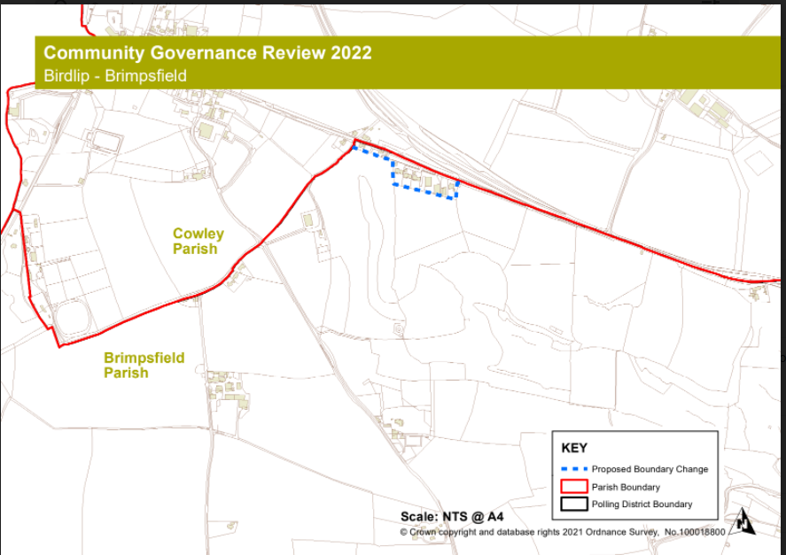

Council approved letter to property owners/contractors at Woodfield, Caudle Green to repair tracks across Brimpsfield PC owned common land -Cllr Claire Jardin
Any other business for the purpose of information sharing as no decisions can be made at this point
21/03856/FUL The Mill House additional information available -noted
Date of next meeting noted as 17th May 2022 at 7.00pm- AGM and 8pm for Parish Assembly
Village website to be asked to publicise. Agenda for Parish Assembly to be distributed 14 days before hand. Village Hall Committee Chair to be invited to present a report,
Close of meeting 20.17

Year- end financial reports to 31/3/22
Cash book
Date | Detail | Chq no | Payment/receipts | balance
01.04.21 | opening credit bal (TREASURERS C/A) |  |  | 4029.17
22/04/2021 | precept |  | 4743.00 | 8772.17
26/04/2021 | b j holder salary | so | 194.18 | 8577.99
17/05/2021 | b holder expenses | 580 | 59.61 | 8518.38
17/06/2021 | hmrc | 584 | 149.40 | 8368.98
19/07/2021 | b holder expenses | 585 | 68.81 | 8300.17
01/09/2021 | came & co | 586 | 374.50 | 7925.67
25/05/2021 | b j holder salary | so | 194.18 | 7731.49
25/06/2021 | b j holder salary | so | 194.18 | 7537.31
25/07/2021 | b j holder salary | so | 194.18 | 7343.13
25/08/2021 | b j holder salary | so | 194.18 | 7148.95
25/09/2021 | b j holder salary | so | 194.18 | 6954.77
23/09/2021 | precept |  | 1581.00 | 8535.77
14/10/2021 | hmrc j,a,s | 587 | 149.60 | 8386.17
14/10/2021 | pata | 588 | 23.85 | 8362.32
14/10/2021 | dicon roberts | 589 | 385.00 | 7977.32
16/10/2021 | b holder expenses | 590 | 67.99 | 7909.33
16/10/2021 | I selkirk | 591 | 105.00 | 7804.33
19/10/2021 | hmrc o,n.d | 592 | 149.60 | 7654.73
01/12/2021 | I partridge | 593 | 1290.00 | 6364.73
25*10/21 | b holder salary | so | 225.48 | 6139.25
25/11/2021 | b holder salary | so | 225.48 | 5913.77
25/12/2021 | b holder salary | so | 225.48 | 5688.29
17/01/2022 | pata | 594 | 23.85 | 5664.44
28/01/2022 | b holder salary | so | 225.48 | 5438.96
28/02/2022 | b holder salary |  | 225.48 | 5213.48
18/01/2022 | b holder expenses | 595 | 13.74 | 5199.74
20/01/2022 | wayleave | receipt | 28.98 | 5228.72
28/03/2022 | b holder salary | so | 225.48 | 5003.24
09/03/2022 | pata | 596 | 94.20 | 4909.04
08/03/2022 | b holder expenses | 597 | 13.54 | 4895.50
10/03/2022 | t overbury website fees | 598 | 195.60 | 4699.90
22/03/2022 | b holder backpay | 599 | 41.64 | 4658.26
31/03/2022 | hmrc jfm | 600 | 160.00 | 4498.26

Payment list for approval at May meeting
Expenses/clerk £16.81
HMRC £50.60 x3
GAPTC subscription £74.04
PATA Payroll annual fee £95.40
Roger Lock paint £59.99
Insurance £446.53.

Bank reconciliations

BANK SUMMARY
 | o/bal 1/4/21 |  | 4029.17
 | payments TO 28/12/21 |  | 5883.89
 | receipts TO 28/12/21 |  | 6352.98
 | Closing balance28/3/22/22 |  |  | 4498.26
BANK RECONCILIATION
treasurers | bank statement 28/3/22 |  |  | 4658.26
 | unpresented cheque | 600 | 160.00
 |  |  |  | 4498.26
 | current account |  |  | 4498.26
 | deposit account |  |  | 3146.86
 | BANK BALANCE |  |  | 7645.12
 | reconciled balance |  |  | 7645.12

Reserves at year end
 |  | 2021 | 2022
 | reserves brought forward | 6479 | 7176
 | general reserves | -1273 | 520 | Council budgeted for £900 overspend but achieved £1377 underspend
 | earmarked DEFIB grant | 625 | 625
 | earmarked equipment | 1500 | 1500
 | contingency fund | 6324 | 5000 | Ideally = 1 yr precept
 | at year end bank balance | 7176 | 7645

Council approved distribution of reserves at year end.
Council to consider charges for contested elections to be imposed by District Council and considered if some of the contingency fund should be vired to new “election” earmarked reserve

Budget against actual at year end
 | BUDGET | income/ expenditure 31/3/22 | BALANCE
INCOME
Precept | 6324 | 6324 | 0
Interest | 1 | 0 | 1
VAT refund | 0 | 0 | 0
Wayleave | 30 | 29 | 1
other | 0 | 0 | 0
TOTAL INCOME | 6355 | 6353 | 2
EXPENDITURE
Clerks Salary | 2910 | 3044 | -134
Admin / Expenses | 360 | 348 | 12
Payroll Management | 100 | 142 | -42
Insurance | 365 | 375 | -10
Audit | 120 | 105 | 15
Grass cutting Brimpsfield | 500 | 500 | 0
Grass cutting Caudle Green | 1000 | 790 | 210
Meeting Room hire | 200 | 0 | 200
Subscription | 80 | 0 | 80
Training | 0 | 0 | 0
legal/specialist Advice | 150 | 0 | 150
Maintenance & repairs | 800 | 385 | 415
Grants / Donations | 200 | 0 | 200
FROM RESERVES |  | 0 | 0
Equip & Assets | 0 | 0 | 0
Web- site | 176 | 196 | -20
Sect 137 | 0 | 0 | 0
Village hall Grant | 300 | 0 | 300
EXPENDITURE TOTALS | 7261 | 5884 | 1376
Anticipated from reserves | 906 | 471 | Actual underspend
 | 6355 | 6355

AGAR forms approved and signed

Annual financial statement

