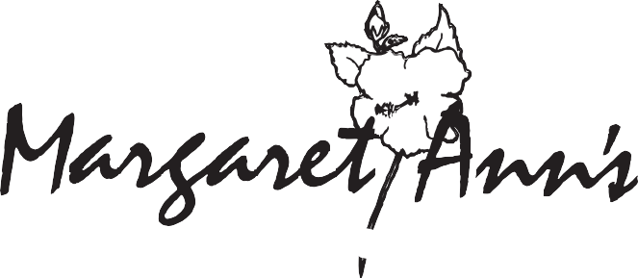
ALL NATURAL GOURMET COOKIES / CATERING
Holiday Cookies

Margaret Ann’s Gourmet Cookie Varieties
Chocolate Chunk -Semi-sweet chocolate chunks folded into a rich batter
Toffee Crunch -Crushed Heath bars and pecans folded into a brown sugar batter
Oatmeal Raisin -Oatmeal and raisins folded into a cinnamon batter
Chocolate Whopper -A chocolate lover’s fantasy – three kinds of chocolate and pecans folded into a dark chocolate batter
Cookies by the Pound !! -A treat for your parties, cookie jars, gift enclosures or cookie exchanges. They are generally sold as a gourmet mix of all four varieties. You may specify your particular favorites. (Approximately 24 cookies per pound) 1lb Gourmet Mix - MA116 $13.00 1lb Chocolate Mix - MA117 $15.00

Gift Selections For Local Delivery And Shipping
Asterisk (*) designates items available for shipping
Gourmet Gift Bag -Our distinctive gold striped bag filled with one pound of Margaret Ann’s Gourmet Cookies tied up with a bright bow all ready for gift giving. MA100 - $16.00
Margaret Ann’s Signature Gift Box -Our Logo Box filled with one or two pounds of cookies, decorated with the colors of the season!
1 lb – MA004 - $22.00 2lb – MA005 - $32.00
*Cookie Tins -A variety of sizes filled with a mix of Margaret Ann’s Gourmet Cookies. 2lb Tin – T102 $34.00 3lb Tin – T103 $44.00
4lb Tin – T104 $54.00 5lb – T105 $64.00
Our Famous Cookie Boxes and Baskets -Colorful containers filled with a mix of Margaret Ann’s Gourmet Cookies wrapped up with ribbons and bows. Add-Ons welcome!
2lb Box – MA102 $34.00 3lb Box – MA103 $44.00 4lb Basket – MA104 $54.00 5lb Basket – MA105 $64.00 You Name the Size – MA118 We Name the Price

Margaret Ann’s Gift Certificates – If you have a “hard to buy for” person on your list, send them a Margaret Ann’s Gift Certificate! You tell me how many dollars you want to spend and I will fill out one of our gift cards to reflect that and mail it to the recipient. Easy gift giving!! The person can use it for cookies or one of our wonderful dinner bags

Holiday Specials
Holiday Gift Bags - Dashing Reindeer, Woodland Santa, Jolly Christmas Trees, Chalkboard and Chevron Strips plus all of our regular Get Well, Happy Birthday, etc.
1 Pound – MA001 $24.00 2 Pound – MA002 $34.00 3 Pound – MA003 $44.00

Tower Of Treats – Choose a two or four pound tin of Margaret Ann’s Gourmet Cookies topped with a red tin of Margaret Ann’s Sharp Cheddar Cheese Wafers topped with a tin of Hubs Virginia Peanuts - all wrapped in holiday colors. 2 Pound - W111 $68.00 4 Pound – W110 $88.00

Celebration Basket Or Tin - A perfect gift for a family! A beautiful basket filled with three pounds of Margaret Ann’s Gourmet Cookies, Hubs Virginia Peanuts, Margaret Ann’s Cheese Wafers, coffee, tea, holiday candy and Margaret Ann’s Elegant but Easy Desserts Cookbook.
Basket – W115 or Tin – W114 $110.00

Holiday Extravaganza - A tower of Holiday Tins stacked two feet high!! A large tin, filled with wine and coffees and teas, is topped with a two pound tin of Margaret Ann’s Gourmet Cookies. This duo is topped with a red tin of Margaret Ann’s Sharp Cheddar Cheese Wafers and a tin of Hubs Virginia Peanuts. This tower is all tied up with ribbons and topped with holiday candy.
W112 $135.00

Sheer Indulgence Basket or Tin - A beautifully decorated basket or tin with a bottle of wine, two pounds of Margaret Ann’s Gourmet Cookies and candy.
Basket - W113 - $60.00 Basket – T113 - $60.00

ADD-ONS: Can be added to all baskets and tins!
COFFEE | AD100 | $4.00 | HUBS PEANUTS | AD113 | $16.00
TEA | AD101 | $4.00 | CHEESE WAFER TIN | AD110 | $14.00
CANDY | AD103 | $5.00 | WINE | AD115 | $14.00
MARGARET ANN’S ELEGANT BUT EASY DESSERTS COOKBOOK MAC100 $10.00

RECEIVE 10% DISCOUNT BY PLACING YOUR HOLIDAY ORDERS BEFORE NOVEMBER 13, 2021
How To Order Margaret Ann’s Gourmet Cookies
BY PHONE, FAX OR EMAIL – After hours, leave your phone number so your order can be confirmed.
CORPORATE GIFT SERVICES – Our cookies make excellent business gifts. Corporate Accounts are welcomed.
Discounts are offered for large quantity orders.
PAYMENT METHOD - Check, Cash, Master Card, Visa, and American Express.
LOCAL DELIVERY - Daily delivery in the Tampa Bay area. Cost based on the delivery location.
SHIPPING AND HANDLING – Cookie gifts will be packaged and shipped via UPS Ground Service. Air and Overnight delivery are also available. Charges are based on destination and weight.
PHONE: 727-525-3983 • FAX: 727-525-1785 • margaretann@margaretanns.com

Margaret Ann’s Catering
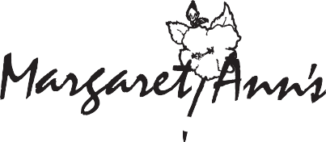

ALL NATURAL GOURMET COOKIES / CATEIRNG
Parties and Dinners. See our menus at www.margaretanns.com
Margaret Ann’s at Home
-Remember our wonderful frozen appetizers, entrees and side dishes for this busy time of year. You can
order a full party and come by and pick it up or have us deliver to you! These items are also found at our website - www.margaretanns.com

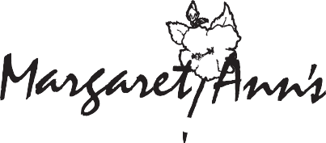

ALL NATURAL GOURMET COOKIES / CATERING

5625 4th Street North St. Petersburg, FL 33703
Holiday 2013

PHONE: 727-525-3983
FAX: 727-525-1785
www.margaretanns.com margaretann@margaretanns.com

Holiday 2021

