REGULAR MEETING
JUNE 16, 2022
The Regular Meeting of the Town Board of the Town of Hampton, County of Washington and the State of New York was held at the Town Hall, 2629 State Route 22A, Hampton, New York, on the 16th day of June 2022.

PRESENT: David K. O’Brien------------Supervisor
Donald Sady-----------------Councilman
Tamme Taran----------------Councilwoman
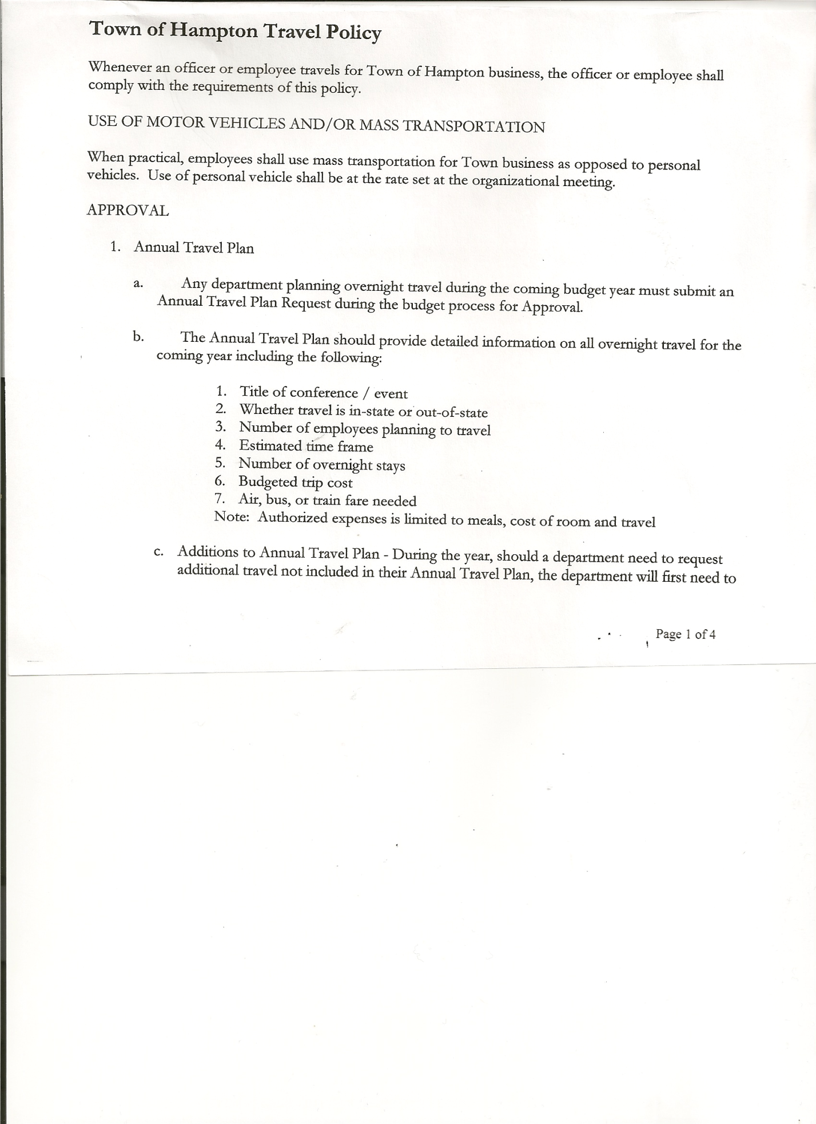
Michael Pietryka------------Councilman
Travis Dean------------------Councilman - absent
Rebecca Jones---------------Town Clerk
Camilla Shaw----------------Tax Collector/Deputy Town Clerk
Tyler McClure---------------Highway Superintendent

Planning Board Member (s):… Bonnie Hawley, Chair; Matthew Pratt and Richard Cole
Others present at the Town Hall: See attached sheet

The Regular Meeting was called to order by Supervisor O’Brien at 7:30pm, followed by the Pledge of Allegiance. Location of Fire Exits were given. Quorum of board members present.

Supervisor O’Brien asked for a moment of silence in memory of Shirley Dayton (Nancy Moore’s mother, who resided at County Route 11)

RESOLUTION NO. 45-2022
APPROVAL OF THE MINUTES
On a motion of Councilwoman Taran, seconded by Councilman Sady, the following resolution was ADOPTED: AYES 4 O’Brien, Sady, Taran, Pietryka
NAYS 0
ABSENT 1 Dean
RESOLVED, that the Regular Town Board Meeting Minutes for May 19th, 2022 are approved.

Larry Carman, Dog Control Officer resigned as DCO effective June 14th, 2022.
Richard Cole is interested in the position. He spoke with the Town Board and expressed the need for a local person to hold this position, has experience with animals and he also has a kennel at his home. He understands and is willing to complete the necessary education and interview with NYS Department of Ag and Markets.
Following the above discussion, the following resolution was introduced.

RESOLUTION NO. 46-2022
APPOINTMENT OF NEW DOG CONTROL OFFICER
On a motion of Councilwoman Taran, seconded by Councilman Pietryka, the following resolution was ADOPTED: AYES 4 O’Brien, Sady, Taran, Pietryka
NAYS 0
ABSENT 1 Dean
RESOLVED, to appoint Richard Cole as the new Dog Control Officer.

Camilla Shaw, Tax Collector….. no activity. Submitted Bank Statement to the Board for review and signatures.

TOWN BOARD MEETING
JUNE 16, 2022 PAGE 2

Bonnie Hawley, Chair gave Planning Board Report……copy of the minutes of their meeting held June 8th, 2022 are attached. Next meeting is planned for July 13th, 2022 at the Town Hall.

Tyler McClure, Highway Superintendent submitted his report, copy of which, is attached.
Also received a revised Highway Roadside Mowing Contract from the County. Original payment was going to be $2244.94, the revised payment is going to be $2923.83.

SUPERVISOR’S REPORT/ COUNTY UPDATES/ COMMUNICATIONS

RESOLUTION NO. 47-2022
APPROVAL OF SUPERVISOR’S MONTHLY REPORT
On a motion of Councilman Sady, seconded by Councilman Pietryka, the following resolution was ADOPTED: AYES 4 O’Brien, Sady, Taran, Pietryka
NAYS 0
ABSENT 1 Dean
RESOLVED that, the Supervisor’s Monthly report be accepted as submitted for MAY
04/30/22 05/31/22
ACCOUNT BALANCE RECEIPTS DISBURSEMENTS BALANCE
General Fund $ 58,238.04 $ 837.34 $ 5,693.93 $ 53,381.45
Highway Fund $342,678.18 $ 8.76 $ 9,608.94 $ 333,078.00
Equipment Reserve $114,932.44 $ 2.93 $ 0.00 $ 114,935.37
Fire #1 $ 44,163.00 $ 0.00 $ 0.00 $ 44,163.00
Fire #2 $ 10,404.00 $ 0.00 $ 0.00 $ 10,404.00
Cemetery $ 1,759.02 $ 1.44 $ 0.00 $ 1,760.46
Totals $572,174.68 $ 850.47 $ 15,302.87 $ 557,722.28
All Board Members present signed Supervisor’s Report.

NEW BUSINESS
Dog Control Law….current law was done in 2016. Town Attorney reviewing. Possibly increasing fees and fines.

Town Assessor…..Vicki Hayner will be retiring at the end of 2022. Checking on info, may go with County Assessing.

PUBLIC COMMENTS/COUNCIL COMMENTS
Richard Cole, President of the Hampton Fire Co. shared that the Fire Co. had received a $25000.00 donation from Ray Energy to buy a fire engine rescue truck from Greenwich, NY for District #2 Fire Station. There will then be an Engine Tanker and Engine Rescue Truck for District #2 Fire Station.

Question was asked about filling pools….not at this time, due to ages of trucks and availability of members to do it.

TOWN BOARD MEETING
JUNE 16, 2022 PAGE 3

RESOLUTION NO. 48 -2022
AUDIT OF CLAIMS
On a motion of Councilwoman Taran, seconded by Councilman Sady the following resolution was ADOPTED: AYES 4 O’Brien, Sady, Taran, Pietryka
NAYS 0
ABSENT 1 Dean
RESOLVED that the bills have been reviewed by the Town Board and are authorized for payment in the following amounts.
General Fund No. 71 through No. 90 $ 32,329.93
Highway Fund No. 57 through No. 63 $ 11,931.29
Total both funds $ 44,261.22

The Town Clerk’s report for May 2022 was submitted to the Board. The Town Clerk had Board Members review and sign bank reconciliation statements for the Town Clerk Account and Special Clerk Account dated May 31, 2022.

RESOLUTION NO. 49-2022
MEETING ADJOURNED
On a motion of Councilman Sady, seconded by Councilwoman Taran, the following resolution was ADOPTED: AYES 4 O’Brien, Sady, Taran, Pietryka
NAYS 0
ABSENT 1 Dean
RESOLVED that the meeting adjourned at 8:14pm.

Respectfully submitted,

Rebecca S. Jones, RMC
Town Clerk

