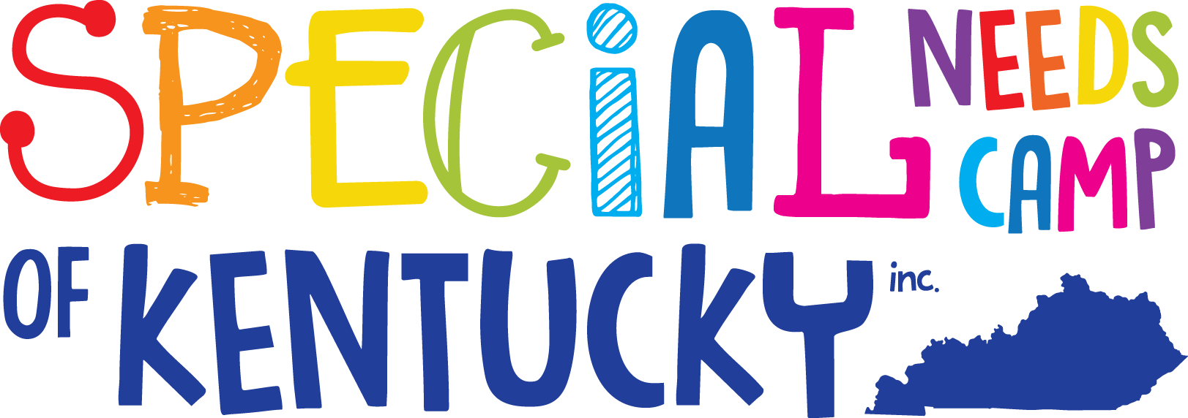

Who is it for?
Individuals, who are 13 years old and up with intellectual disabilities.

What is it?
An annual, week-long summer camp in Eastern Kentucky. Accepted campers will participate in a wide array of exciting activities and events during camp.

When is it?
June 22nd thur 26th, 2020

Where is it?
Bath County High School 645 Chenault Dr., Owingsville, KY. 40360

Campers and volunteers are encouraged to apply now!

Donations are needed and graciously accepted! SNCKI is a 501(c)3 non-profit organization entirely funded by donations.

To donate or apply, please contact us via any of the following ways:
PO BOX 875
Owingsville, KY 40360
(606) 336-0326
Website: www.specialneedscamp.org

