Public Aquarium California Specimen List
Marine Aquaria Receiver’s Lis. 84973

ECHINODERMS SPECIMEN LIST
Robert Burhans: (858) 774-2806 or email: Bob@matsucollections.com

**Special order specimens are those which are infrequently encountered or pose specific collecting challenges.

EXAMPLE | COMMON NAME  LATIN NAME | COMMENTS* | SIZE & DISTRIBUTION | US$
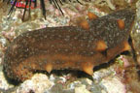 | Warty Sea Cucumber  Parastichopus parvimensis  Obtained from Licensed Sea Cucumber collector | On rocky substrate and soft bottoms | To 10 inches (25 cm)  Monterey, Ca. to Baja California Sur | 15.00
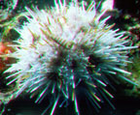 | White Sea Urchin  Lytechinus anamesus  Obtained from Licensed Urchin collector | On rocky substrate and soft bottoms | To 3 inches (7.5 cm)  Monterey, Ca. to Baja California Sur | 15.00
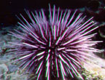 | Purple Sea Urchin  Strogylocentrotus purpuratus  Obtained from Licensed Urchin collector | On rocky substrate and soft bottoms, usually below kelp beds | To 3.6 inches (8.5 cm)  Monterey, Ca. to Baja California Sur | 20.00
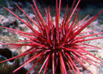 | Red Sea Urchin  Strongylocentrotus franciscanus  Obtained from Licensed Urchin collector | On rocky substrate and soft bottoms, usually below kelp beds | To 10 inches (25 cm)  Alaska to Cedros Island, Baja California Sur | 25.00
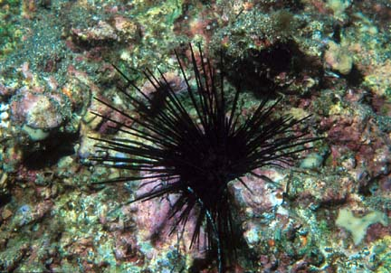 | Long Spined Sea Urchin  Centrostephanus coronatus  Obtained from Licensed Urchin collector | On rocky bottoms coming out to forage at nights on soft bottoms. | To 7 inches (175mm)  Channel Islands, California to Galapagos Island | 35.00
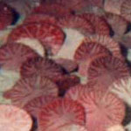 | Sand Dollar  Dendraster excentritus | Soft Sandy bottoms | To 6 inches (15 cm)  San Pedro, California to Ecuador | 7.50.
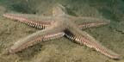 | Spiny Sand Star  Astropecten armatus | Soft Sandy bottoms | To 3 inches (7.5 cm)  San Pedro California to Panama | 15.00
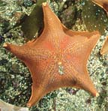 | Bat Star  Asteria miniata | On rocky as well as sandy bottoms | To 8 inches (20 cm)  Sitka, Alaska to Isla Cedros, Baja California | 30.00
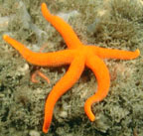 | Blood Star  Henricia leviuscula | On rocks encrusted with sponges and bryozoans | To 8 inches (20 cm)  Aleutian Islands to Baja California | 35.00
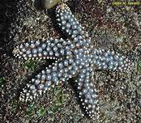 | Giant-spined Star  Pisaster giganteus | Rocky and sandy bottoms | To 22 inches (56 cm)  Vancouver, British Columbia to Isla Cedros, Baja California | 35.00
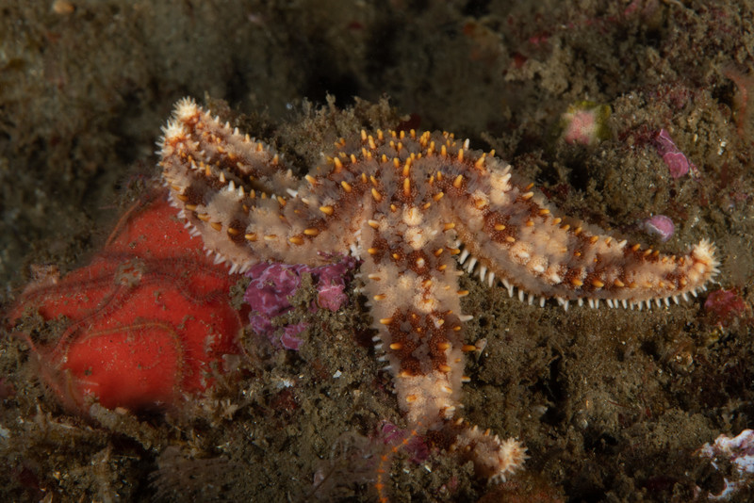 | Fragile Rainbow Star  Astrometis sertulifera | Rocky bottoms | To inches (7.5 cm)  Santa Barbara, California to Gulf of California | 35.00
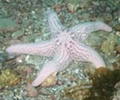 | Short Spined Sea Star  Pisaster brevispinnis  **Difficult to find | Rocky and soft bottoms | To 24 inches (60 cm)  Sitka, Alaska to San Diego, California | 75.00
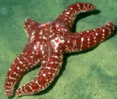 | Ochre Star  Pisaster ochraceus  Currently not recommended! | Soft Sandy bottoms | To 3 inches (7.5 cm)  Alaska to Baja California | 30.00
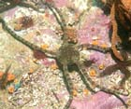 | Smooth Brittle Star  Ophioplocus esmarki | On rocky and sand bottoms. | To 6 inches (15 cm)  Tomales Bay to San Diego, California | 10.00
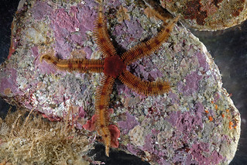 | Spiny Brittlestar  Ophiopteris papillosa | Found on rocks and kelp holdfasts. Very delicate! | To 7” diameter  Range: British Columbia to Baja California | 7.50
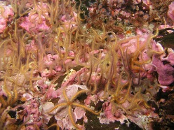 | Spiny Brittle Star  Ophiothrix spiculata | On rocky and sand bottoms | To 15 inches (38 cm)  Central California to Galapagos Island. | 7.50
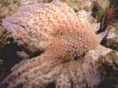 | Sunflower Star  Pycnopodia helianthodes  **Difficult to find | Rocky and soft bottoms. 20 to 24 arms | To 36 inches (90cm)  Aleutian Islands to Baja California | 100.00

