OPTIMIZING A MARKETING PROGRAM
Goals
Understanding the customer
Formulating a winning marketing strategy
Leveraging a marketing program with focus and control
Maximizing the appeal of a product, service or business

Marketing consists of all the activities that contribute to building ongoing, profitable relationships with customers to grow a business or organization. It includes processes of creating, distributing, promoting and pricing goods, services and ideas to facilitate satisfying customers and developing/maintaining favorable relationships with stakeholders. The traditional goal of marketing is to bring about healthy sales through advertising, brand development and other activities. A more long-term goal is to become increasingly useful or valuable to a growing number of customers so as to ensure future success. Watch both short-term sales and long-term development of value to make an organization a growing success.
Marketing Defined
“The activity, institutions
and processes for creating, communicating, delivering
and exchanging offerings
that have value for customers, clients, partners and society
at large.”
A marketing program is a right mix of products or services, pricing, promotions, branding, sales and distribution that will produce immediate sales and also help the business grow over time, as evidenced by profitable sales and enough demand to allow growth at a comfortable rate.
Know Your Customer
For a marketing program to become profitable and growth-oriented, a marketer must thing about how to reach and persuade more of the right customers. When you understand how your customers think and what they like, you may find better ways to make more sales. By knowing exactly what is being offered, marketing activities can help communicate offerings – products or services – to the customer.
What do we need to tell customers to make the sale?

What do we have to offer that is unique?

By asking the right question, marketers are able to avoid the “pollution” of the marketing venues – noisy advertising and one-up salesmanship that produce inefficient and wasteful efforts to reach the customer. The more marketing messages are honed to a true core or essence, the more effective they are. If no unique qualities to advertise are found, postpone media purchases to find out how the product or services can help customers so that they are happy with the purchase of your product or service and you are able to recruit new customers.
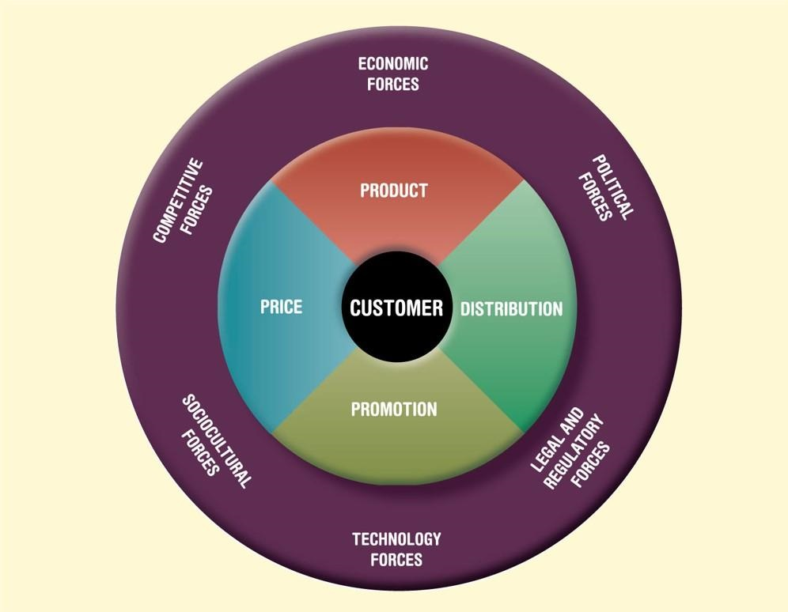
Identifying your target audience
If you draw a large enough circle around a market, you’ll find competitors. Therefore, the work of a marketer involves efforts to improve offerings and become even more unique and special. Start small and then expand: local to international; one product to a line of products; one message to an entire campaign.
Marketing programmes communicate benefits – the qualities your customers value. The essence of marketing is to develop satisfying exchange from which both customers and marketers benefit. The customer expects to gain a reward or benefit greater than the costs incurred in a marketing transaction. The marketer expects to gain something of value in return, generally the price charged for the product. Through buyer-seller interaction, a customer develops expectations about the seller’s future behavior. To fulfill these expectations, the marketer must deliver on promises made. Over time, this interaction results in relationships between the two parties. The right mix of benefits can make a product or service particularly appealing. What are your core benefits, things that a company might be good at doing and the customers value. Benefits can include convenience, ease of use, brand appeal, attractive design, local sourcing, healthiness, a lower price than the competition, to name a few. Even if a company produces a better product or service, customers may still choose the competition, so looking at emotional reasons people make purchases is an important step in identifying the right mix of marketing activities. Look at the emotional impact made by paying close attention to an image being portrayed when seeking ways to boost sales. To truly know your customers, explore these questions:
- What do customers think about the product or service? Do they understand it? Do they think features and benefits are superior to the competition and can meet their needs? Do they feel there is good value given its benefits and costs? Is it easy for them to buy the product when and where they need it?
- How do customers feel about a product or service? Do they make them feel good? How do these make them feel about themselves?

Target Markets
Organizations generally focus their marketing efforts on a specific group of customers, called a Target Market, defined as a vast number of people affected or a relatively small group of consumers at which a product or service is aimed. Market research on demographics will produce a better idea of who you are going to be talking to with marketing activities.
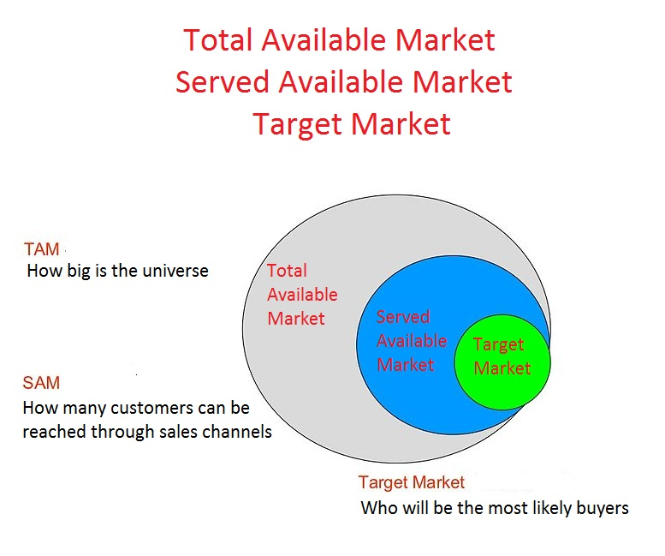
A well-defined target market the first element of a marketing strategy. Four elements of a marketing mix strategy determine the success of a product or service in the marketplace:
Product – determine which aspects of a product are important and have an influence on customer perception and purchase intentions. List all tangible eatures plus intangibles (such as look and feel, packaging, etc.) as aspects that influence customer perception.
Price – the list price is not the only element of the customer’s perception. Discounts and special offers belong on the list of price-based influence point, as well as any extra costs the customer may have to incur, like switching from another product to the one offered.
Promotion – List the ways of promoting an offering by communication with customers and prospects: Website? A regularly-updated blog? Social media presence? Advertisement? Hard copy mailings? Hand-outs and brochures at events? Visibility on signs, buildings, vehicles? Partnerships with distributors who will communicate with common customers?
Placement – When and where is a product available to customers? Place is a big influence because most of the time, customers aren’t actively shopping for an offering. When someone wants something, normally they are strongly influenced by what is available. Getting the place and timing right is a big part of success in marketing.
People – Without people, there can be no marketing. List all the points of human contact that might be important to the success of a marketing programme. The web has also revolutionized the process of making connections with people. A professional and business website, social media presence and other virtual mechanisms of connecting with an audience is an important opportunity for marketing.
Businesses must have a clear definition of their target market, as this can help reach its target consumers and analyze what their needs and suitability are.
Without customers, you don’t have a business.
Every business finds success or failure based on its customers, and a target market is a specific group of people that you have determined to be part of your customer base. There are several factors used in determining a target market, or the group of people considered likely to buy a product or service. To help understand how a target market is developed, you can examine examples of target markets. A target market consists of customers that share similar characteristics, such as age, location, income and lifestyle, to which a business directs its marketing efforts and sells its products. Target markets can be grouped by geography, age, gender, or a combination of many different factors. Because the consumer marketplace has become so differentiated, it's a misconception to talk about the marketplace in any kind of general way anymore. Now, you have to decide whether to market to socioeconomic status or to gender or to region or to lifestyle or to technological sophistication. There's no end to the number of different ways you can slice the proverbial marketing pie.
Learning how to write a target market analysis can help you use your marketing funds more effectively. By analyzing your audience, you identify the most important characteristics about them and use those to promote your product or service directly to them. This will not only help you connect with the individuals who are most likely to use your product or services, but also increase your sales.
As marketing efforts are becoming increasingly online based, the need to find the right audience for marketing campaigns is essential. One of the first steps in developing an effective marketing campaign is determining an appropriate target market so that marketing goals can be set and implemented. Follow these six steps to defining your target market:
1. Understand the problems that you solve
2. Paint a picture of the customer
3. Determine Who will gain from the value in your offer?
4. Think about your market
5. Look internally at the company behind the offerings of products or services
6. Market research on what else is available?
Target markets can be separated into primary and secondary target markets. Primary target markets are those market segments to which marketing efforts are primarily directed and secondary markets are smaller or less important. For instance, the primary target market for a jewelry store might be middle aged women who care about fashion, and their secondary target market could be middle aged men who may want to buy gifts for the women in their lives.
It is important for a business to identify and select a target market so it can direct its marketing efforts to that group of customers and better satisfy their needs and wants. This enables the business to use its marketing resources more efficiently, resulting in more cost and time efficient marketing efforts. It allows for better understanding of customers and therefore enables the creation of promotional materials that are more relevant to customer needs. Also, targeting makes it possible to collect more precise data about customer needs and behaviors and then analyze that information over time in order to refine market strategies effectively.

Attracting Customers
Marketing activities revolve around two major achievements:
- Attracting new customers
- Retaining/Growing existing customers
Marketing to new prospects is usually a different sort of challenge from working with existing customers, so knowing which goals is most important helps improve the focus of a marketing plan.
Here are the most common ways to bring in customers:
Referrals – Word of mouth is often an effective way of securing customers. Viral marketing is included in this category as a current word-or-mouth trend, aiming to give people something (either in the real world or on the web) that they will pass on to multiple other people because they like it. The objective is to get a message to spread naturally. Remember, when customers talk, other customers listen.
Digital Presence – Word Your web identity is the sum of appearances on websites, including search engines that may list a website, any banner or other ads running on the web, blogs and other online conversational appearances, and of course, the ubiquitous social media – Facebook, Twitter, Instagram and others.
Trade Shows, Professional Association Meetings, Community Events – Making contacts and being visible in the right professional venues may be a powerful way to build a business and attract customers by harnessing the power of face-to-face marketing. It has a more personal and human element that gives special marketing leverage and drawing power that is more enduring and durable than electronic transactions. Possibilities for face-to-face marketing include participating in someone else’s event or staging your own event:
- Trade shows support both exhibition spaces and informal networking
- Client-appreciation events can strengthen relationships and also support business networking opportunities
- Community events like a fundraiser, golf tournament, fun run/walk or talent show can attract publicity and raises visilibity
- Serving on client advisory boards or contributing expertise through workshops and other events are great opportunities to provide input and ideas while gaining customers
Advertising – sells products but only if done consistently and frequently, whether in print, on radio or television, outdoors or on the web. Designing printed marketing material requires eight parts:
- Headline – large-print words that first attract the eye
- Subhead – An optional addition to the headline to provide more detail, also in large print, but not quite as large as the headline
- Copy or body copy – the main text, set in a readable size
- Visual – an illustration that makes a visual statement. This image may be the main focus of the ad or other printed material, especially when you have designed an ad to show readers your product.
- Caption - Copy attached to the visual to explain or discuss that visual. Placement varies.
- Trademark – A unique design that represents the brand or company.
- Signature – A company’s trademarked version of its name. Often advertisers use a logo design that features a brand name in a distinctive font and style.
- Slogan – An optional element consisting of a short phrase evoking the spirit or personality of the brand.
Branding – The brand is the heart and soul of any marketing programme. If the product is good and has a strong, appealing identity (the brand), then the marketing programme has a high chance of success.
Required Reading
Why is it important to define a target market for your business?
Guaranteed Success: How to Find Your Target Market So Content Sticks
Target Markets, Entrepreneurs Small Business Encyclopedia
How to Write a Target Market Analysis
Six Steps to Defining Your Target Market
9 Tips for Creating an Awesome Brand
The Essence of Search Engine Optimization
Branding in the Inbound Age

Resources
Pew Internet publishes reports regarding internet use among various demographics. The News Interest Index is a weekly survey conducted by the Pew Research Center for the People & the Press aimed at gauging the public’s interest in and reaction to major news events. http://www.pewinternet.org/2011/03/23/methodology-62/
Nielsen Scarborough Press Room issues press releases with useful data and sometimes publishes free studies and a source for the latest news, and consumer market trend reports. http://www.scarborough.com/press-room
Nielsen also hosts a site for studies by Arbitron. http://www.nielsen.com/us/en/solutions/capabilities/audio/additional-resources.html
You may be surprised what you can find just by doing a search in Google.

