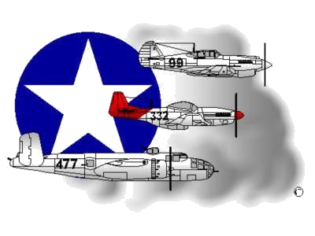 **BIOGRAPHY**

**__________________________________________________________**

**A DOCUMENTED ORIGINAL TUSKEGEE AIRMAN**

**Tuskegee Airmen Inc. Public Relations, P.O. Box 830060**

**Tuskegee, AL 36083**

# Wilbert C. Gore, Sr.

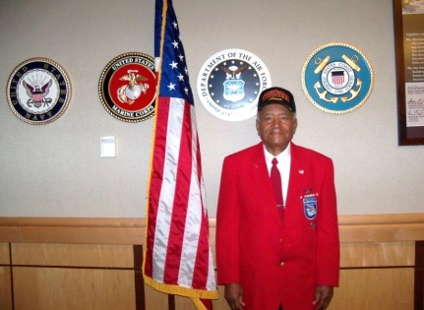Wilbert C. Gore was born in Supply, NC September 9, 1923. He was one of six children. He attended elementary school in Supply, and high school in Brunswick County Training School in Southport, NC. In 1941, he joined the Civilian Conservation Corps near Ft Bragg, NC and entered the U. S. Army on Jan 20, 1944. He was sent to Keesler Field, MS for Basic Training, after which he was transferred to the 6th Ferry Command, Long Beach, CA to support C-47s ferrying back and forth from CA to Hawaii. The extent of Private First Class (PFC) Gore’s expertise was to transfer fuel to bomb bays in support of aircraft departing the Douglas Aircraft factory.

While in Long Beach, he was trained as an Aerial Engineer and was placed on flying status earning approximately $54 dollars per month ($27 for being on flying status). Upon completion of the 30-day Aerial Engineering School, PFC Gore received his Military Operational Specialist (MOS) code (2750) as an Aerial Engineer. As a MOS 2750 soldier, he was qualified to assist the airplane commander in the operation of a multiple engine aircraft by maintaining a constant check on its mechanical functioning. After receipt of his MOS 2750 code, PFC Gore was transferred to Godman Field, KY to serve in the Tuskegee Airmen Experiment. He was assigned to the 477th Bombardment (Medium) Group, which had been activated January 15, 1944, to support the B-25 Mitchell (Medium) Bomber squadrons. At the time, the 477th was commanded by white officers, which was in stark contrast to the manner in which the 99th and 332nd units operated. Weeks later, PFC Gore was reassigned to the 477th Composite Group and subsequently, the 118th Army Air Base Unit at Lockbourne, Ohio. The Lockbourne Unit was comprised of enlisted support personnel and those remaining black pilot graduates who were not selected for squadron assignments in the 616th/617th (Godman Field, Ft Knox, KY) or the 618th/619th (Atterbury Field, Columbus, IN). PFC Gore was among 4-non-officer crew members (such as engineers, flexible aerial gunners, etc) as well as service specialists (i.e. – crew chiefs, intelligence, electricians, etc.) who received training in both segregated and non-segregated centers prior to Lockbourne Field. For a single flight, PFC Gore served as Aerial Engineer for Captain Daniel “Chappie” James who flew a C-47 aircraft.

The 477th Group was known to be plagued with racial tension and disharmony and as a result of growing tension, the 477th never became combat ready with its full complement of flight crews. And although Corporal Gore was at Lockbourne Field, OH and did not directly participate in the “Battle at Freeman Field” (where between April 15-20, 1945, a battle of sort ensued over use of the white only Officers Club by 477th black officers/pilots assigned to Freeman Field, Seymour, IN), he recognized that he did benefit from it directly. Of the 101 stubborn black officers taking a stand at Freeman Field and refusing to sign a “Jim Crow” based regulation, which was punishable by death (64th Article of War), their collective action was found to be justified and Colonel Benjamin O. Davis, Jr. became the new 477th Group Commander. Eventually, PFC Gore was promoted to Corporal but the war ended before he could get to Europe.

After the war, Corporal Gore was shipped back to Ft Bragg, NC and received an honorable discharge. His military/civilian decorations included the American Theater Service Medal, Good Conduct Medal, and the World War II Victory Medal. In March 2007, President George W. Bush conferred the Congressional Gold Medal on all Tuskegee Airmen who participated in the Tuskegee Airmen Experiment and in May 2012, Corporal Gore was one of five Tidewater Chapter DOTAs to receive an Honorary Doctorate Degree in Humane Letters from Old Dominion University, Norfolk, Virginia.

Corporal/Dr. Gore was married to Vivian Gore (now deceased) for more than 50 years. They were blessed with three children resulting in numerous grandchildren and great grandchildren. After 37 years of employment with the Naval Air Rework Facility at the Norfolk Naval Air Station, Corporal/Dr. Gore retired and continued to reside in Portsmouth, Virginia. He was very active in his Church and the Tidewater Chapter until he joined the Lonely Eagle Chapter in 2017. To learn more about Corporal/Dr. Wilbert Gore, Sr., the Tidewater Chapter’s Speakers Bureau and other activities that he participated in, please visit the Tidewater Chapter’s Website at the following location: [www.TAI-TidewaterChapter.Com](http://www.tai-tidewaterchapter.com/).

