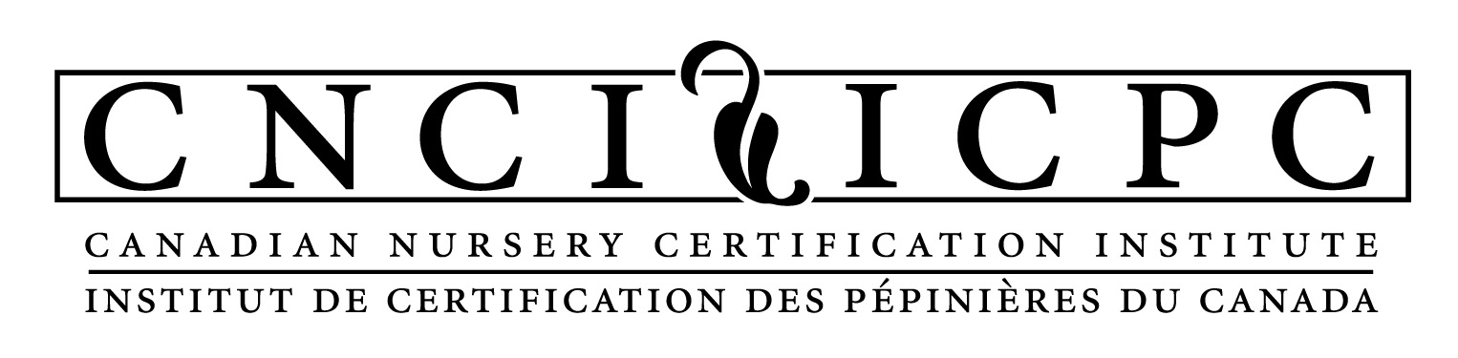

Guidance Document for Clean Plants Phase-In Participation

If you are entering the Clean Plants Domestic Phytosanitary Nursery Certification Program via the BTM Pest Module, provide details in Sections A & B of the Pest Module (BTM-Appendix 1) as well as Section C (“BTM-Appendix 4 – Phase-In Pest Module Section C Template”) using the guidance below. These three sections (A, B, and C) make up the complete Pest Module for Phase-In facilities. When facilities transition out of the Phase-In program, the Clean Plants Manual (Clean Plants Appendix 4) will need to be completed for the entire nursery operation, including specific measures for all relevant pests.

To ship plants as ‘certified’ under the Clean Plants Phase-In process, you must:
- have an approved pest module (Sections A, B and C), verified by CNCI after the Pest Module Evaluation Report has been completed, AND
- have successfully completed the external Initial Facility Audit, AND
- have at least one prior season/year of scouting and trapping data for the pest as specified in the pest module, OR
- have at least 30d residence time at the facility after a) and b) are completed, following the activities described in the pest module.
Note that CFIA may have different requirements for moving host plants out of a regulated area. Contact your local CFIA office for information on specific requirements for each pest.

C.1 Staff – Additional Requirements (C.P. Standard Section 2.0)
In general, your facility will need to identify key people that are responsible for the activities you commit to in the Pest Module.
- At minimum, identify the roles of the Certification Manager (or equivalent) and alternate, Internal Auditor, inspectors/scouts, and owner.
- Who is responsible (position, not names)?
- What are they responsible for?
- Where is the list of names of personnel stored, and who maintains it?
- What are they trained on & where is proof of training, who does the training, and how frequently?

C.2 Shipping to CNCP Nurseries (C.P. Standard Section 3.4)
Only facilities certified under Clean Plants are considered approved facilities (see introduction for the criteria that must be met for Phase-In facilities). Evidence of specific pest certification status must be provided to CNCP customers to allow for export of host plants to the USA (where allowed), following the requirements of the CFIA Directive D-04-01. Special procedures for these shipments will be outlined by the receiving facility.

C.3 Use of the Clean Plants Stamp (C.P. Standard Section 3.6)
While the Clean Plants Stamp is only provided to facilities that are Certified under the full Clean Plants program, a unique certificate identifying the facility as being Phase-In Certified under a specific pest module will be issued. Management, security, and use of the certificate are described in this section.

C.4 Records (C.P. Standard Section 3.7)
Records should be maintained for at least 3 years, while traceability records need to be kept for 7 years. Be clear where and how records are stored, as well as detailing who is responsible for maintaining/preparing various records. Example records include:
- Clean Plants Training (i.e., all responsibilities under the program, not just pest-specific components)
- Specific Pest Scouting Training
- Sourcing/purchasing paperwork (or propagation records)
- Plant Supplier List
- Receiving inspection
- Scouting/treatment/trap records (i.e., monitoring and control activities)
- Plant movement records (i.e., location(s) throughout crop cycle)
- Shipping inspection
- Outbound/shipping/sales documentation (i.e., customer invoices)
- Use of the Clean Plants Pest-Specific Phase-In certificate
- Internal and external audit reports and related documentation

C.5 Audits (C.P. Standard Section 4.0)
First, your facility needs to identify personnel responsible for the audit process, including both internal and external audits.
- Who is responsible for the audits (arranging, facilitating, follow-up)?
- Who is responsible if there are non-compliance issues? What is the process for handling these situations?
- Who is responsible for updating the Pest Module?

Audit Frequency
- Initial external facility audit (within 4 months of approval of the Phase-In Pest Module)
- External audits every 3 years by a CNCI-approved auditor
- Internal audits twice per year by the facility

C.5.1 Internal Audits (C.P. Standard Section 4.1)
The internal audit process must be detailed by the facility. The internal audit will verify which procedures are being accurately carried out and identify areas where they are not. It will also identify where the Pest Module needs to be updated or changed to maintain the integrity of the program. In this section, the nursery will describe how the findings of the internal audit will be communicated and to whom to ensure continual improvement.

All parts of the Pest Module do not have to be reviewed at each audit, providing all of the components are reviewed over a one-year period. However, examination of host plants for the specific pest should be performed at each audit*. A minimum of two (2) internal audits must be conducted every year, with one audit during the shipping season, and the second at some point during the growing season. Other internal audits can be conducted when deemed necessary by the facility, for example ahead of an External Audit.

The internal audit can include a range of activities. For example:
- Using the Pest-Specific External Audit checklist
- Communication with staff and observation of staff activities related to the pest program
- Examining documents and records required by the pest program
- Examining the procedures described in the Pest Module
- Confirming the nursery is able to carry out its pest management program
- Examination of host plants in production for evidence of the pest*

C.5.2 External Audits (C.P. Standard Section 4.2)
External Audits are arranged through CNCI and performed by trained third-party auditors every three years, either virtually or in-person. The list of accredited auditors can be found on the website of CNCI at www.cleanplants.ca. In this section, the facility details:
- The nursery staff position that will schedule the external audit (e.g., Certification Manager)
- The key nursery staff contact prior and after the audit
- The person(s) responsible for implementing corrective actions
- The person(s) responsible for updating the Pest Module as required

At least one week prior to the scheduled audit, this person will provide the external auditor with a copy of the Pest Module and Pest Module Evaluation Report. Ahead of the audit, the External Auditor will communicate to the Certification Manager the scope of the audit, which staff members need to be available for interviews, and the office space required.

C.6 Updates to the Pest Module (C.P. Standard Section 6.0)
Any revisions to procedures, assignment of tasks, key positions, etc. in the Pest Module should be summarized and dated. Describe how the revisions will be tracked. The Certification Manager is responsible for all updates to the Pest Module, and for ensuring that the most recent version is shared with CNCI.

